Centre Number : 18143,

Candidate Number : 5424

Sonny Cooper

Table of Contents

Analysis (10 mark) 4

• Described and justified the features that make the problem solvable by computational methods, explaining why it is amenable to a computational approach. 4

Intro 4

The Interview Setup 5

The Interview 7

Computational Methods 10

• Identified suitable stakeholders for the project and described them explaining how they will make use of the proposed solution and why it is appropriate to their needs. 11

Stakeholders 11

• Researched the problem in depth looking at existing solutions to similar problems, identifying and justifying suitable approaches based on this research. 12

Alternative Automatic Gate Solutions 12

Similar Software Solutions 14

• Identified the essential features of the proposed computational solution explaining these choices. 16

Number Plate Recognition 16

App Communication 17

• Identified and explained with justification any limitations of the proposed solution. 18

My Skills 18

Time And Cost 18

Other Limitations 19

• Specified and justified the requirements for the solution including (as appropriate) any hardware and software requirements. 20

• Identified and justified measurable success criteria for the proposed solution. 21

Design (15 marks) 23

**•** Broken the problem down systematically into a series of smaller problems suitable for computational solutions, explaining and justifying the process. 23

Number Plate Recognition 23

App 25

• Defined in detail the structure of the solution to be developed. 29

• Described the solution fully using appropriate and accurate algorithms justifying how these algorithms form a complete solution to the problem. 32

ANPR Side 32

App Side 34

• Described, justifying choices made, the usability features to be included in the solution. 38

• Identified and justified the key variables / data structures / classes (as appropriate to the proposed solution) justifying and explaining any necessary validation. 42

• Identified and justified the test data to be used during the iterative development of the solution. 43

• Identified and justified any further data to be used in the post development phase. 46

Developing the Coded Solution (25 mark) 48

Iterative Development of a Coded Solution (15 marks) 48

ANPR Side - Development of the object recognition module 49

ANPR Side - Final iteration of the object recognition module 56

ANPR Side - Development of the Character Recognition Module 61

ANPR Side - Final iteration of the ANPR module 63

ANPR Side – Final iteration with MySQL Database 75

App Side – Login Module 78

81

81

App Side – Final Iteration of login page module 81

App Side – Primary Users home screen module 86

App Side – Add companies module 87

App Side – View data module 88

App Side – View Companies Module 89

App Side – Final iteration of view companies module 91

App Side – Add number plate module 97

App Side – View entries module 98

App Side – View entries final iteration 100

App Side – Open gate module 106

App Side – JavaScript for primary users page 114

App Side – Secondary users home screen module 121

App Side – Request number plate module 122

App Side – JavaScript for secondary users 123

App Side – Full CSS for all pages 125

Testing to Inform Development (10 marks) 128

Evaluation (20 marks) 140

Testing to Inform Evaluation (5 marks) 140

Evaluation of Solution (15 marks) 145

• Used the test evidence to cross reference with the success criteria to evaluate the solution explain how the evidence shows that the criteria has been fully, partially or not met in each case. 145

• Provided comments on how any partially or unmet criteria could be addressed in further development and provided comments on how any issues with partially or unmet usability features could be addressed in further development. 148

• Provided evidence of the usability features justifying their success, partial success or failure as effective usability features. 149

• Considered maintenance issues and limitations of the solution. 150

• Described how the program could be developed potential improvements / changes. 150

# Analysis (10 mark)

## • Described and justified the features that make the problem solvable by computational methods, explaining why it is amenable to a computational approach.

### Intro

My step father David is the owner of commercial industrial units in Beeston which he rent out monthly to his clients. On average there is typically 23 companies present at the site, this means lots of people enter and exit. However, at the moment there is little security to control the flow of people entering and exiting the site along with no way to monitor who enters the site and when, this is an obvious flaw in David’s current system and could lead to things being stolen as people could easily trespass.

This problem however, could be solved through a computational approach as a camera linked to a Raspberry Pi or Arduino could monitor the vehicles entering the site via reading the number plates and search for a match before opening the gate to ensure only legitimate users of the site may enter. This could be achieved through the combination of both machine learning and Pytesseract (an optical character recognition tool) to recognise the white box of a number plate before reading the sequence of numbers and letters and comparing the string to those in a database. This is more secure than other alternatives such as gate clickers which can easily be stolen or lost. Gate clickers are also extra hardware which could amount to an expensive price as 23 companies with multiple people would need access to them. In contrast, using number plates is not only more secure as it is less at risk to social engineering but cheaper as you would only need the initial hardware price of setting up the system.

After discussing my initial plan with David we decided that it would also be necessary to create an app which could be used to open the gate as an alternative method for clients using vehicles not yet registered on the system, this would also be useful as clients could open the gates for their guests without going to David for help. My plan for this is that you would get a login that you could use to open the app. After this, clients would be granted a low user access level where they would be able to add number plates under their company names and open the gates through the app to allow their guests to enter. David will also be given a login; however, he will be given a higher user access level which he could use to view who enters and when along with the ability to add and delete companies from the database as they come and go, keeping the whole system secure and updated.

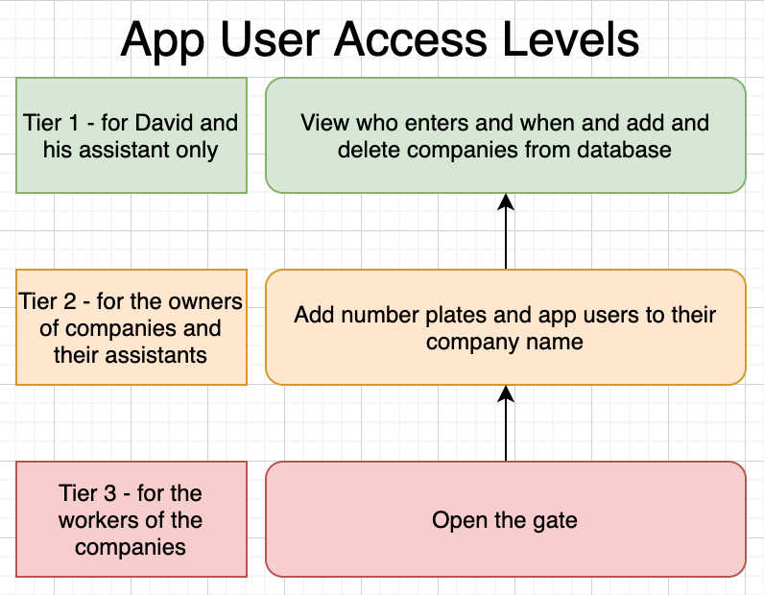

### The Interview Setup



Here is screenshot of us arranging an interview for June 16th, 2020 and below are the questions to be asked in the interview along with the reasoning why

1. **Background company information**
   * How do people contact?
   * How do new customers normally find you to take on rentals for units?
   * Location of the site?
   * Number of clients?
   * When did the company start?

These questions are aiming to show me how David’s business works through some background knowledge. This is so I know what to expect in terms of number of clients and the formalities of adding new clients to the site, meaning I can predict if company data would have to be regularly updated and changed in the database along with finding the general volume of this data.

1. **Definition of the problem**
   * How big is the site?
   * How many people come in and out per day?
   * Are you planning on expanding your sight in the future?
   * When things are delivered to the site are they typically delivered to the front desk or inside the site?
   * How much are you willing to spend on this system?

These questions give me a general idea of the needs of this system so I can ensure it is long lasting, maintainable, and actually more useful then the original system

1. **The people/stakeholders**
   * What types of companies rent here?
   * Do the companies renting here get many deliveries, eg car parts?
   * How many people and vehicles are typically present in these companies?
   * How many clients might you have in the future?

These questions are designed to give me a general idea of the clients here to give me an idea of the number of deliveries which need to enter through the gates along with the types of vehicles driven eg truck, car, bike

1. **The current system (hard & software)**
   * Do you have any form of security at the moment?
   * How old are your CCTV cameras and where do you view the footage from?
   * How long do you keep your CCTV footage before deleting it?
   * Does your security system work constantly or is it turned on or off at night?
   * What security do you have inside the site, e.g. locks, cameras, etc?
   * What issues are present in your security system?
   * What don’t you like about your current security system?
   * Has your current security system failed you in the past?
   * Is there an opportunity for human error in the current system?

These questions give me an idea of the standard of security present at the site and so help set a benchmark for the new system along with giving me some idea of some of the things David wants in the system

1. **Collection of current documentations**
   * Do you have copies of your CCTV footage?
   * Where is the data stored?

These questions give me an idea of the general security in present system and possibly where David would like the information from the new system to be backed up to

1. **Alternatives research**
   * Have you looked into any other security systems in the past?
   * Why have you not chosen these systems before? Expense? Security?
   * Why do you think a personalised system would be better than these alternatives?

Further sets the benchmark and helps give me an idea of what I need to do to meet David’s requirements

1. **The new system requirements (essential/desirable)**
   * What do you need out of this system?
   * What would you ideally like out of this system? Y
   * How much power do you want your clients to have with your security system?
   * How many people may need to access the app at the same time?
   * Do you intend to adapt and expand this system later on?
   * Would you like a bypass to keep the gates open on busy days but still read the number plates going in and out?

These questions show me what David wants out of this system in terms of key features

1. **New user requirements (essential/desirable)**
   * Would you like to take a hands-on approach to adding users or have the option for them to set it up by themselves?
   * How much power do you want to give to the owners of the companies?

This helps me determine the power at different access levels

### The Interview

**Background company information**

**How do people contact?**

Typically, via email or mobile numbers

**How do new customers normally find you to take on rentals for units?**

Through current tenants recommending the site, I do not advertise for new customers

**Location of the site?**

PE32 2NQ, Beeston, King’s Lynn, Norfolk

**Number of clients?**

Approximately 20-25 currently

**When did the company start?**

The site has been renting some property since the 1970’s

Analysis - This is a stable company, as shown by the fact that it’s been running for 50 years and has many customers. This means I need to develop a database which stores not only a lot of data but a database that can be easily maintained so it will not run into errors in later years, this means it needs to be easy to add and delete companies from the database to ensure old companies do not get lost in there and forgotten to be deleted.

**Definition of the problem**

**How big is the site?**

Approximately 12 acres

**How many people come in and out per day?**

About 75 per day including suppliers i.e. lorries and vans

**Are you planning on expanding your sight in the future?**

Yes

**When things are delivered to the site are they typically delivered to the front desk or inside the site?**

Depends on whom deliveries are going too. Most are delivered directly to the individual industrial unit

**How much are you willing to spend on this system?**

No budget decided as yet

Analysis – This is a big site with many people entering and exiting per day with the likely possibility of this number expanding, this means I need to ensure the camera has a high success rate when opening the gates to stop the hassle of going through the app. I also need to look into alternative ways of letting in deliveries as using the guest button may become annoying for the company owners. At the moment a possible alternative is to have a camera which reads the side if the lorry so if the number plate is not recognized it can instead look at the company logo and compare it to those in a database.

**The people/stakeholders**

**What types of companies rent here?**

Engineering, transport, parcels, electrical, cars, boats, tiles, auctions, aggregates, scrap

**Do the companies renting here get many deliveries, eg car parts?**

Yes, all companies get deliveries but does vary on amount

**How many people and vehicles are typically present in these companies?**

Difficult to say, some companies are one-person others have 10 people and others may have more

**How many clients might you have in the future?**

Possibly another 10 as it grows

Analysis – These stakeholders are from a variety of different businesses, this means I need my cameras to be able to read number plates from a variety of different vehicles from large lorries to bikes.

**The current system (hard & software)**

**Do you have any form of security at the moment?**

Yes

**How old are your CCTV cameras and where do you view the footage from?**

Three years old, these can be viewed from a hard drive or my mobile phone

**How long do you keep your CCTV footage before deleting it?**

It runs over every 30 days approximately

**Does your security system work constantly or is it turned on or off at night?**

24 hours, 7 days a week

**What security do you have inside the site, e.g. locks, cameras, etc?**

Locks, gates, cameras, lighting

**What issues are present in your security system?**

Secure fencing and gates being left open

**What don’t you like about your current security system?**

Needs to be more modern and flexible to allow each user to access the main gate at all times

**Has your current security system failed you in the past?**

People leaving the gate unlocked can pose a risk to the security of the site

**Is there an opportunity for human error in the current system?**

Yes, see above

Analysis – This current system is very good with the exception of the gate which appears to not only be a hassle for the stakeholders but also a risk for the site as it can sometimes be left unlocked. This means that I need to develop a system which eliminates this hassle as much as possible, meaning I will need it to be accurate and user friendly.

**Collection of current documentations**

**Do you have copies of your CCTV footage?**

Yes, which stay for 30 days before being run over

**Where is the data stored?**

On a hard drive and phone

Analysis – It would be useful for my system to record in the same fashion so the records of cars entering is in sync with the cameras in case someone does break the rules of the site or trespasses. This would save time as you could easily see which company the vehicle braking these rules belongs to.

**Alternatives research**

**Have you looked into any other security systems in the past?**

Other than current systems I have not looked into other designs of systems at present

**Why have you not chosen these systems before? Expense? Security?**

More pressing decisions to be made in other work

**Why do you think a personalised system would be better than these alternatives?**

A personalized system would be better as it would achieve 100% of our goals, unlike alternatives which would be more generalized. This is also better as alternatives can be costly as more hardware may be required.

Analysis – David is looking for a system with bespoke software rather than the proprietary software on the market as it will benefit him more, overall price and ease seem the main goals for David.

**The new system requirements (essential/desirable)**

**What do you need out of this system?**

Flexibility, simplicity, and a cheap price

**What would you ideally like out of this system?**

Something to also monitor client’s health to reduce spread to illness on the site (e.g. something to monitor temperature upon entry, if too high warn people or don’t let them in)

**How much power do you want your clients to have with your security system?**

None other than usage only

**How many people may need to access the app at the same time?**

All people coming to the site but not suppliers/ deliveries of mine or other on the site, they will need to contact the individual whom can then allow access onto the site

**Do you intend to adapt and expand this system later on?**

I would think so as the site becomes busier, ideally built to last with messages if storage is becoming full

**Would you like a bypass to keep the gates open on busy days but still read the number plates going in and out?**

No

Analysis – David priorities as stated above are flexibility, simplicity and price and his aims for this system are as expected. However, I doubt that I will be able to achieve his ideal goals as they seem rather complicated and will likely be hard to implement, especially at a low price.

**New user requirements (essential/desirable)**

**Would you like to take a hands-on approach to adding users or have the option for them to set it up by themselves?**

Most definitely. Only I would have access to set up each user and company

**How much power do you want to give to the owners of the companies?**

None other than usage, that way I can keep control of access

Analysis – David seems to want a hands-on approach where the stakeholders are not involved in the setup of the system, this means I will need two user access levels rather than the original three as David prioritizes being in control over ease.

### Computational Methods

This problem is suited to computational methods as David wants people to be able to access the site at all times without running the risk of the gate being left unlocked at night. The use of an automatic gates would clearly be the best alternative as it stops the chances of the gate being left unlocked as it automatically closes after use. For this plate recognition is the best solution as it is both less at risk for human error than the alternatives such as gate clickers, that can be lost or stolen, and it is easier to track who enters and when as it can all be logged in a database. In conclusion, using computational methods to solve this problem not only is the best way to improve security but also ensures David maintains in control of the system.

#### Decomposition

This problem can be decomposed into a few steps for how to execute this number plate recognition. My initial idea for these steps is as follows:

1. Take picture from central camera every 5 seconds
2. If a number plate is present in the picture crop image
3. Read the number plate and compare the string to that in a database
4. If same as in database open gates

The problem of opening the gates through the app can also be put into a few steps. My initial idea for these steps is as follows:

1. Click the open button in the app
2. Alert Raspberry Pi that gate needs to be open
3. Open gates

#### Abstraction

There are many forms of unnecessary data present in this problem, this unnecessary data needs to be kept to a low degree as extra data may slow the execution of the program which is vital in something such as opening gates where it is all about time saving and making it easier. The second need of abstraction in this problem is to ensure the storage does not fill up with unnecessary data as there will already be a vast amount of vital data such as the companies and their number plates being used. The first use of abstraction will come as the photo is taken every 5 seconds, if a white box is not present in the image the image should delete, however if the box is present the image should be cropped to abstract the important data from the rest. The second use of abstraction will come in the database as I need to ensure only vital information is stored to save room and ensure that as the business grows the storage won’t run out.

My initial Field names for the database is as follows (keeping unnecessary data to a minimum):

**Car Details:**

PK – Number Plate

Company

**Data Recorded:**

PK – dailyEntryNumber

Time

Company

Guest/NumberPlate

**Photo Details**

PK – photoNumber

CarPhoto

NumberPlateString --- if numberPlateString == false delete image from the database

## • Identified suitable stakeholders for the project and described them explaining how they will make use of the proposed solution and why it is appropriate to their needs.

### Stakeholders

The primary stakeholder of this system is David as owner of the multi-user site, due to this there are many benefits for him with the main one being an increase in security as he will now have the power to control who has access to the site and track when they enter which in turn improves the sites reputation as it is secure and less at risk to having things stolen compared to other sites which may not have such security. Another benefit for David is that he can finally allow access to the site 24/7 which was a need which he expressed in the interview above and one his current system cannot allow, this will likely give him advantage over his competitors who will likely not be able to give this privilege to their clients.

The other main stakeholders of this system are the clients themselves who’s main benefit will be security as they can now be reassured that their equipment is definitely secure and not at risk of theft. Their second benefit will be the fact that they can now enter the site 24/7 which is good as they can now stay at the site for as long as they want. Some of them such as mechanics may need to stay late to make deadlines or may need to be in early for deliveries or other reasons, with this all-time access this would be possible. This may increase their efficiency and in turn boost their business as they would be more versatile as a result of the sites own versatility.

## • Researched the problem in depth looking at existing solutions to similar problems, identifying and justifying suitable approaches based on this research.

### Alternative Automatic Gate Solutions

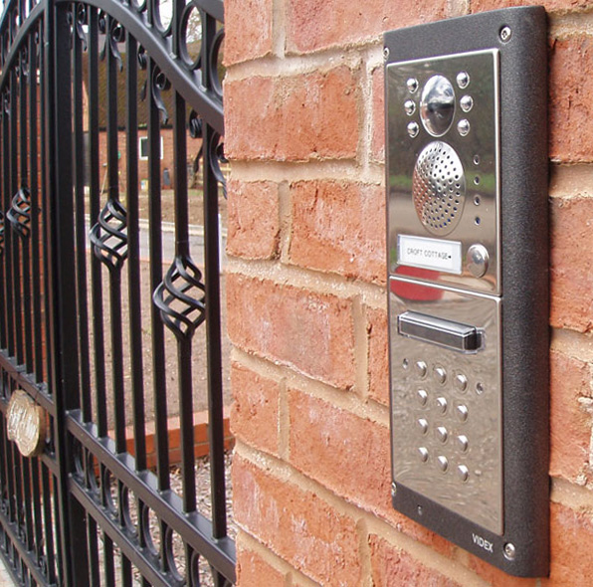

Keypad Solution

Telephone Intercom

#### Telephone Intercom

Telephone intercom works by the guest clicking a button on the gate, this then alerts people inside who communicate with guest, finding the reason for entry before deciding whether or not they’ll let them in via clicking a button on their side.

Pros:

* Is an easy and secure way to allow guests onto a site as a person on the inside is required to give access and so the guest must have a viable reason which is communicated via the intercom to gain access

Cons:

* Is only a solution for guests, is useless for regular users
* Relies on someone responding on the intercom, if no one is there then the guest cannot get in

#### Keypad Solution

Keypad solution works via a keypad on the outside of the gate which has a code which is required to open the gate, if you get the code wrong it won’t let you in and if you get the code right the gate will open. This solution is typically paired with the telephone intercom.

Pros:

* Little hardware required only the keypad is needed
* Ensures access 24/7 as no humans are required to gain access unlike the telephone intercom
* Makes it easy to give new users access to the site

Cons:

* There is no way of restricting access to people who know the pin such as old users or people who have overheard the code (susceptible to social engineering)

#### Remote control (clickers)

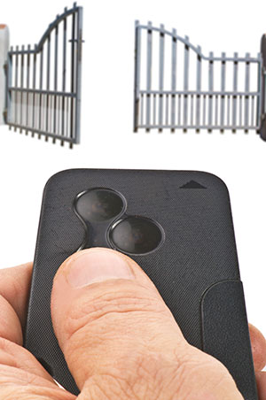

Clickers are a form of remote control which opens the gates when clicked, this is useful as it can be kept on your keys so will always be on hand and will mean you don’t have to get out of the car to open the gates.

Pros:

* Easy and quick way to access the site as you don’t even need to get out of the car to open the gates
* Unlikely to get lost as they are typically with your keys, this means it is unlikely for unwanted people to access the site
* 24/7 access as no humans are required to gain access to the site

Cons:

* The clickers are expensive hardware and will likely add up to a large sum of money when 20 companies need them. They can also get lost or broken meaning more may have to be brought down the line
* If stolen it is hard to deny access to the thief as unlike the keypad it is hard to change meaning they will likely have 24/7 access like that of legitimate users

#### Timed Openings

Timed openings mean the gates will be open between certain times in the day, this is useful for sites which have many guests throughout the day and only care about security at night while no one is there.

Pros:

* Quick and easy access throughout the day for both users of the site and guests
* No human interaction is required to operate the gate

Cons:

* Not as secure as other options as it is open for everyone in the day
* If a company wants to work overtime one day this is not an option as the gate will be closed (not 24/7 access)

#### Evaluation

The main aspects that I like from these current solutions is their ability to maintain open 24/7, their lack of staff to operate the systems and their ease in use as shown by solutions such as the timed opening and the remote control which allow the users to stay in their vehicle while opening the gate. However, none of these solutions are necessarily cheap which for David is a must and a reason why he has probably not invested in any of these solutions in the past. With my solution however, I hope to lower this price as I will be the main source of production and so expensive aspects will hopefully be avoided.

Despite all these solutions being effective all of them have similar issues and that is the fact that all of them are susceptible to some form of human error. The solutions which handle this weak point better in turn increase in price as more hardware is required to function (e.g. clickers). The cheaper solutions are also a hassle as you have to get out of the car to open the gates, except for the timed opening which is just not secure enough for David’s needs. In their defense the remote control, keypad solution and telephone intercom are typically pair together; however, pairing their strengths in turn also pairs their weaknesses. My aim is to make a system with all their strengths of ease, price and security but eliminate as many weaknesses as possible.

### Similar Software Solutions

#### The Dartford Crossing Charge

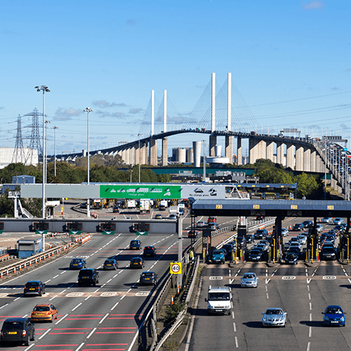

To the left is an image of the Dartford Crossing before the ANPR changes when toll booths were still used. The image clearly shows that this system is slow and results in congestion. I could not find any after pictures as there is nothing there, instead it now just looks like a normal bridge where cars flow in and out without any stopping or congestion.

The Dartford crossing is a perfect example of how number plate recognition can be used to increase efficiency where it comes to allowing access. Originally the Dartford crossing was like most crossings; you would be stopped at a barrier and would to pay a charge to cross, however in Dartford’s case this was a little more complicated due to it being one of the main crossings into London and so was typically busy with queues that could last for over 30 minutes in rush hour. This in turn became a stressful part of journeys and so to solve this issue they decided to utilize number plate recognition. With this there was no barriers, instead cameras would read your number plate as you crossed and then charge you online for the drivers to pay later. This resulted in little congestion and drastically improved the drivers experience of crossing the bridge as it was no longer such a hassle.

Benefits:

* New system stopped congestion, which was a past problem before the system, and in turn increased efficiency as cars no longer had to stop to get charged
* No need for people in toll booths, this would have likely increased profits as they no longer had to pay as many staff members

Issues in system:

* Number plate recognition was faulty, a 2016 article by The Guardian reads as follows “Bundy, from Blandford Forum in Dorset, was the victim of a licence plate misreading by the automated camera system which incorrectly fined his blue Nissan Navara instead of the white van that had gone through the toll in May 2015. Almost a year later he is being threatened with legal action to recover a debt he doesn’t owe, for a journey he never made.” This was due to “the camera confused a C with a G on the plate”
* Signs showing that the charge should be payed online were unclear and so new people to the system could miss it, the same Guardian articles claims “The only warning of the levy is a large C which is identical to the symbol for the congestion charge, the £11.50 fee for vehicles entering central London. A recent poll by the AA found that 60% of drivers mistook it for the latter, an entirely different fee which is not payable on the Dartford crossing.”

#### Facial Recognition Doorbells (Nest Hello)

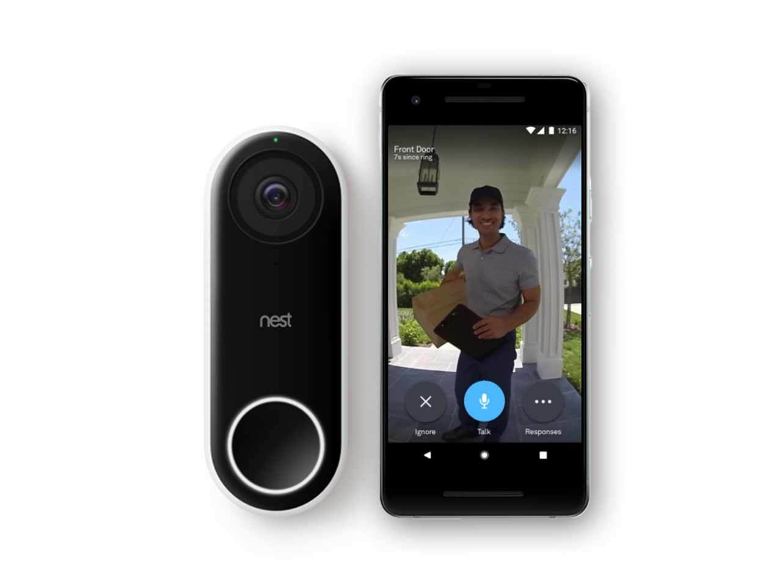

The Nest Hello is a facial recognition doorbell with some useful aspects which are similar to my problem. Firstly when rung an alert is sent through to the homeowner alerting them of a visitor, this is a possible solution to my guest feature issue as the person expecting a delivery could input the time into the app of said delivery and then if the gate is rung around that time the relevant company could receive an alert telling them that their delivery is there before giving them the option of opening the gate. This is better than alternative methods as it will not alert all companies only the relevant ones, keeping the stakeholders happy. This may also help increase security as the delivery input could be sent to David’s phone, both making him aware of the situation and logging the delivery into a database, keeping him in the loop and keeping the site secure. This concept of David accepting the requests could also be used with adding the number plates as he could remain the only one with the power to add or decline them but would have the benefit of less of a workload as new companies join.

Finally, the facial recognition part of the Nest Hello is interesting as it could be a possible solution as to where to store the data of number plates and how to communicate that information through an app as the Nest Hello allows users to add names to faces so they can be identified upon future visits.

#### Evaluation And Relevant Questions

**Evaluation**

The Dartmouth crossing example is interesting as it shows the capabilities of number plate recognition as it can read number plates going at 50mph, this gives me confidence in my idea of using number plate recognition as a simple and good method of security as it will not only be efficient but accurate as the number plates being read in my circumstances will hopefully be going at 10mph maximum straight towards the camera ensuring a much lower margin for error. The Nest Hello on the other hand gave me a bit of insight on ways similar security problems have been solved, giving me some idea on what to do with the app communication in order to make a simplistic and easy to use app for stakeholders as that is in my opinion the best aspect of the device and a part I intend to take a lot of inspiration from in my own project.

## • Identified the essential features of the proposed computational solution explaining these choices.

### Number Plate Recognition

#### How Does Number Plate Recognition Typically Work?

1. When a car is sensed a picture is taken using an Infra-red camera (IR is used to reduce glare and help read the images at night ensuring a clear picture is always taken)
2. The image is then transmitted to a processor in or out of the camera
3. This processor then uses OCR technology (optical character recognition) to examine the image, this is done via machine learning that ‘reads’ the number plate from the image before creating a string
4. This string is then sent to a database which compares it to present records in the system, if there is a match the car is let in, if not it is charged (this is a parking lot example)

Sources:

* <https://www.primoregistrations.co.uk/article/view/your-guide-to-automatic-number-plate-recognition>
* <https://www.regtransfers.co.uk/content/how-does-number-plate-recognition-work>

|  |  |
| --- | --- |
| Requirement | Explanation |
| An effective ANPR (automatic number plate recognition) | This is the key feature of the system and the main form of entry. This means the ANPR needs to be quick and accurate to ensure stakeholders see the new system as a benefit rather than a mistake. If this feature doesn’t work stakeholders would have to open the gate through their phone every time which goes against the idea of it being an easy and efficient system. |
| Quick communication between the camera, processor and database | This is essential for a quick gate opening which is a main goal for the system (if the system takes more than 10 seconds to open then it is annoying for the stakeholders and then slower than alternatives such as clickers and pins). |
| Easy to navigate database | This is a key feature as an easy to navigate database is required for quick comparisons between the database and the number plate strings. This is also important for easy editing to ensure adding and deleting companies remains simple for David. |
| Alternative way to add and delete number plates and companies | This is important in case the app breaks David still needs the option to add and delete number plates to the system. This is also important for set up before the app is completed as I need a way to add number plates for testing the system before starting on the app section itself. |
| Alternative opening | In case of a power cut or a failure in the system there needs to be a way to disconnect the system from the gate and turn it back into the original manual gate to ensure the entry is still possible during these rare but possible occurrences. |

### App Communication

#### How Do Database Servers And Applications Typically Communicate?

1. A Database Server - A database server is a computer program that provides database services to other computer programs or computers using a client-server model. This works via a constantly running central computer that stores the database. When computers that are allowed to communicate with this server choose to send a command it is processed, and the necessary data is selected or updated to/from database storage before being sent back to the requester.
2. An Application Server - An application server is a mixed framework of software that allows both the creation of web applications and a server environment to run them. This is important as it provides your organisation with an additional layer of security. By sitting in between web pages and databases, an application server helps act as an additional barrier to SQL injection cyber-attacks, as there is no direct link between a web page and a database.
3. The Clients Phone – The client downloads the app (hosted via the application server) on their phone, this means that while connected to the internet they can now communicate with the application server and in turn the database server, giving them the ability to edit and view the database.

Sources:

* <https://www.guvi.in/blogs/how-do-database-servers-work/>
* <https://www.itpro.co.uk/strategy/29643/what-is-an-application-server>

#### For Businesses

|  |  |
| --- | --- |
| Requirement | Explanation |
| Be able to open gate through app | This is an important feature as it is a backup in case the number plate fails, this ensures the user can still enter. This is also important in case the user wants to enter on foot rather than via their vehicle. |
| Be able to request deliveries to David and get delivery notifications | This is an important feature as it ensures only the relevant people are alerted when the delivery is rung. It also ensures David is kept in the loop and aware of what is happening on his site. |
| Be able to submit number plates to David | This is an important feature as it means the companies can fill in their own number plates before being sent to David to be accepted, lowering David’s work load and simplifying the process of adding new number plates. |
| Be able to log in as a new member | This is an important feature as it ensures new companies and new staff in companies can use the app to ensure they can enter the site with the button. |

#### For David

|  |  |
| --- | --- |
| Requirement | Explanation |
| Be able to add and delete companies and number plates | This is important as it ensures the database is kept up to date. It also ensures David can quickly and easily add new members even when he is away from the site. |
| Be able to accept and decline number plates | This ensures David keeps in control of number plates on the system, keeping it secure. This is also a shortcut as he only has to accept the requests rather than entering it himself. |
| Be notified with delivery requests | This ensures David is kept in the loop and aware of who is allowing access to the site for deliveries and when. |
| Be able to change the database effectively through the app | This is an important feature as it ensures David can quickly add and delete number plates when away from the office. This is a valuable feature as it will likely be the first thing new clients will experience and a quick and effective set up ensures first opinions of the site are good. |

## • Identified and explained with justification any limitations of the proposed solution.

### My Skills

One limitation for this solution is my present skill set, as writing this I am only knowledgeable in python and have not yet used a raspberry pi. This is an issue as the size and scale of this project is very large and so will require me to learn a number of new skills including new python phrases for raspberry pi, how to set up a server and finally JavaScript in order to code the app for both apple and android users. Due to the fact that I will have to pick up a lot of new skills I have a few limitations which include time and scope. Firstly, I am planning to do the app in JavaScript rather than swift and java as despite it limiting my overall presentation of the app, lowering my scope, it will in fact save valuable time needed to combat the scale of this project in this deadline of 2 years. The second measure I have taken to soften the blow of this time limitation is the fact that I will finish the analysis section of my project before school starts again in the summer, bringing me a half term ahead of schedule and ensuring I can now spend more time on the design section of my project.

### Time And Cost

Time and cost are the two major limitations in this project. Cost is a major limitation as David want the price of the whole project to understandably be as cheap as possible while ensuring security standards are still met, due to this more time will likely be required as I will have to take longer routes to find my solutions in order to save money. This brings me onto my second major limitation which is time, due to the scale of the project combined with the fact that I will have to learn new skills and ensure prices are kept to a minimum time will be rather restricted. This is further limited by my busy schedule which consists of two other A level subjects, plus further work in computer science along with my rowing career which typically consists of around 10+ hours of work per week. One way I have attempted to combat this issue is by choosing a project interesting to me in order to make the whole thing feel more like a past time and a way to relax then a hassle.

### Other Limitations

Other limitations to this project include the fact the present gate on the site is not yet electric, this means time and money will be spent doing this which in turn further limits my own time working with the gate itself. Another limitation is the location of the site, it is an hour away from me and so means I will not be spending much time actually on site, running the risk that the work I do at home may not work with the environment set at the site, e.g. location of power cables and WIFI speeds.

#### Data Protection Law

The data protection law along with other relevant laws is a topic which certainly limits what I can do as I will have to use personal information such as number plates in order for it to work.

After reading the Data Protection Act I have come to the conclusion that my uses of number plates in fact do not have to conform to the laws set out in the act as the number plates are in no way linked to personal data such as names, instead only businesses and so for the DPA to be broken the company itself must in fact breach the law in order to make any valid connection. I also do not process any data which is a major reason for the DPA’s existence. To further ensure the security of personnel, users of the app will be given names such as ‘User 1’ to ensure my database does not show any names. If a user breaches the rules of the site David will instead go to the company and ask for ‘User 1’ or hold the boss liable depending on the situation. Despite this I still intend to conform to the 6 rules laid out for law enforcement (there are no specific rules for general processing).



Measures to ensure these rules are met are as follows:

Law 1 – Despite not processing the data, acquiring the data will be fair as I will give people to option to only use the app rather then their number plates in case they are uncomfortable with that option.

Law 2/3 – Reasons for the number plates are specified and relevant (definitely not excessive).

Law 4/5 – For people to enter the data must be accurate and will always be up to date as David would likely want a secure system where old clients cannot enter; therefore data is not held longer than necessary.

Law 6 – Data will be as secure as possible as two servers will be used in order to prevent SQL injections

## • Specified and justified the requirements for the solution including (as appropriate) any hardware and software requirements.

Software and hardware of the current security system cannot be used as it is old and serves a different purpose to the services needed in my solution. Using this system would also mean tampering with a system that must remain on at all times (for security) making it dangerous. My solution is also intended as a separate addition to the current system rather than an upgrade to it, meaning separate hardware and software will be used, also making it safer as it will not run the risk of me breaking the current security leaving David with no security.

|  |  |  |  |
| --- | --- | --- | --- |
| Hardware | Picture | Description/Cost | Justification |
| Option 1: Raspberry Pi 4 B Model B 4GB starter kit |  | £92.99 – comes with a raspberry pi, a cooling system, an SD card and a case | Despite the price this kit has all the stuff suitable for starting, it is also 4GB RAM rather than 2, ensuring more speed which is important as it will be hosting a server. This is also good as it has a camera opening which could be good for the number plate recognition. |
| Option 2: Raspberry Pi 4 B Model B 4GB started kit parts (bought separately | Raspberry Pi - £54  Cooling fan - £3.35  Copper heatsink - £4.50  32GB SD card - £7.39  Power supply - £8 | £80 (estimate) – comes with everything the starter kit has minus the case | This is a cheaper version however without the case, this is not an issue as David has a water cutter which could cut a case if needed. However, option 1 is possibly still more reliable as it is a legitimate kit. Buying parts separately may also be more expensive as there will be separate shipping costs |
| Raspberry Pi NoIR Camera Module V2 |  | £24 – this is a camera which has a no infra-red filter on it, this reduces glare and ensures things can be seen in low light | This is important as it ensures cars can enter the site at all times as it reduces the risk of glare or low light levels ensuring the pictures are readable to the Raspberry Pi. |
| Illuminated Push button |  | £3.50 – is an illuminated button which can be connected to a Raspberry Pi | This is a feature needed for guests so they can ring and alert David along with the relevant people when they are at the gate. The fact that it is illuminated also helps when it is night |
| Possibly:  Infra-red illuminator light |  | £10.49 – this is a light that is used at night with security cameras with filters similar to the NoIR camera to ensure photos can be taken in the dark | This is an important feature if 24-hour access is wanted at the site. However, this may not be necessary as cars entering the site at night will have their headlights on. |
| Some form of electric gate | N/A | N/A | This is important as an automatic gate is required for the system to work, without the gate the system is useless. |

At the moment the options I have chosen for this project are as follows: 2x Raspberry Pi starter kit, 1x NoIR camera and an electric gate. Overall this brings the price of hardware up to £210 + gate price. Despite this being quite a steep price for hardware £210 to upgrade an ordinary electric gate into one with number plate recognition this is quite a good price. This is still good compared to gate clicker alternatives which with hardware will still be more expensive. 1 clicker is £12 and so with only 1 per company between 20 companies this will still cost £240.

## • Identified and justified measurable success criteria for the proposed solution.

|  |  |
| --- | --- |
| Success Criteria | How To Evidence |
| Able to identify a number plate from an image | Screenshot of car image with string of number plate displayed in python |
| Able to add and delete companies and number plates through the Raspberry Pi | Picture of database being edited |
| Turns on LED when car number plate matches one in the database (later LED will be changed to gate) | Picture of car, database and LED |
| Able to add and delete companies and number plates through the app | Screenshot to app screen |
| Able to turn on LED when clicked through app (later LED will be changed to gate) | Picture of button being pressed and LED lighting up |
| The system must store and query data in an effective matter | Screenshot of database showing entries to the site along with times |
| Must be able to view entries to the site through the app | Screenshot through the app |
| Must be able to enter delivery times and be alerted when bell is rung between those times | Screenshot of entering time and screenshot of phone being alerted |
| Photo of car is shown when phone is alerted for a guest | Screenshot of the car being displayed on screen |
| App keeps David aware of what’s going on at the site | Email showing David’s opinion on it |
| Number plate recognition is effective and efficient at night | Picture of it working at night, gate must open 15 seconds of stopping at the gate |
| Number plate recognition is efficient and time saving | Gates must open within 10 seconds of stopping at the gate |
| System must be consistent with its results | Works without any number plate problems for a 24-hour period (without need to open through app) |
| Application server must run consistently without problem | Works for a 24-hour period without crashing |
| When the bell is rung David and the relevant people are alerted | Screenshot of alert on phone |
| People can submit number plates through the app and David can decline or accept them | Database is changed after a submission |
| Editing the database is efficient and effective | New number plates can enter the site after half an hour of being submitted |

This success criteria has been agreed with David, the main stakeholder

# Design (15 marks)

## **•** Broken the problem down systematically into a series of smaller problems suitable for computational solutions, explaining and justifying the process.

### Number Plate Recognition

The number plate recognition can be broken down into 4 stages:

1. Taking a photo from the camera – this step is a section in itself as it is an infinite loop which will run until movement is present and so is the foundation of all the other steps
2. Searching for rectangular box – once movement is present the rectangular box should be searched for, this is a separate step as it will likely save time and data as the program will not bother with searching for a rectangle in every image and will instead only search for one where there is a change in scenery
3. Processing the number plate – this step is necessary for extracting the string which is needed to compare the number plate to those in the database
4. Comparing the number plate to those already in the database – this section decides whether the gate should open or not depending on the success of the search

Below I have constructed an IPO chart which goes further into depth with these 4 stages and the processing behind each of them:

|  |  |  |
| --- | --- | --- |
| Input | Processing | Output |
| * Photo * Time | * A.I. is used to compare the photo to the control photo of that hour time period, if photos are less than 60% similar the photo is processed. * A.I. is used to search for rectangular objects in the photo, if present a photo of the rectangular object is taken * Original photo is deleted | * Photo of rectangular shape |
| * Photo of rectangular shape | * Photo is run through an integrated development environment | * Number plate string |
| * Number plate string * Time | * Number plate database is opened * String is searched for in the database via a binary search * If string is present save time/date, company and number plate to the time database | * Gate is opened is string is present |

Jackson Structured Programming For The Number Plate Recognition

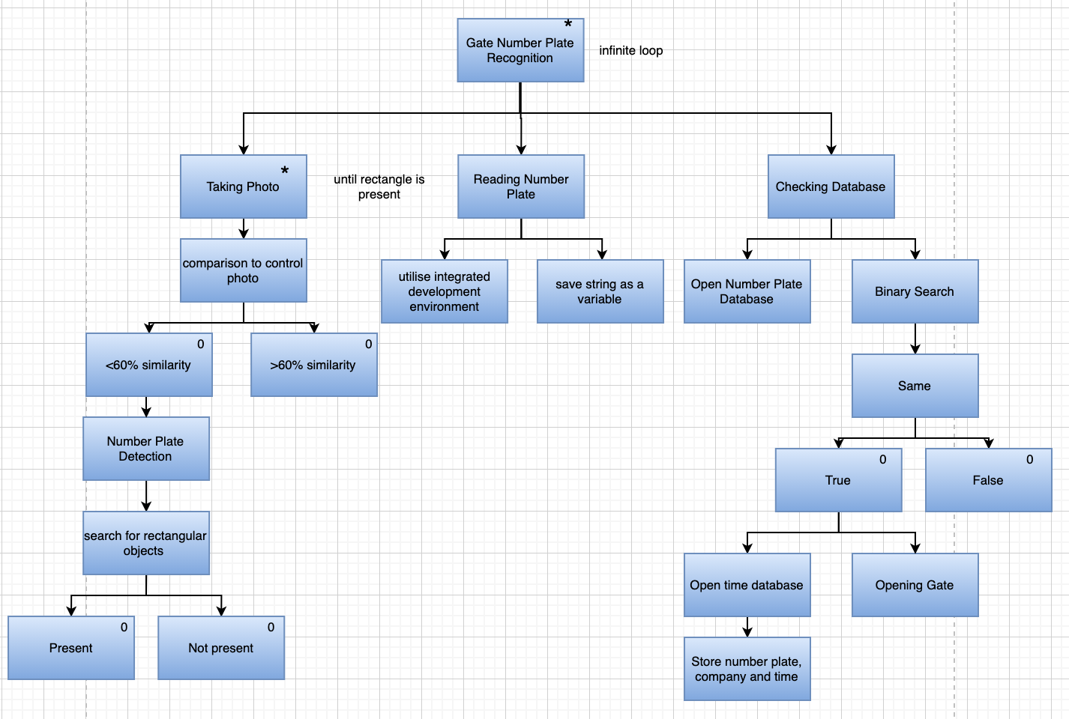

Data Flow Diagram Of Number Plate Recognition

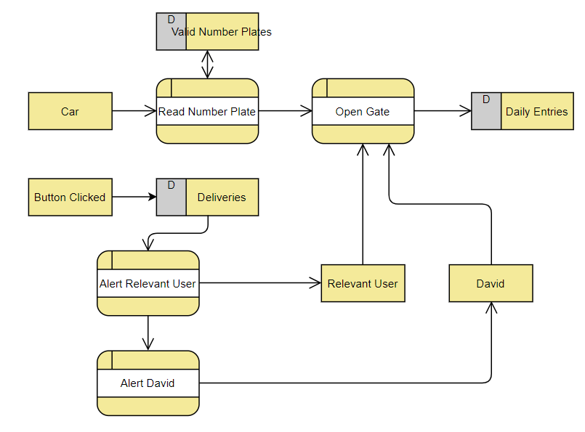

Data Key

Company =

Time =

Time Written =

Number Plate =



### App

The app section can be broken down into 2 user access levels:

1. David’s access level features required:
   * Add and delete number plates and businesses
   * Accept and decline requested number plates
   * Get alerts when delivery drivers have rung the bell
   * View the times of entry
2. All user’s access level features required:
   * Open the gate
   * Request number plates to be added
   * Request delivery alerts
   * Get alerts when delivery drivers have rung the bell in your delivery time slot

Below is an IPO chart for all these features for all user’s access level:

|  |  |  |  |
| --- | --- | --- | --- |
| Feature | Input | Processing | Output |
| Open the gate | * Click button in app | * Send request to the web server * Send request to raspberry pi | * Open gate |
| Request number plates to be added | * Number plate | * Send number plate to the web server * Send the number plate to the application server | * Adds business and number plate to the requests class in the database |
| Request delivery alerts | * Time slot * Delivery type | * Sends time slot and delivery type to the web server * Sends time slot and delivery type to the application server | * Adds business, delivery type and time to the deliveries class in the database |
| Get alerts when delivery drivers have rung the bell in your delivery time slot | * Bell rung * time | * take photo from gate camera * open database through the application server * open the deliveries class * look for relevant time slot | * send alert and gate photo to business linked to time slot |
| * user clicks accept request | * sends request to the web server * sends request to the raspberry pi | * opens the gate |

Below is an IPO chart for all these features for David’s access level:

|  |  |  |  |
| --- | --- | --- | --- |
| Feature | Input | Processing | Output |
| Add or delete number plates and businesses | * Number plate or business choice * Add or delete choice | * If business, then call business function. If number plate call number plate function * If add then enter string * If delete, then print database and ask for row to delete | * Ask for row number or ask for string |
| * Row number or string | * Connect to database server * Edit the database | * Input is added or deleted from the database |
| Accept and decline requested number plates | * Requested number plate * David’s choice | * If accepted adds the number plate to the database through the servers and deletes the number plate from the requests class of the database * If declined deletes the record of the number plate in the requests class of the database | * Number plate is added or discarded |
| Get alerts when delivery drivers have rung the bell | * Bell is rung * Time | * take photo from gate camera * open database through the application server * open the deliveries class * look for relevant time slot | * send alert, gate photo, business linked to time slot and reason to David |
| View the times of entry and delivery times | * select view entries and date or select view delivery times | * sends request to the application server * retrieves data from the database server and sends it to David’s phone | * displays a list of entries on that day or displays a list of current delivery times |

**Data Flow Diagram Of App**

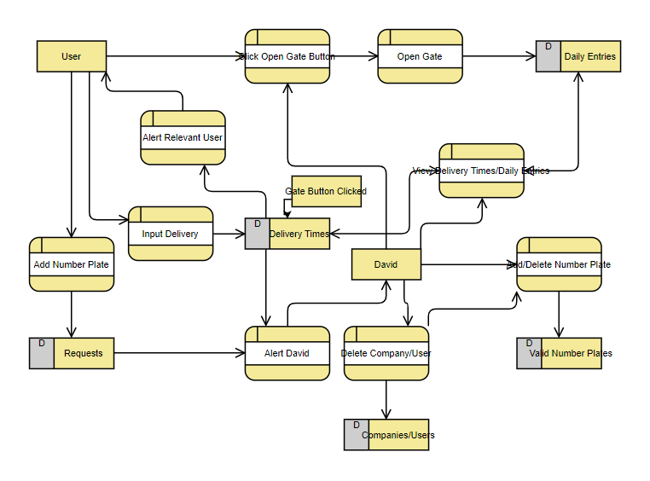



Data Key

Company =

Time =

Time Written =

Number Plate =

**Hardware Diagram of whole system**

Database Server (RP2)

Application Server (RP1)

Button

Camera

Gate Actuator

Interface

ROM

CPU (RP1)

CPU (RP2)

Clock

Phone

The system will run off two Raspberry Pi’s. The first Raspberry Pi will be the interface of the system and will handle functions involving external hardware such as opening the gate, responding to the button being pushed and utilising the camera for ANPR. This Raspberry Pi will be where the majority of the program is based and will also be responsible for the database server (this means the RP1 doesn’t have to fetch data from the RP2 to confirm number plates, making opening the gates faster). The second Raspberry Pi is responsible for the application server and will focus only on the app aspect of the program. This is good because the majority of functions that can be performed through the app do not need to be time efficient, e.g. adding number plates and delivery times. The exception to this rule being opening the gate and receiving delivery alerts, however this is less important than other time crucial features as delivery drivers are not common users of this system and so can afford to wait a little longer. Also, they will likely take time getting in and out of the car to push the button.

I will attempt to design the whole program on one Raspberry Pi as it will be cheaper, however, if it affects performance I will switch to the initial 2 idea. This dual Raspberry Pi setup may also be better as it means editing one part of the system, such as the app, will not affect the other section of the system which will keep running. This means users can still get in and out of the gate when work is being done on the system in the majority of cases. Having the application server and the database server on separate hardware is also safer as it ensures the two servers cannot be intertwined and vulnerable to SQL injections.

## • Defined in detail the structure of the solution to be developed.

**ER Diagrams**

Below are two different entity related diagram showing the connections between all the entities involved in the project. The first one shows in depth the attributes and how the entities are connected, whereas the second one shows more how they communicate with eachother:

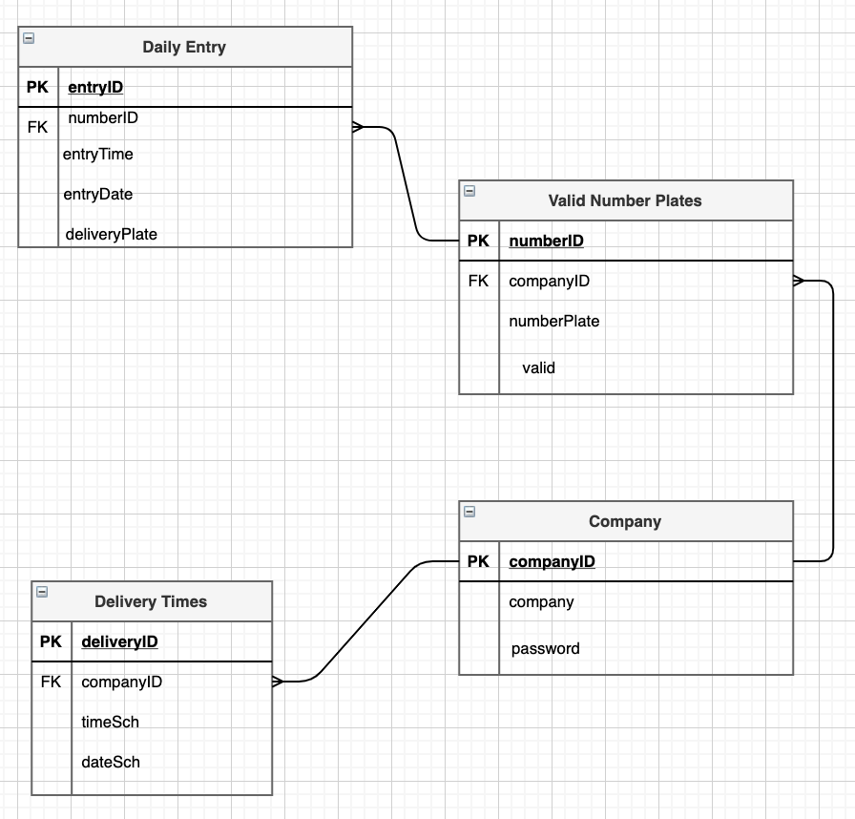

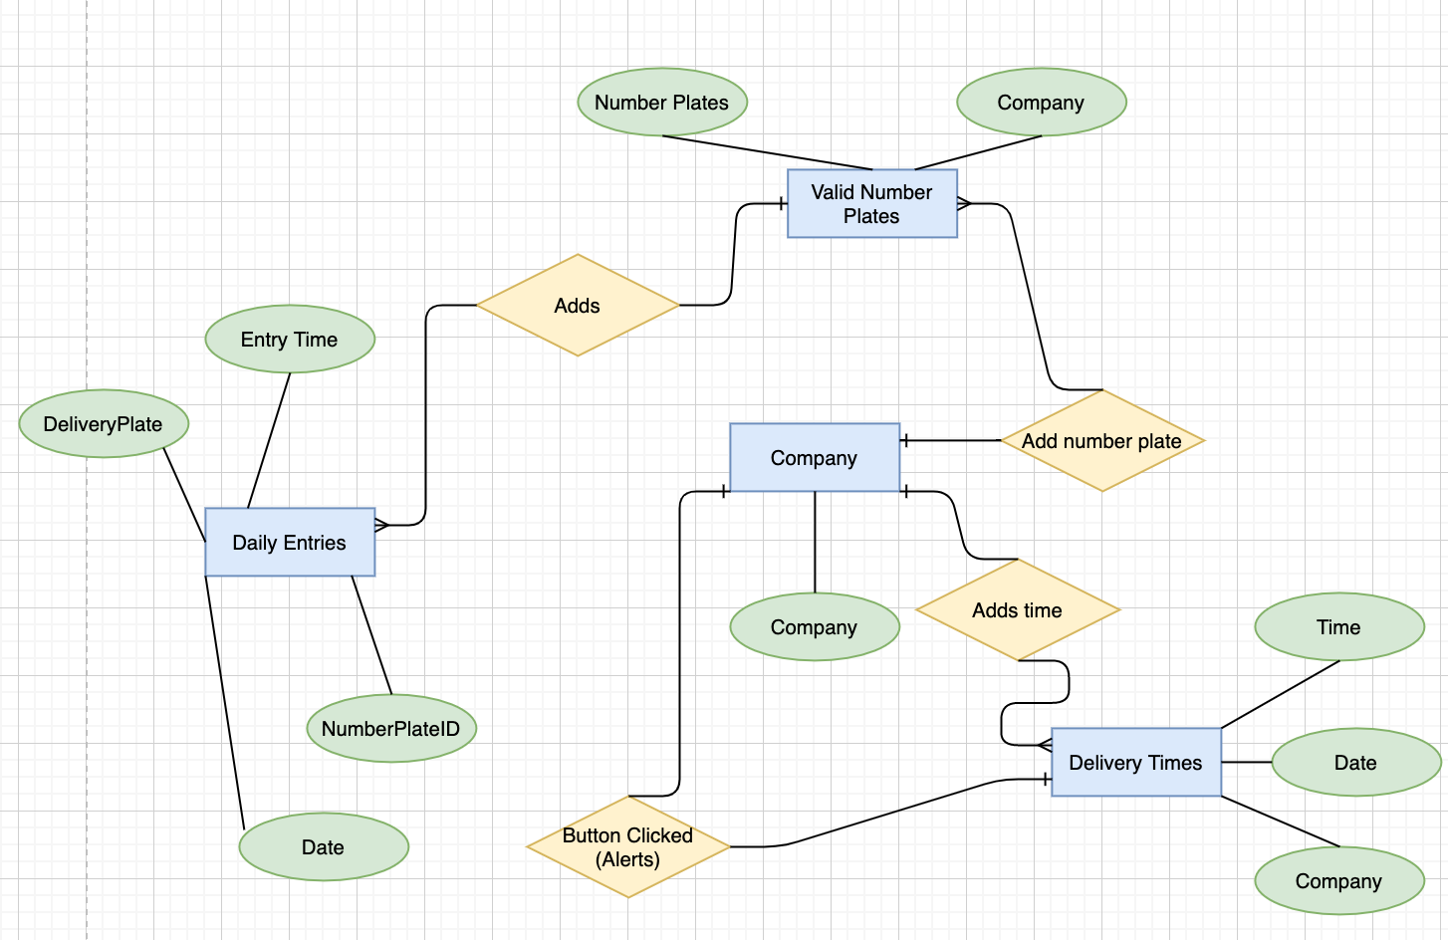

Daily entries is the entity whose purpose is to supply David with the information of who entered the site, when they entered and in the case of strangers, who let them in. Due to this it is on the many side of a many-to-one relationship with valid number plates, ensuring information about any entry may be found through the foreign key in daily entries.

When the bell is rung the delivery times entity alerts the relevant company entities and a picture is sent to help confirm it is the right delivery truck. When the company lets in the truck this action is added to daily entries along with the delivery trucks number plate.

Company can add delivery times when this happens the company is referenced in the delivery times entity as a foreign key and the time is added. When a company requests a number plate to be added to the system a similar thing happens as the company ID and number plate are sent to the valid number plates database, however valid is set as false. As David accepts the number plate it is then set to true.

**Data Definition tables**

Entity: Daily Entries

|  |  |  |  |  |  |
| --- | --- | --- | --- | --- | --- |
| Attribute | Key | Data Type | Format | Max Size (Bytes) | Required |
| entryID | PK | Integer |  | 2 | yes |
| numberID | FK | Integer |  | 2 | yes |
| entryTime |  | String | HH:MM | 5 | yes |
| entryDate |  | String | D/M/YY | 8 | yes |
| deliveryPlate |  | String |  | 8 | no |

NumberID is chosen over the companyID in the Daily Entries table as it is able to give a more specific description as both the number plate and the company can be found. This also works for people who open the gate through the app as the number plate attribute can be null in this table and so an entity can be formed in this relation which consists of just the numberID and the companyID ensuring the same information is given without adding in an extra field to the daily entries table.

Entity: Company

|  |  |  |  |  |
| --- | --- | --- | --- | --- |
| Attribute | Key | Data Type | Max Size (Bytes) | Required |
| companyID | PK | Integer | 2 | yes |
| company |  | String | 30 | yes |
| password |  | String | 15 | yes |

Entity: Valid Number Plates

|  |  |  |  |  |
| --- | --- | --- | --- | --- |
| Attribute | Key | Data Type | Max Size (Bytes) | Required |
| numberID | PK | Integer | 2 | yes |
| numberPlate |  | String | 8 | no |
| companyID | FK | Integer | 2 | yes |
| valid |  | Boolean | 1 bit | yes |

The number plate entity references company ID rather than labelling the whole company. This is because for each reference of a company up to 30 bytes of storage can be taken up, as this is a lot of storage compared to all the other attributes and so I have decided to make it into its own entity, saving storage as companyID can now be referenced as a foreign key for just 2 bytes.

If the attribute valid is set to false then the vehicle will not be able to get through the gate. For this to change David must validate the number plate turning it to true, this means the car can now gain access to the site.

Entity: Delivery Times

|  |  |  |  |  |  |  |
| --- | --- | --- | --- | --- | --- | --- |
| Attribute | Key | Data Type | Format | Max Size (Bytes) | Required | Validation |
| deliveryID | PK | Integer |  | 2 | yes |  |
| companyID | FK | Integer |  | 2 | yes |  |
| timeSch |  | String | HH-HH | 5 | yes |  |
| dateSch |  | String | D/M/YY | 8 | yes | Date >= Today |

This entity uses companyID over numberID as this feature can only be accessed through the app and so number plates will never be present. dateSch require validation, this ensures that no dates can be added to this table if they in the past, this also ensures deliveries that have been missed are deleted at the end of the day, decluttering the database. I have not put timeSch for a validation in case a delivery is delayed by a couple hours, however if it is delayed by a day or more they will have to resubmit the delivery time.

With this if the bell is rung it will first alert people who have a delivery at that time and then alert people who have a delivery slot from earlier in the day (in case it was delayed). Whoever lets them in has their delivery taken off the database ensuring they don’t get alerts for other deliveries throughout the day.

## • Described the solution fully using appropriate and accurate algorithms justifying how these algorithms form a complete solution to the problem.

### ANPR Side

Due to my code being rather language specific I have decided to create a flow chart for the entire hardware side, writing pseudocode for the subroutines which are not specific to python



Format number plate subroutine pseudocode

function formatPlate(plate):

possPlates = [plate]

#removes the possible : positioned at the start of the string

if len(plate) > 7 then

plate = plate[1:]

endif

numArea = plate[2:]

numArea = list(numArea[-3:])

letters = [B, O, I, Z, 8, 0, 1, 2]

#checks the part of the number plate that should be numbers

if numArea.isnumeric() == false then

#changes the letters to the appropriate numbers

for i in range(4)

if letters[i] in numArea[0] then

numArea[0] = letters[i+4]

elif letters[i] in numArea[1] then

numArea[1] = letters[i+4]

endif

end loop

alterPlate = list(plate)

alterPlate[2] = numArea[0]

alterPlate[3] = numArea[1]

alterPlate = “”.join(alterPlate)

possPlates.append(alterPlate)

endif

return possPlates

end function

what it does

This function takes the number plate read by the tesseract OR module and creates alternatives to account for the errors this module usually has such as misreading 1 as I and 8 as B along with reading the GB at the start of the number plate as “:”. In this code it first removes the “:” is the string it over 7 characters (tailored to standardised number plates), it then looks at the 3rd and 4th numbers in the string and changes any characters to the appropriate number. It then connects it back together and adds it to the possible plates array which is returned.

### App Side

Due to this section being mainly html and php it is quite hard to translate it into pseudocode templates, due to this I have focused of pseudocode from the JavaScript functions.

Adding a new company Pseudocode

procedure addComp(comp, pass)

if comp == null or pass == null then

print(“error you must enter a company and password”)

else

if len(pass) < 7 or pass.isalnum() == False then

print(“error password must be longer than 7 and contain a number”)

else

conn = sqlite3.connect(“gateProject.db”)

cursor = conn.cursor()

sql = “insert into companies (company, password) values (comp, pass)”

cursor.execute(sql)

conn.commit()

conn.close()

endif

endif

end procedure

what it does

this code takes the parameters company and password and does the required validation checks, doing a presence check for both company and password and doing a type and length test for the password. If both are fine, it then adds the company and password into the database so that it can be used to access the app as a secondary user.

View companies page flow chart



View companies page pseudocode

*Main program*

conn = sqlite3.connect(“gateProject.db”)

cursor = conn.cursor()

sql = “select compName from companies”

companies = cursor.execute(sql)

insertTable(companies)

conn.close()

if delete.click then

deleteFunction()

elif edit.click then

editPassFunction()

elif plates.click then

viewPlatesFunction()

endif

What it does

This code gets all the company names from the company table in the database and formats it into a table. Due to all the companies being returned in order of ID it does not have to be formatted and all the secondary features can be used directly.

*Delete function module*

deleteFunction():

conn = sqlite3.connect(“gateProject.db”)

cursor = conn.cursor()

sql = “delete from companies where compID = rowNum”

cursor.execute(sql)

conn.commit()

conn.close()

end procedure

What it does

This module deletes the chosen company by going off it row number. Due to all the row numbers and compID’s being the same this means I can delete the company in one move rather than finding the relevant company ID first. This module is initiated by clicking the delete button for that row

*Edit password module*

editPassFunction():

newPass = input(“enter new password”)

while newPass.len < 7 or newPass.inter() == false

newPass = input(“please enter a password longer than 7 characters that has at least one integer)

end loop

conn = sqlite3.connect(“gateProject.db”)

cursor = conn.cursor()

sql = “update companies set password = newPass where compID = rowNum”

cursor.execute(sql)

conn.commit()

conn.close()

print(“password updated”)

end procedure

What it does

This module also uses the row number to find the right place in the table to change the password. This module starts by asking the user to input the new password. If the password passes the length check and the type check then it will be updated in the table where the row number is equal to the company ID. This module is initiated when the edit button is pressed for a certain company.

*View number plates module*

viewPlatesFunction()

conn = sqlite3.connect(“gateProject.db”)

cursor = conn.cursor()

sql = “select numberPlates, valid from validNumberPlates where compID = rowNum”

for row in cursor.execute(sql)

plates, valid = row

end loop

insertTables(plates, valid)

conn.close()

end procedure

What it does

This module is initiated when the company name is clicked on. When this happens, the code selects all the number plates from the validNumberPlates table where the row number is the same and the company ID. It then puts them all into the table, showing which plates are valid.

## • Described, justifying choices made, the usability features to be included in the solution.

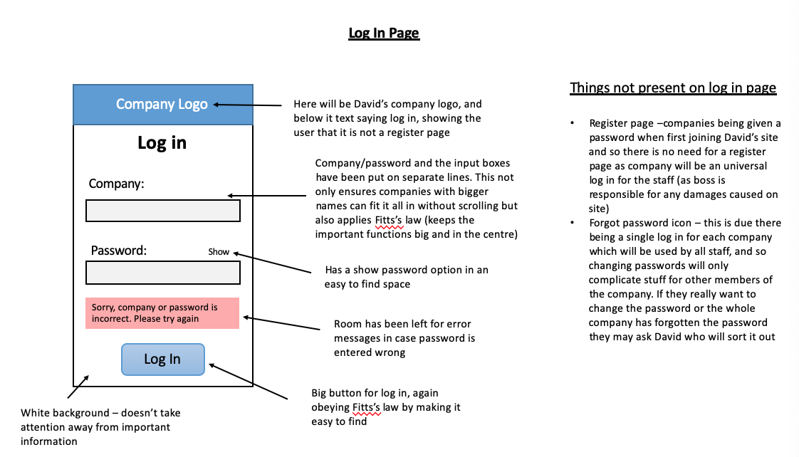

Colour:

**#00aaff**

rgb(0, 170, 255)

hsl(200, 100%, 50%)

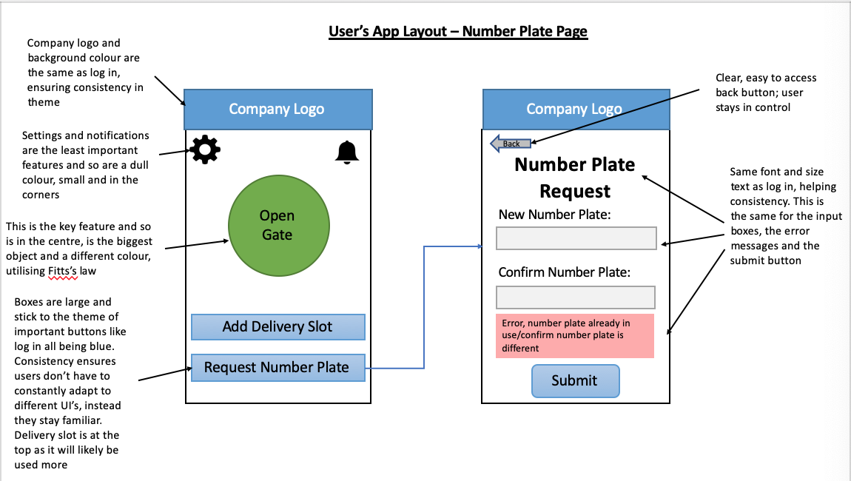

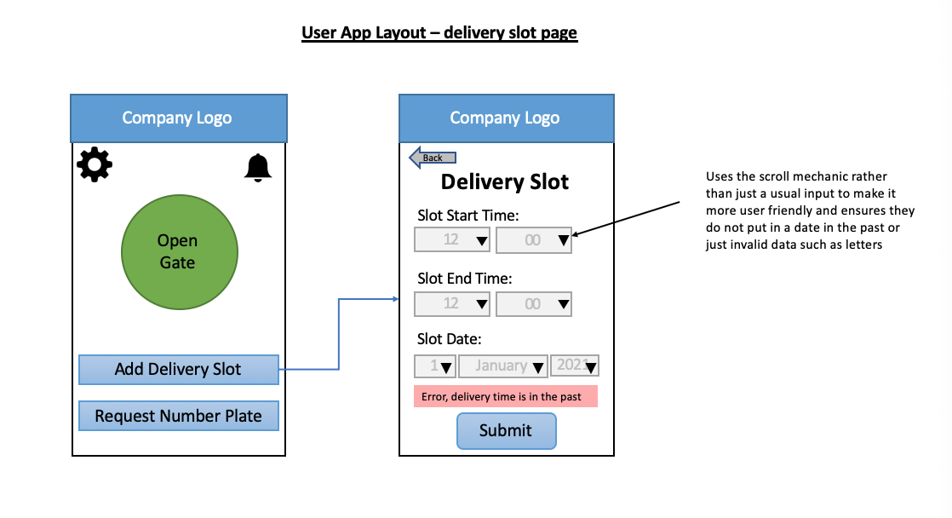

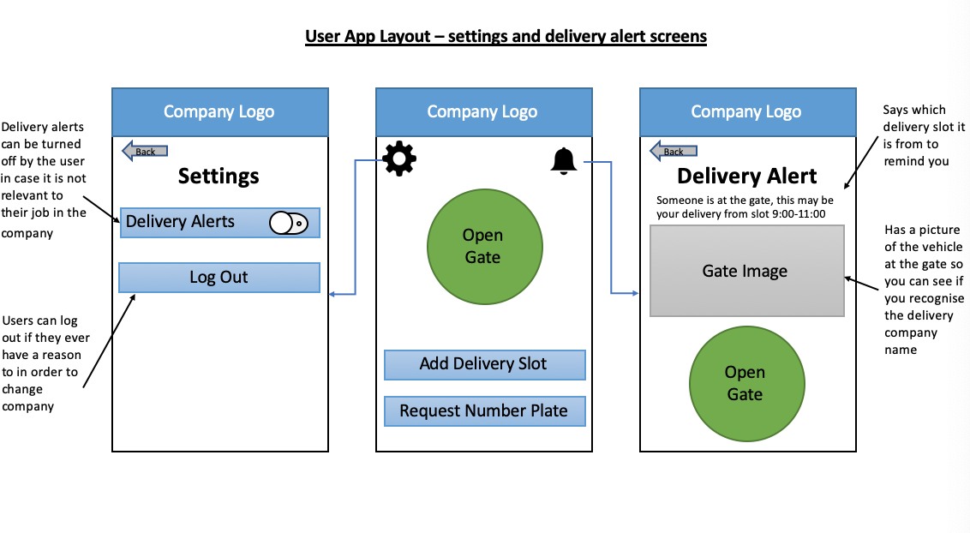

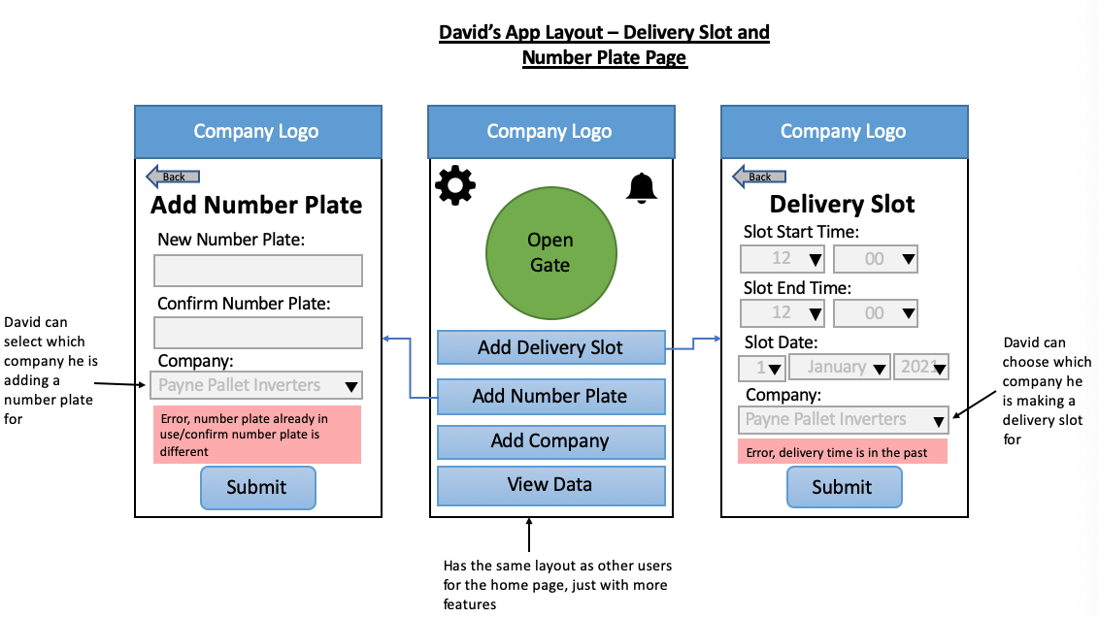

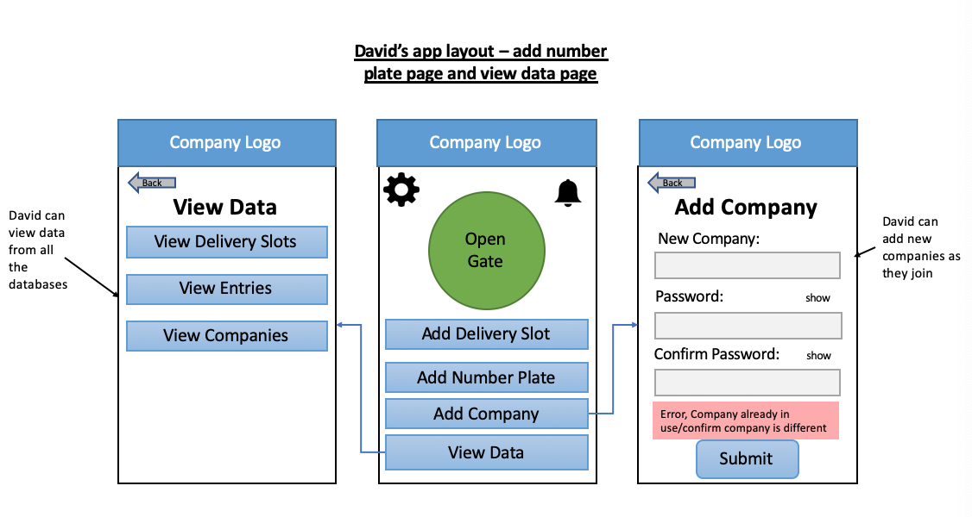

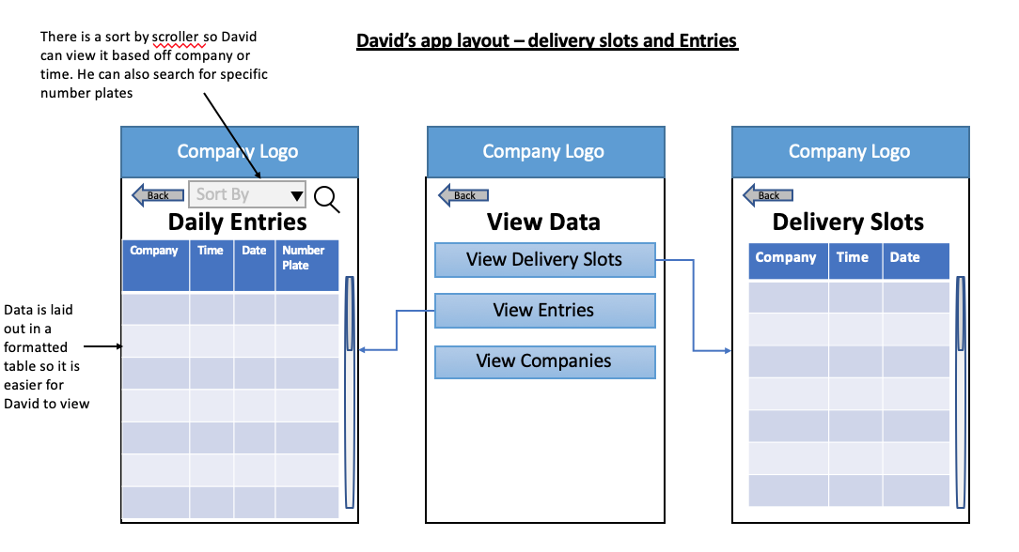

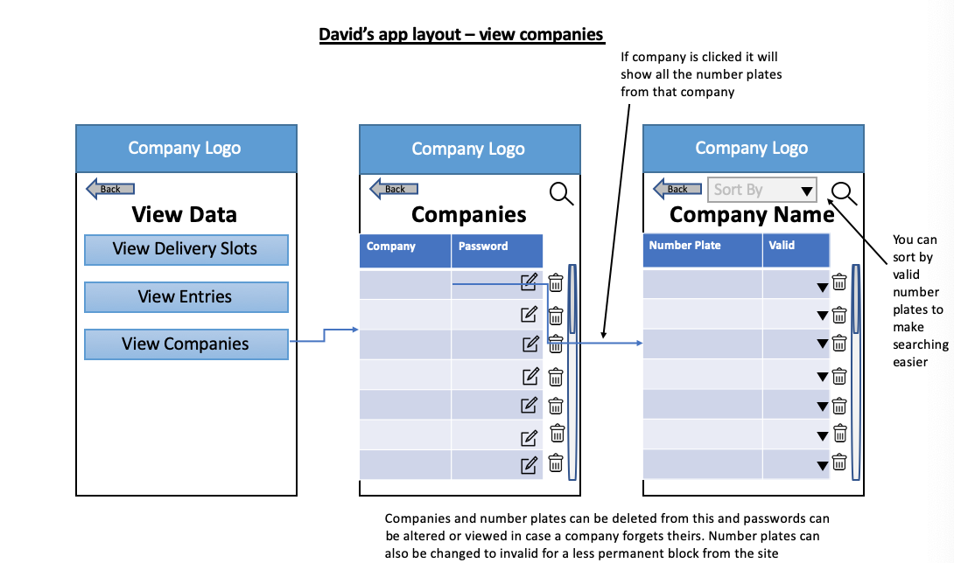

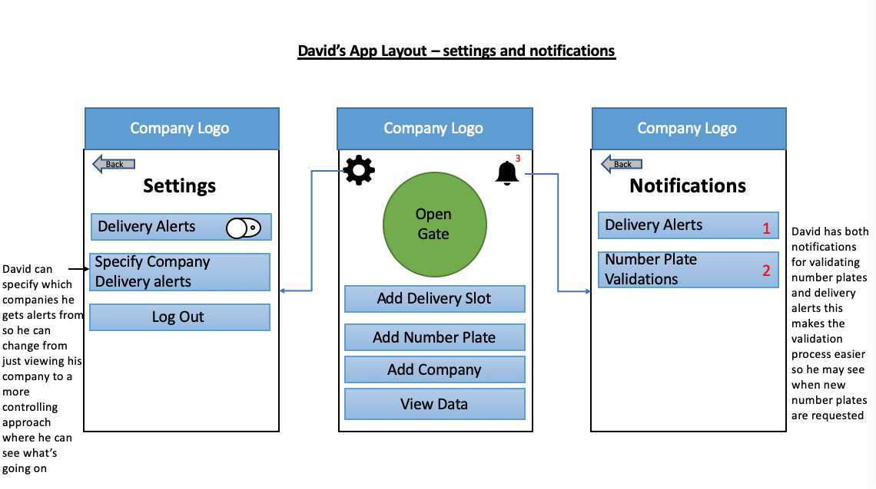

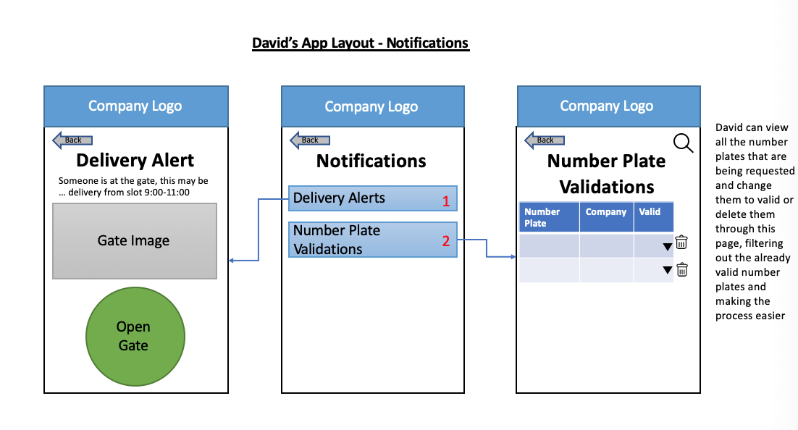

## • Identified and justified the key variables / data structures / classes (as appropriate to the proposed solution) justifying and explaining any necessary validation.

|  |  |  |  |
| --- | --- | --- | --- |
| Input Data | Validation Check | Example | Justification |
| Company | Type Check,  Presence Check, | string | Company name must be a name and so cannot be an integer or Boolean type |
| Company Password | Length Check, Presence Check,  Type Check | Password length >= 8  string | Password must be of a certain length, so it is less vulnerable to a brute force attack |
| Number Plate | Length Check,  Presence Check,  Type Check | Number plate length <= 9  string | Number plate must be less than or equal to 9 as that is the maximum number plate length in Europe (Ireland is the largest with 9). Due to private number plates there cannot be a picture check |
| Valid | Type Check | Boolean | It is either valid or not valid |
| Delivery Time | Picture Check  Range Check | HHMM-HHMM  Greater then present time where delivery date is equal to today | Despite you still getting alerts for delayed deliveries you cannot put in times that have already happened as this would not make sense |
| Delivery Date | Type Check,  Range Check | Date  Greater or equal to present day | This ensures no dates in the past can be entered as this will not work as you can’t be alerted for a date that has already happened |
| Is gate open | Type Check,  Presence Check | Boolean | Ensures you know whether the gate is open, is Boolean because there are options open or closed |
| Has signal from camera been sent | Type Check,  Presence Check | Boolean | Makes sure the camera is actually working, is either on or off so is a Boolean data type |

## • Identified and justified the test data to be used during the iterative development of the solution.

|  |  |  |  |
| --- | --- | --- | --- |
| Test Number | Test Descriptions | Test Data (extreme, normal, erroneous) | Expected Outcome |
| 1 | Check company inputted in login is valid | “Payne Pallet Inverters” | When submitted login is successful |
| “Steve’s Automobiles LMT” | When submitted login is unsuccessful and error message appears saying “Error, Company name is incorrect” |
| 1537 | When submitted login is unsuccessful and error message appears saying “Error, Company name is incorrect” |
| 2 | Check password inputted in login page is correct | “CorrectPassword03” | When submitted login is successful |
| “LetMeIN” | When submitted login is unsuccessful and error message appears saying “Error, company name or password is incorrect” |
| 3 | Adding a new number plate | “WR18 LSO” | When submitted number plate is accepted and request is sent |
| “18 DAP” |
| “151D88752” | When submitted number plate is accepted and request is sent |
| “NumberPlate123” | When submitted it does not pass validation check and so is not sent. Error message appears saying “Error, this is not a valid number plate format” |
| 4 | Open gate through the app | Open gate button is clicked | Gate is opened |
| 5 | Delivery slot time and date are entered (assuming it is 12:00pm on 4th March 2021) | 9:00-10:30  10-March-2021 | Time and date are accepted and delivery slot is added |
| 13:00-15:30  4-March-2021 | Time and data are accepted and delivery slot is added |
| 18:00-20:00  3-March-2021 | Time and date are not accepted and error massage appears saying “Error, time is in the past, cannot be added” |
| 6 | David adding new company | “Bob’s Mechanics”  “123BOBFixesCars” | Company and password are accepted and is added to the database |
| “Steve’s Trucks”  “Password” | Despite password being the minimum valid length company and password are added to the database |
| “Business Company”  “Yes” | Password is too short so company is not accepted. Error message appears saying “Error, password too short” |
| “Payne Pallet Inverters”  “PaynePallet” | Company is already in use and so will not be added to the database. Will get the error “Error, company name already in use” |
| 7 | David views delivery slots | Clicks on button in app | Displays all delivery slots in chronological order |
| 8 | David views daily entries | Clicks on button in app | Displays all daily entries in chronological order |
| 9 | David changes order in which daily entries is displayed | Clicks sort by scroller and changes it to by business | Displays all daily entries in alphabetical order of businesses |
| 10 | David searches for a specific entry | Clicks the search button and types in a time | Displays all daily entries in that time period |
| 11 | David views companies | Clicks on button in app | Displays all the companies in alphabetical order |
| 12 | David deletes company | Clicks on the delete button and clicks confirm | Deletes the company from the database, also deletes all number plates under that company name |
| 13 | David edits company password | Clicks on the edit button and enters new password, then clicks confirm | Changes the password in the database for that company |
| 14 | David searches for company | Clicks the search button and types in the company name | Displays all companies with that start, ordered alphabetically |
| 15 | Viewing all number plates for a company | Clicks on a company name | Displays all number plates for that company in alphabetical order |
| 16 | David changes the order in which company number plates are displayed | Clicks sort by and changes it to by invalid | Displays all company number plates with the invalid ones displayed first and the valid ones displayed last, in alphabetical order |
| 17 | David searches of a company number plate | Clicks the search button and starts typing in the number plate | Only number plates starting with those letters are shown |
| 18 | David makes a number plate valid | Clicks the validate button and changes it to valid | In the database the number plate is changed from invalid to valid and the car with the number plate can now enter the site |
| 19 | David makes a number plate invalid | Clicks the validate button and changes it to invalid | In the database the number plate is changed from valid to invalid and the car with the number plate cannot enter the site anymore |
| 20 | Delivery alerts are turned off | Clicks the delivery alerts button so they are turned off | Is no longer notified when deliveries for their company are at the gate, or for David if any delivery is at the gate |
| 21 | David selects specific company alerts | Clicks specific company alerts and only selects Payne Pallet Inverters | He is only notified when deliveries for that company are at the gate |
| 22 | When notifications are on David is notified for new number plates and deliveries | Delivery is at the gate and the button is clicked | David’s phone gets an alert that a delivery has arrived, and an image is on the page showing what the delivery vehicle looks like |
| New number plate is requested | David’s phone gets an alert that there is a new requested number plate |
| 23 | Gate can be opened for deliveries | Button is clicked through the delivery page | Gate opens for the delivery |
| 24 | Gate opens when vehicle is at the gate | “16 SKC” | Gate opens when number plate is present |
| “WR18 LZI” |
| “151D88752” |
| “ZR15 XLO” | Gate does not open when number plate is present as it is not valid |
| “Payne Pallet inverters” | Gate does not open when vehicle is present as it is not valid as it is not a number plate, software has read the wrong thing |
| 25 | Camera detects when vehicle is present | Car is at the gate | Software runs |
| Lorry is at the gate |
| Bike is at the gate | Software does not run as a number plate is not present, app must be used to open the gate |
| Man is at the gate |
| 26 | When button on gate is pushed code runs | Button is clicked | Code to notify the relevant companies run |
| 27 | When a picture of a number plate is taken a string of it is made | Image of number plate | Shows the number plate as a string |

There is an issue when it comes to reading bike number plates as they are on the back of the vehicle, the only options to solve this is for the bike to reverse in which is a bad idea, for the rider to use the app to open the gate, or for me to add in another camera pointing towards the gate. I will ask David which option he feels is best, however at the moment will assume he will open the gate through the app when on a bike

## • Identified and justified any further data to be used in the post development phase.

At the end of this project I will give the end user a series of tests to complete to ensure the software is working as expected. These tests are known as user testing and I will give a range of tests to test different aspects of the code such as the data integrity of the database, the consistency and usability of features in the user interface and the system as a whole, i.e. how consistently and quickly does it open the gate in a range of environments such as night, sun and rain. The different types of tests I will be doing are shown below:

**Logical Testing** - Test every aspect of each form, report, module etc. as it is being implemented

**Functional Testing**- Each menu item will be tested to ensure that no function has been left out.

**System** - When the system is complete the whole range of tests will be carried out again to ensure that no errors have been introduced.

**Recovery**- The computer will be re-booted while the database is open to ensure that the minimum amount of data is lost or corrupted in the event of a power failure.

**User Testing (Acceptance)** - The user will be involved and asked to test all the capabilities of the program to ensure that all required functions are present and working in the manner expected. Test table to use as you build and document

|  |  |  |  |
| --- | --- | --- | --- |
| Test Number | Test Descriptions | Test Data (Extreme, Normal, Erroneous) | Expected Outcome |
| 1 | Gate opens when vehicle is at the gate | Car at the gate | Number plate is read and gate opens in less then 10 seconds upon approach |
| Lorry at the gate |
| Bike at the gate |
| Man at the gate | Gate does not open |
| 2 | When button is clicked on the app the gate opens | Click the button on the App homepage | Gate opens in less then 10 seconds, when the phone had a good connection |
| Click the button on the App deliveries page |
| 3 | When button is clicked on the gate a notification is sent the relevant people | Button is clicked on the gate | A notification is sent to David and the relevant companies if alerts are on for the app |
| 4 | David adding new company | “Bob’s Mechanics”  “123BOBFixesCars” | Company and password are accepted and is added to the database |
| “Steve’s Trucks”  “Password” | Despite password being the minimum valid length company and password are added to the database |
| “Business Company”  “Yes” | Password is too short so company is not accepted. Error message appears saying “Error, password too short” |
| “Payne Pallet Inverters”  “PaynePallet” | Company is already in use and so will not be added to the database. Will get the error “Error, company name already in use” |
| 5 | David can delete companies | Clicks the delete button for the company and clicks confirm | Company and all the number plates with it are deleted from the database |
| 6 | Delivery slot time and date are entered (assuming it is 12:00pm on 4th March 2021) | 9:00-10:30  10-March-2021 | Time and date are accepted and delivery slot is added |
| 13:00-15:30  4-March-2021 | Time and data are accepted and delivery slot is added |
| 18:00-20:00  3-March-2021 | Time and date are not accepted and error massage appears saying “Error, time is in the past, cannot be added” |
| 7 | Company with valid name and password can log into the app | “Payne Pallet Inverters”  “CorrectPassword03” | When submitted login is successful |
| “Derricks Cars”  “Password” |
| “Steve’s Automobiles LMT”  “PasswordISGOOD” | When submitted login is unsuccessful and error message appears saying “Error, Company name does not exist” |
| “Payne Pallet Inverters”  “LetMeIN” | When submitted login is unsuccessful and error message appears saying “Error, company name or password is incorrect” |
| 8 | David selects specific company alerts | Clicks specific company alerts and only selects Payne Pallet Inverters | He is only notified when deliveries for that company are at the gate |
| 9 | When notifications are on David is notified for new number plates and deliveries | Delivery is at the gate and the button is clicked | David’s phone gets an alert that a delivery has arrived, and an image is on the page showing what the delivery vehicle looks like |
| 10 | David makes a number plate valid/invalid | Clicks the validate button and changes it to valid | In the database the number plate is changed from invalid to valid and the car with the number plate can now enter the site |
| Clicks the validate button and changes it to invalid | In the database the number plate is changed from valid to invalid and the car with the number plate cannot enter the site anymore |
| 11 | Adding a new number plate | “WR18 LSO” | When submitted number plate is accepted and request is sent |
| “18 DAP” |
| “151D88752” | When submitted number plate is accepted and request is sent |
| “NumberPlate123” | When submitted it does not pass validation check and so is not sent. Error message appears saying “Error, this is not a valid number plate format” |

# Developing the Coded Solution (25 mark)

## Iterative Development of a Coded Solution (15 marks)

With the ANPR side of the project I plan to code the modules in this order:

1. code the object recognition module to verify that a vehicle is present
2. code the module which finds the number plate in the image and crops it around the number plate
3. combine the two modules so that it outputs a cropped number plate of the vehicle present
4. code the character recognition module
5. code the number plate formatting module
6. code the module that checks if the number plate is valid in the database and opens the gate if it is, adding the plate to the daily entries table
7. combine all modules to create the finished ANPR system



With the app side of the project I plan to code the modules in this order:

1. login module
2. primary user home screen
3. add companies module
4. view data screen
5. view companies module
6. secondary user home screen
7. bring the code onto the raspberry pi
8. set up pi server and MySQL database
9. add number plate module
10. request number plate module
11. view entries module
12. open gate module

### ANPR Side - Development of the object recognition module

First Iteration

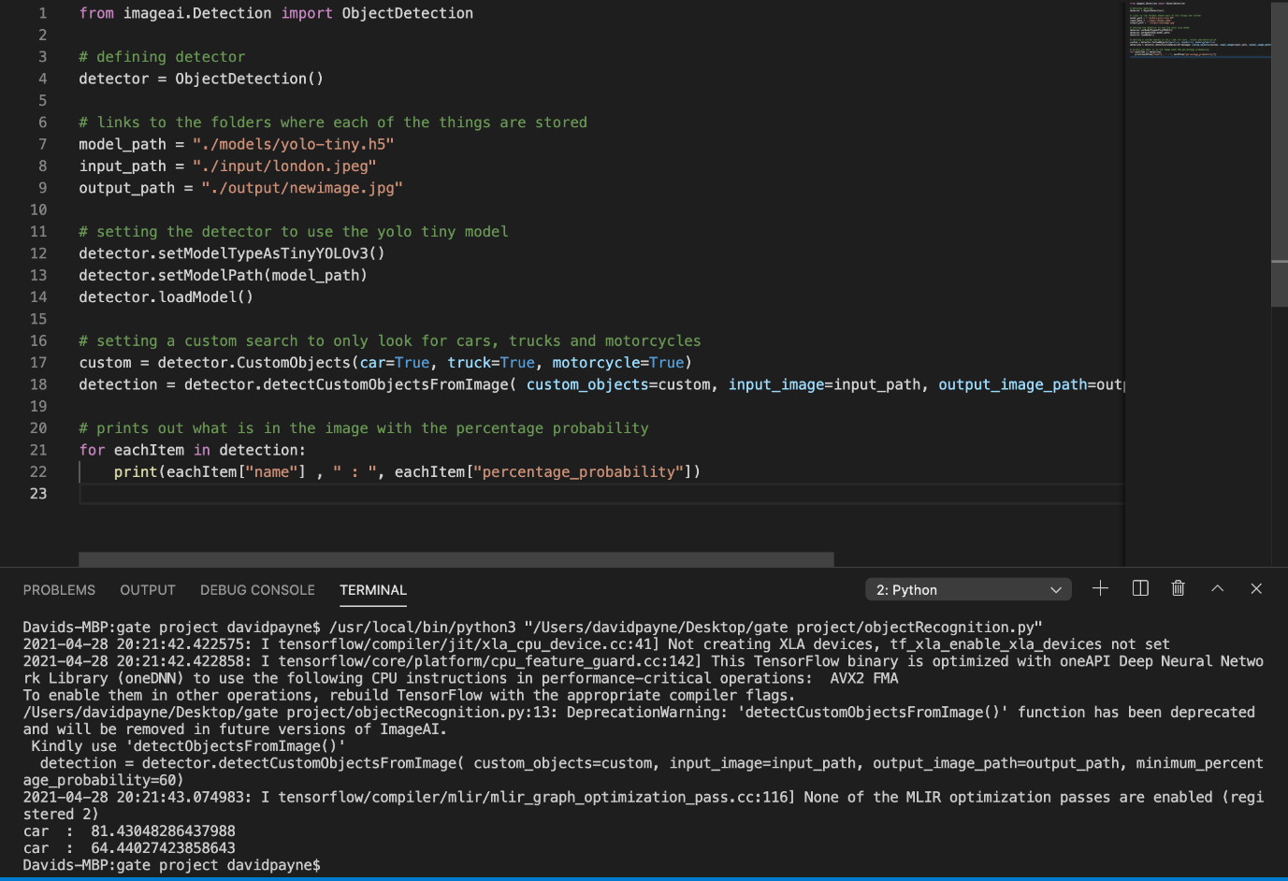

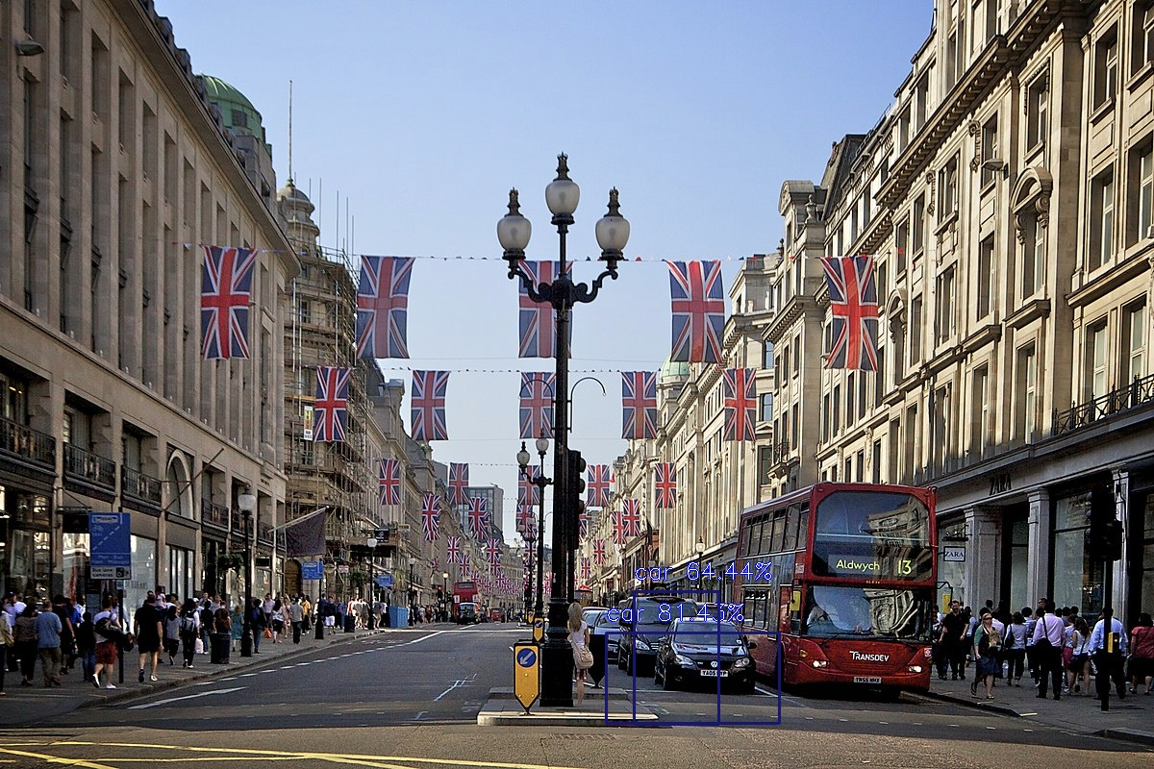

What it does

I have coded an object recognition test where the program finds all cars, motorcycles and trucks from the photos and output a highlighted version of the image to an output folder. This is intended to be a more abstract version of my idea to help me get to terms with how yolo object recognition works on a basic level before evolving it to work with video instead.

Problems

After running the code, I found it was only working with cars and not recognise trucks or motorcycles despite being obvious in the frame. I found that this was an error in how I have defined the variable custom as car is the first and only variable working in that list. I tested this by changing the order and rerunning to see if it affects results.

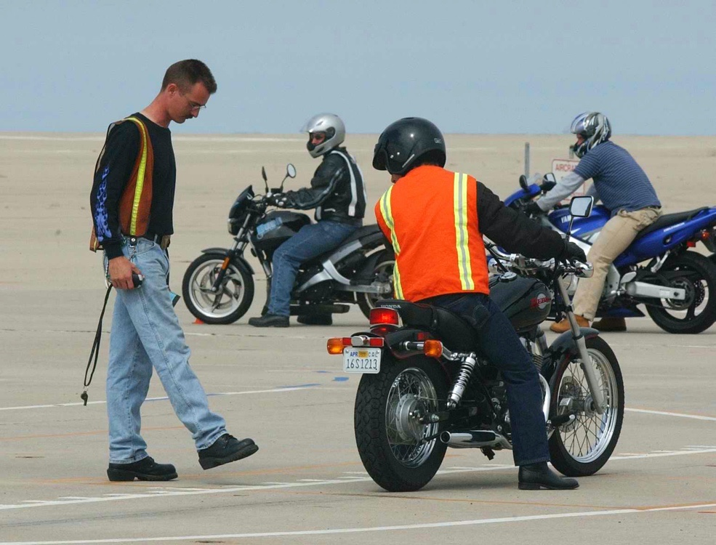

as you can see in this image there are very obviously bikes in the image. However, the code does not recognise them.

Solution and further development

I changed model from yolo-tiny to yolov3 which is quicker and more reliable. I then found some code online which annotates videos and put a bounding box around objects. Using this as a structure I coded a program which takes an input from my raspberry pi camera and rather than output a new annotated video it instead found the objects in real time. I then put in some code to print the type of vehicle when there is one present ignore all other objects

Evidence of second iteration

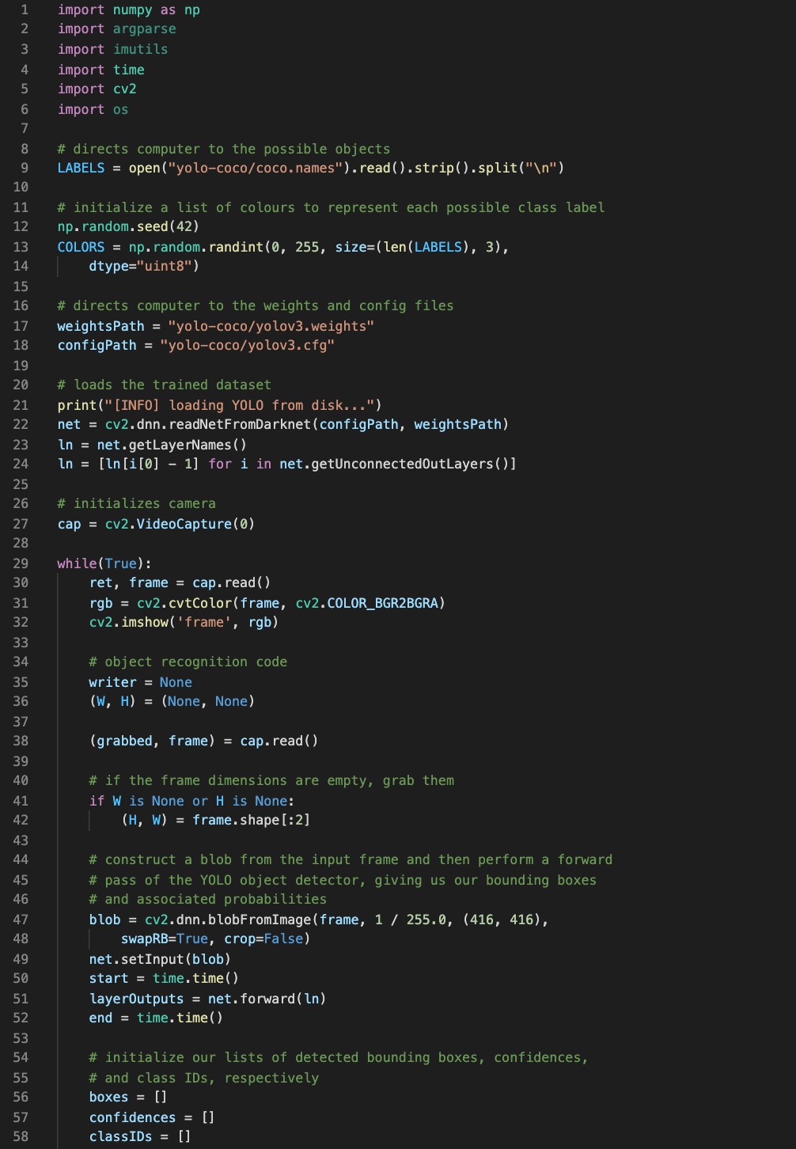

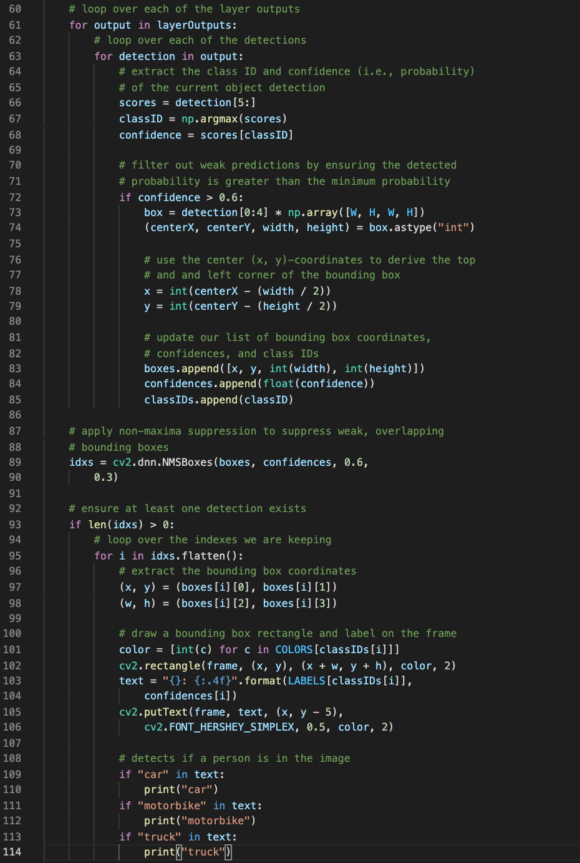

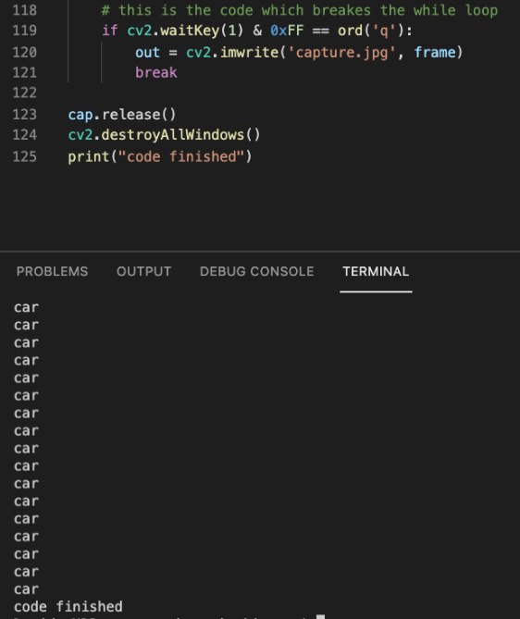

Evidence of third iteration

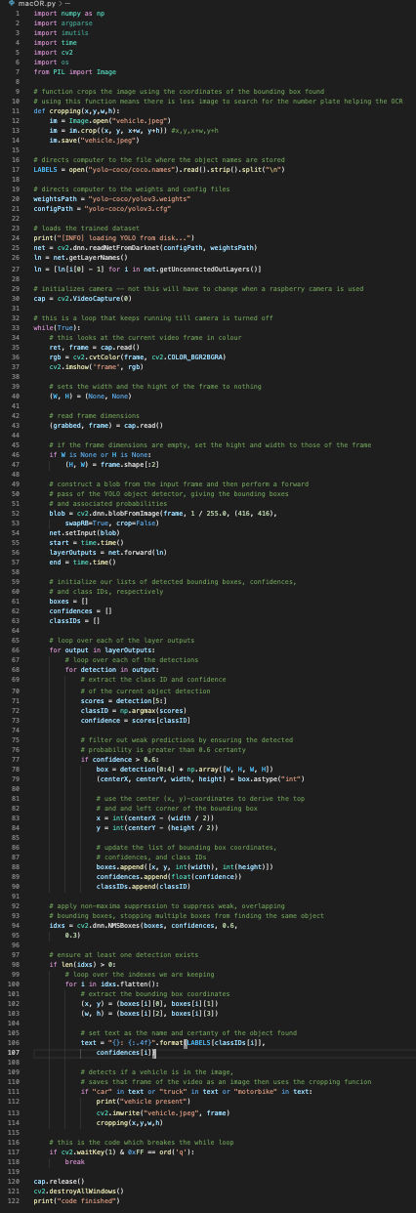



What’s changed

After testing the code and seeing that it was all working properly, I removed the bounding boxes from the image to ensure the frame remained clean and important information such as the number plates were not obstructed. I also added in a function which cropped the image frame using the bounding box coordinates before saving it as a new image. Finally, I changed the code printing the vehicle type to only print vehicle as this information was irrelevant.

Problems

After moving the code from my mac onto the raspberry pi I found the code was a lot slower and the raspberry pi overheated.

Solutions

To fix the overheating problem I bought a fan to cool it.

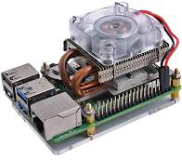

To counter the slower processing of the raspberry pi I decided to lower the frame rate of the camera so there is less to process. I also decided to retrain the model so it I decrease the weights of the object recognition from the original 32 objects to only cars, bikes, and trucks. However, this increase in speed came at the price of accuracy.

However, while lowering the frame rate, I realised that there was still a backlog in frames to processing ratio, causing a delay. To solve this, I changed the code so instead of running a video and analysing each frame it would instead take a photo at the end of each loop to ensure backlog does not occur.

### ANPR Side - Final iteration of the object recognition module

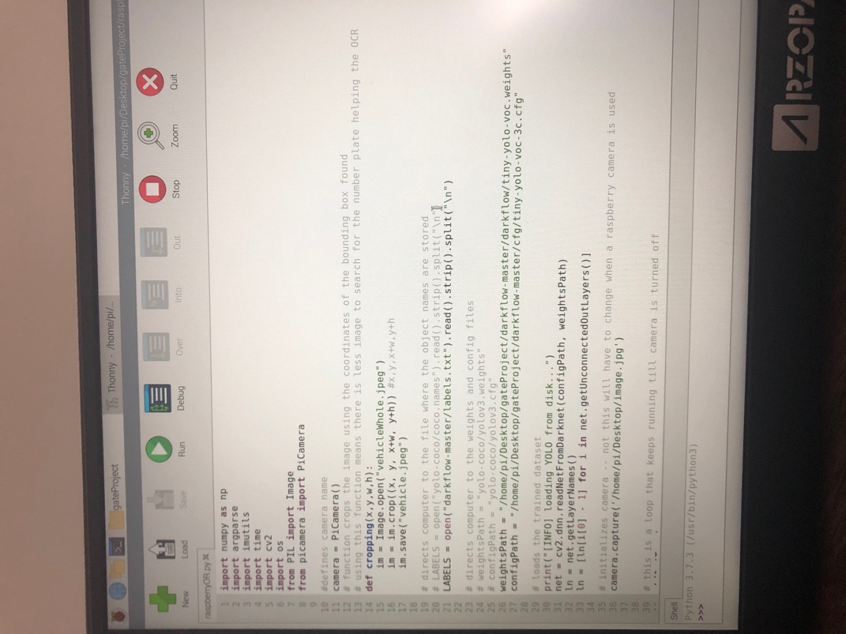

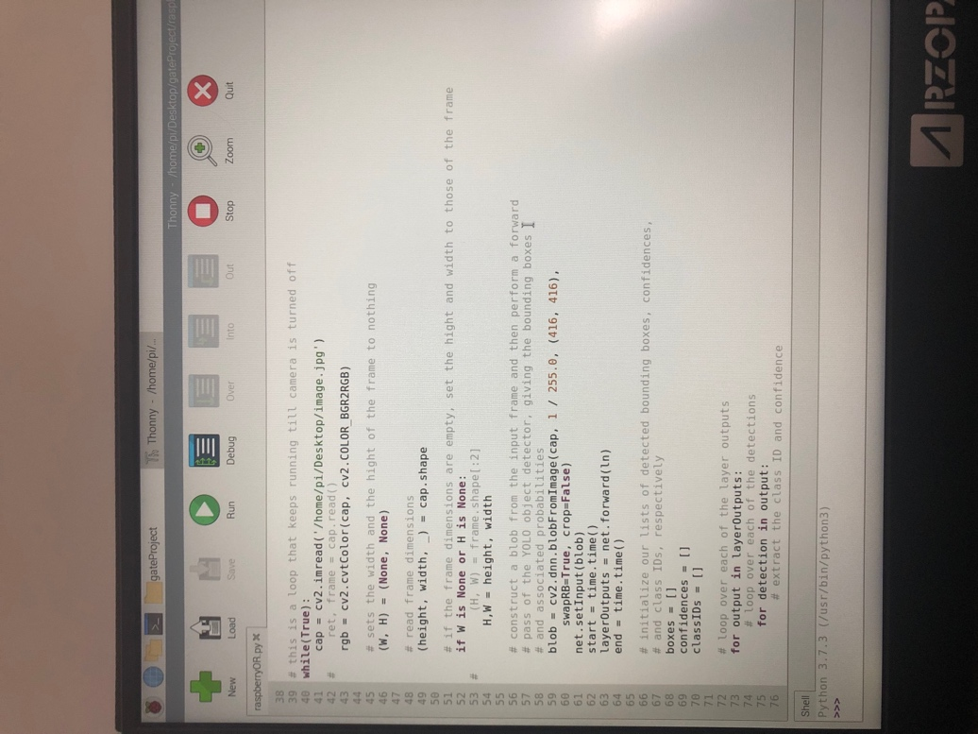

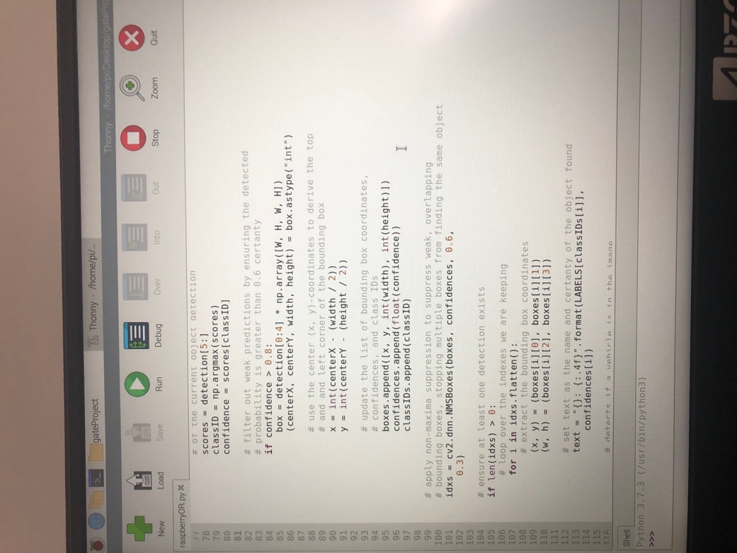

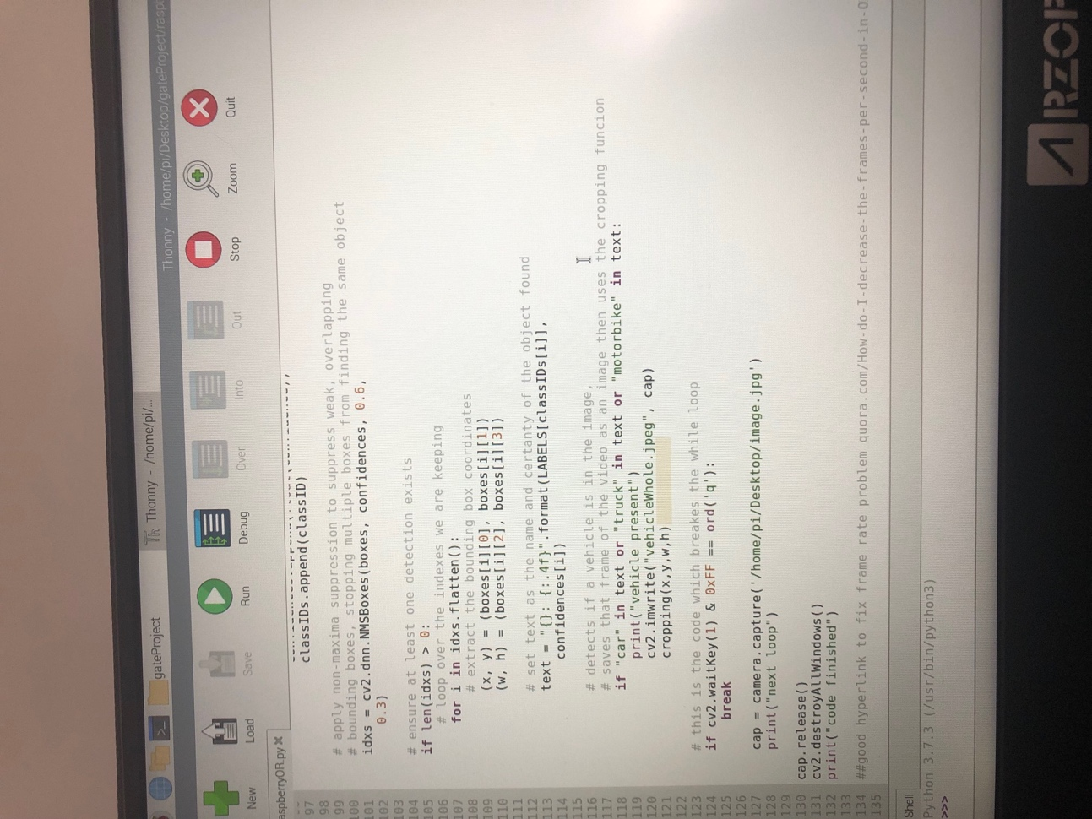

Retraining the model

Before retraining the model, this code would complete a single loop every 13 seconds, meaning if timed wrong a car could be waiting at the gate for 25 seconds, this is obviously not good enough for the system, so I had to undergo the retraining process. This process turned out to be one of the hardest parts of the project with many things not working, my first issue was the TensorFlow file not working. In total I spent around 8 hours fixing all these issues which once solved opened a whole new issue in which the raspberry pi’s CPU usage would reach 100% then crash. After another 12 hours of errors, I finally got it to retrain using my MacBook terminal. I left this to train for a week and exited the process when the average loss reached 0.9 (started at 135.5), I then tested this on a video to ensure it was still accurate.

I then put this retrained model into the code above and found that it would now find a vehicle every loop despite there not being one present. After a bit of testing, I realised that my training went a bit wrong, causing the object recognition to look a little like the image below.

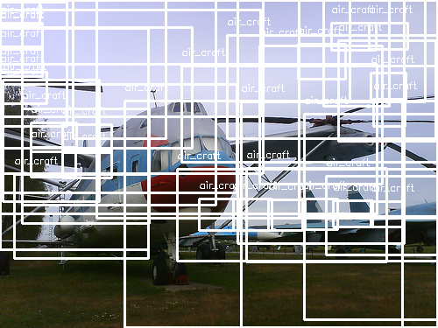

Fixing this issue

To solve this issue, I increase the confidence level up to 0.9 so vehicles would only be detected when they were present. However, as you can see in the image above this produced inaccurate bounding boxes, so I had to remove the code which cropped the image around the vehicle. I found this was a good compromise as retraining the model would mean using time I simply didn’t have. This is an issue I may fix later when I do not have time limitations.

Despite all these issues the retraining process it in fact improved the loop time from 13 seconds to 1.38 seconds which is much better for the task.

### ANPR Side - Development of the Character Recognition Module

First Iteration

I coded something which looks at an image and finds the box of the number plate. It then grey scales the number plate and displays it using matplotlib

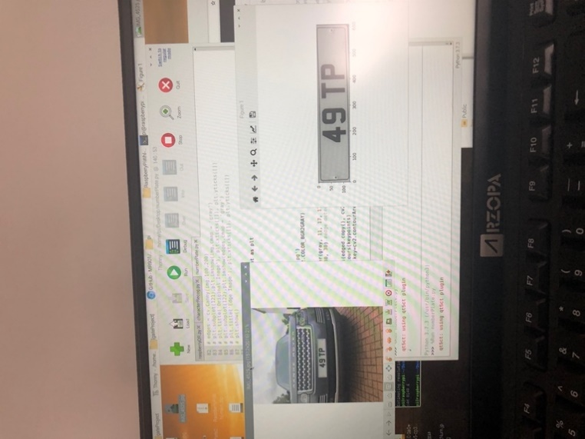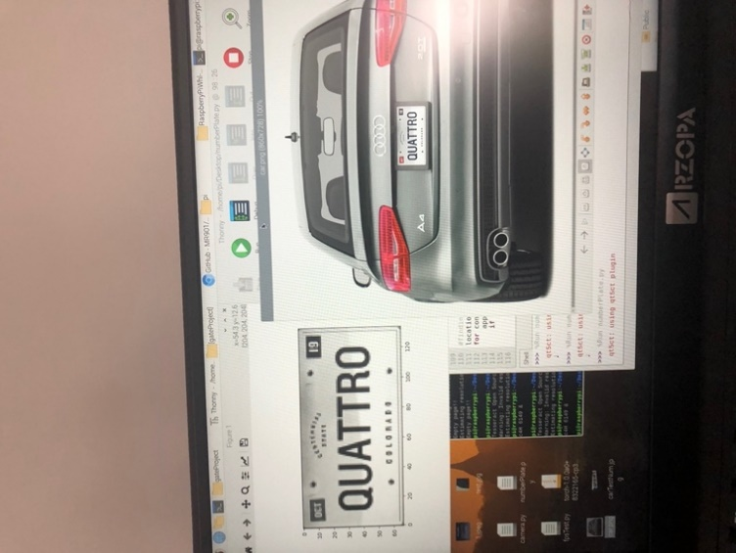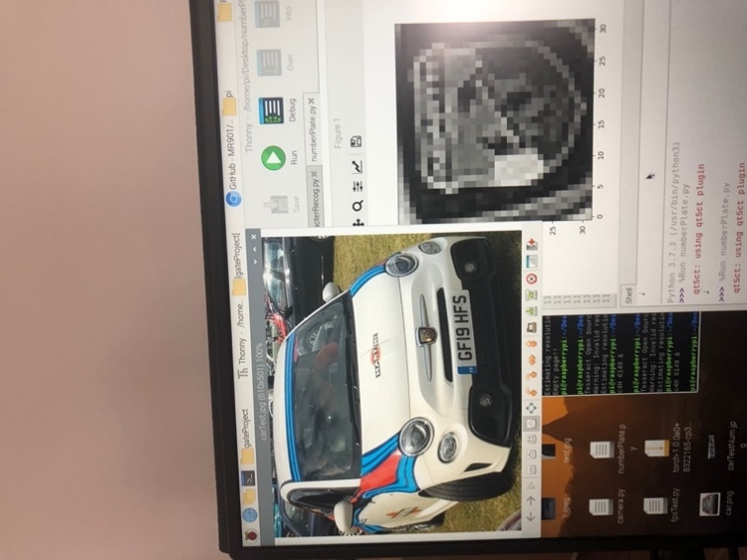

As the Abarth logo is square and above the number plate this was prioritised over the number plate below it

Problems

Despite this code finding the number plates of most of the vehicles, cases where there is a square badge above the number plate ruin this. Instead returning the badge of the car.

Second Iteration

I linked the code of the number plate bounding box finder with that of the and the object recognition module so that the camera would run on loops until a vehicle was found at which point it would find the number plate and output the cropped image on the screen

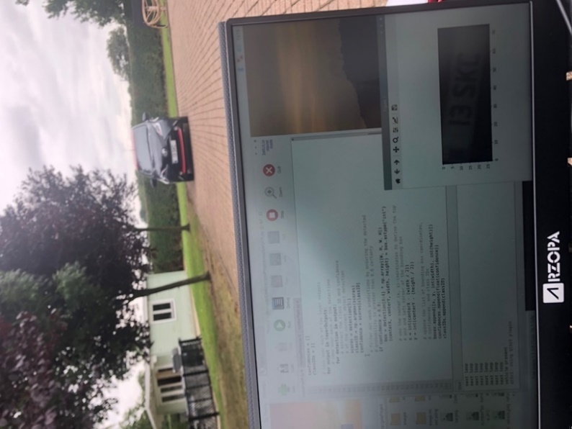

Prototyping comments

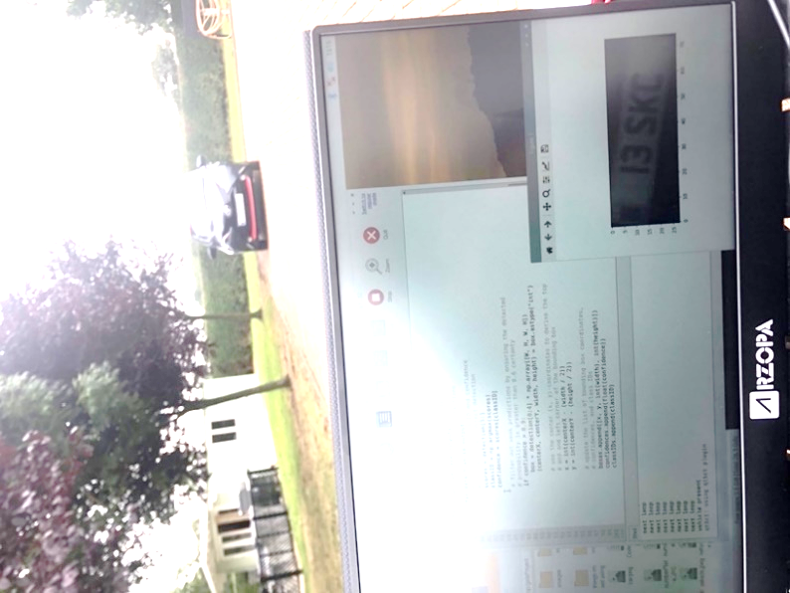

As shown here the code found the number plate and cropped it so that it can be read in later iterations of the code where character recognition is used.

Steps after this prototype:

1. Use tesseract so the number plate can be read and produce a string
2. Format the string to account for tesseract mistakes
3. Check the string against those in the database and turn on the LED if it is valid

### ANPR Side - Final iteration of the ANPR module

I then added in the tesseract code to get it fully working. At this point I realised that letter such as 1 and I would sometimes be misread along with 8 and B, however always in the favour of the letter. To solve this, I simply created multiple strings with the most likely outcomes, putting them in an array then comparing their outcomes to those in the database. To reduce the possible outcomes, I formatted it to the usual AANN EEE of a normal number plate. Due to this, possible errors are more likely in private number plates as they have more freedom of variation and so are harder to predict.

Below this is the file for the object recognition module which calls the image cropping module

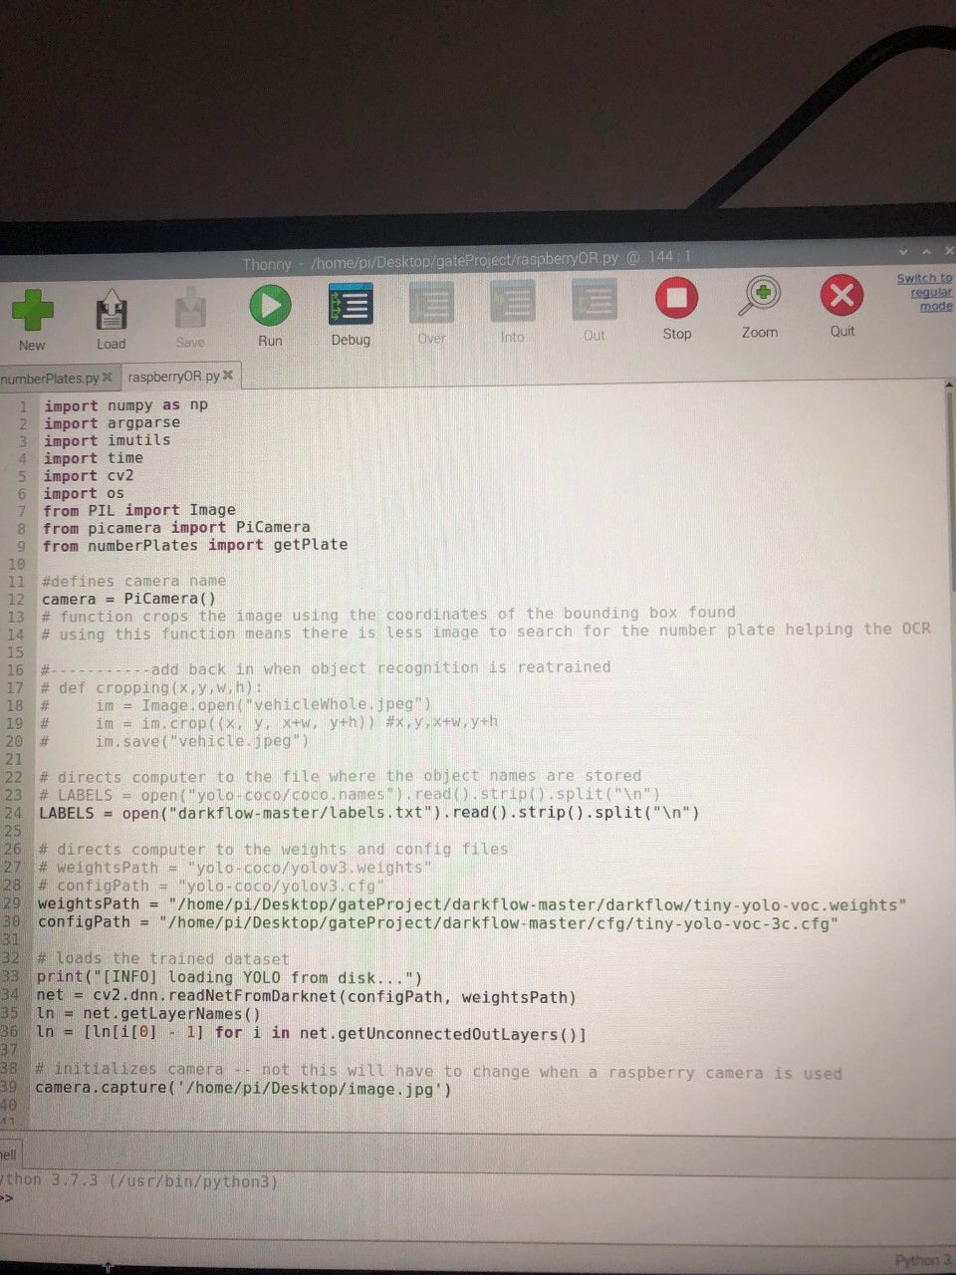

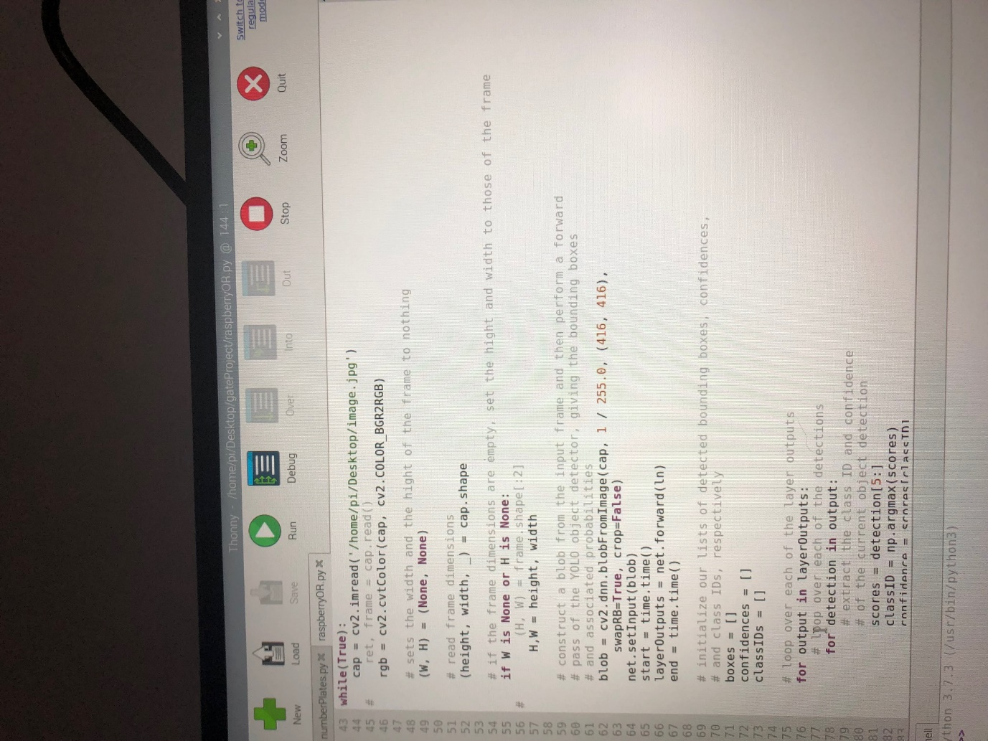

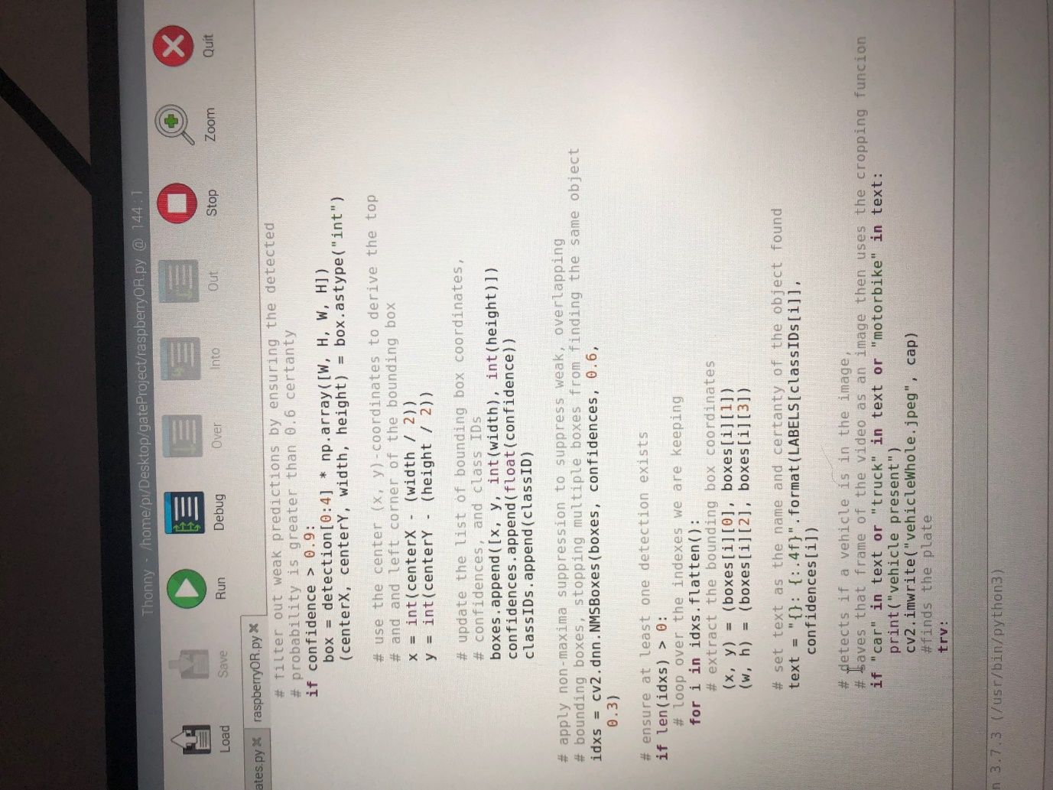

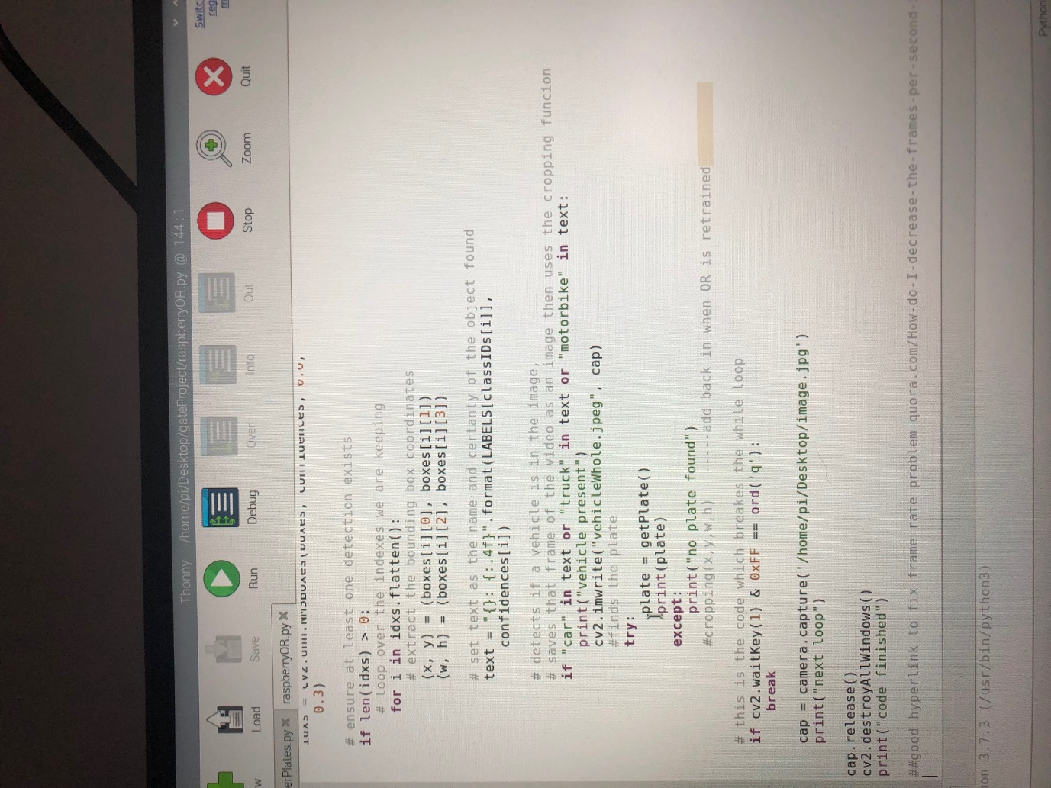

Below is the character recognition module

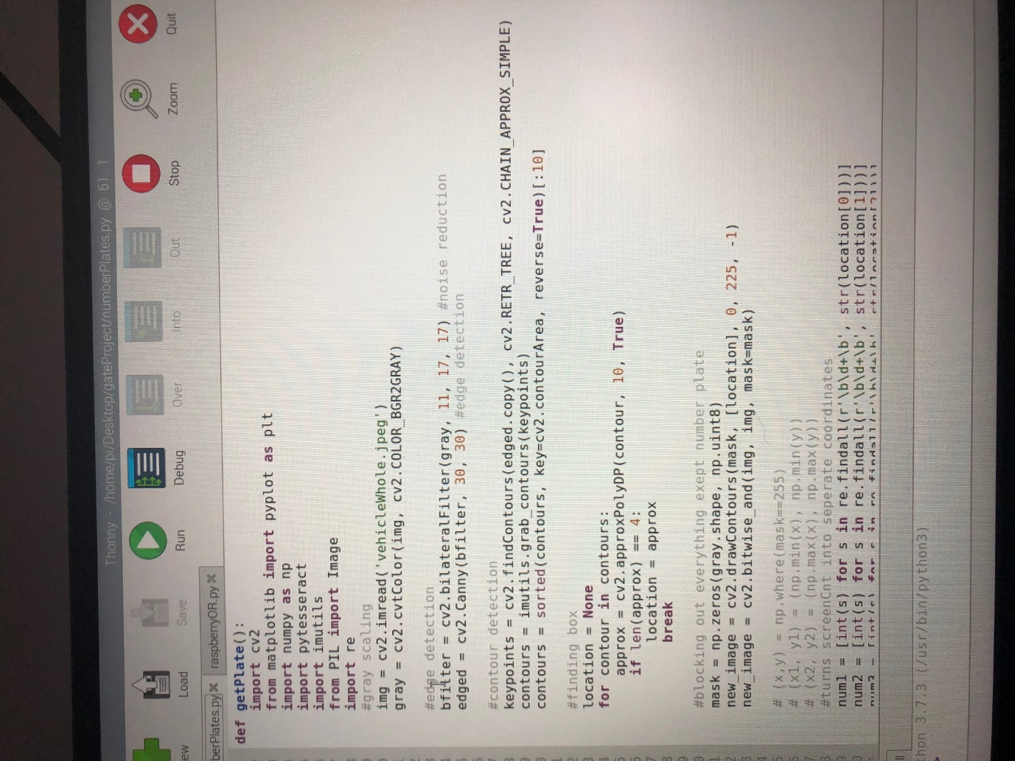

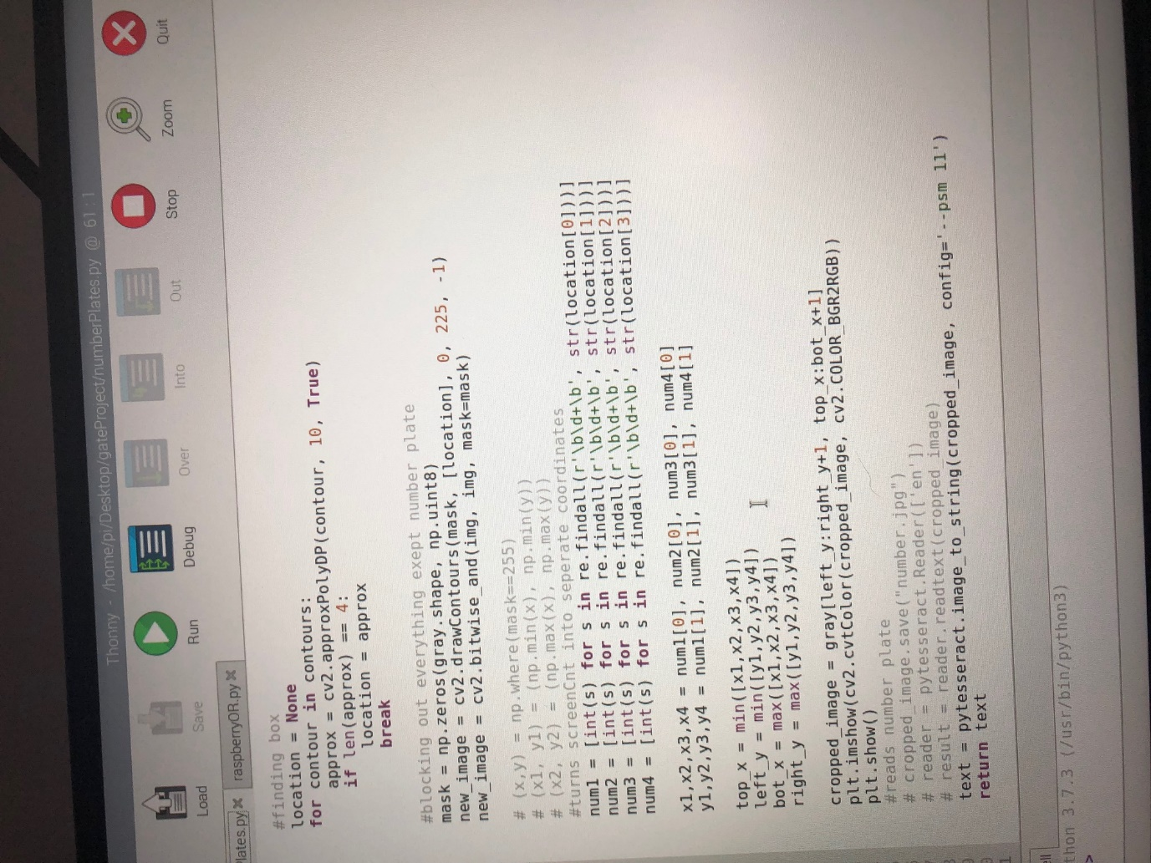

Below is the file I linked to the rest of the code which is used to verify the number plate string (and its likely alternatives). After finding the number plate in the verified number plates table of the database it then checks that the number plate itself is valid. If it is it will turn on the LED; this simulated the process of giving current to the gate to open it. After the LED turns off it then logs the numberID, time and date into the entries table.

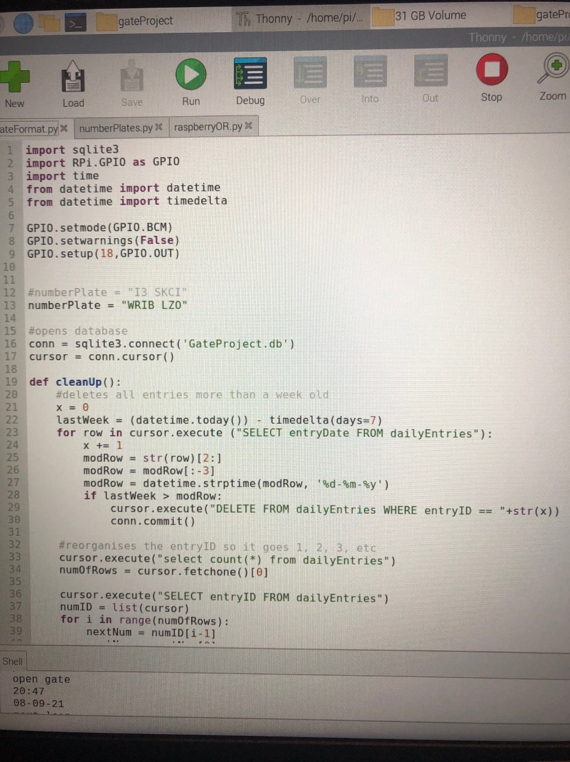

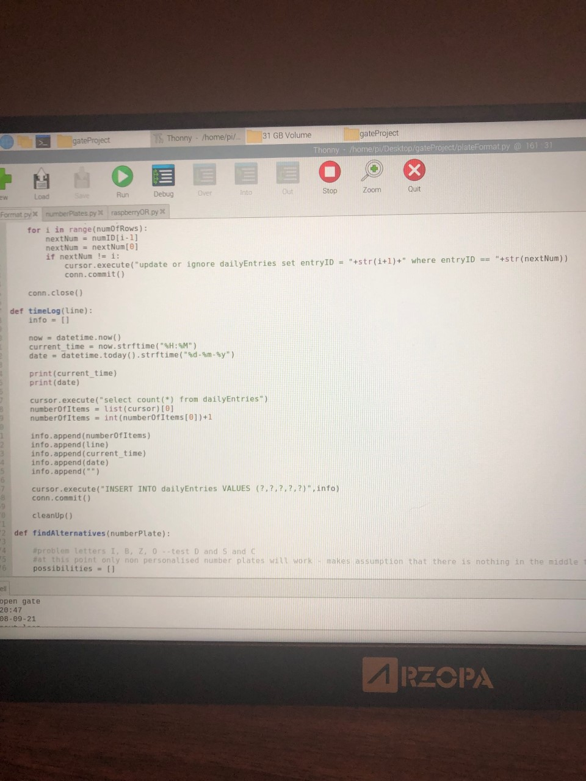

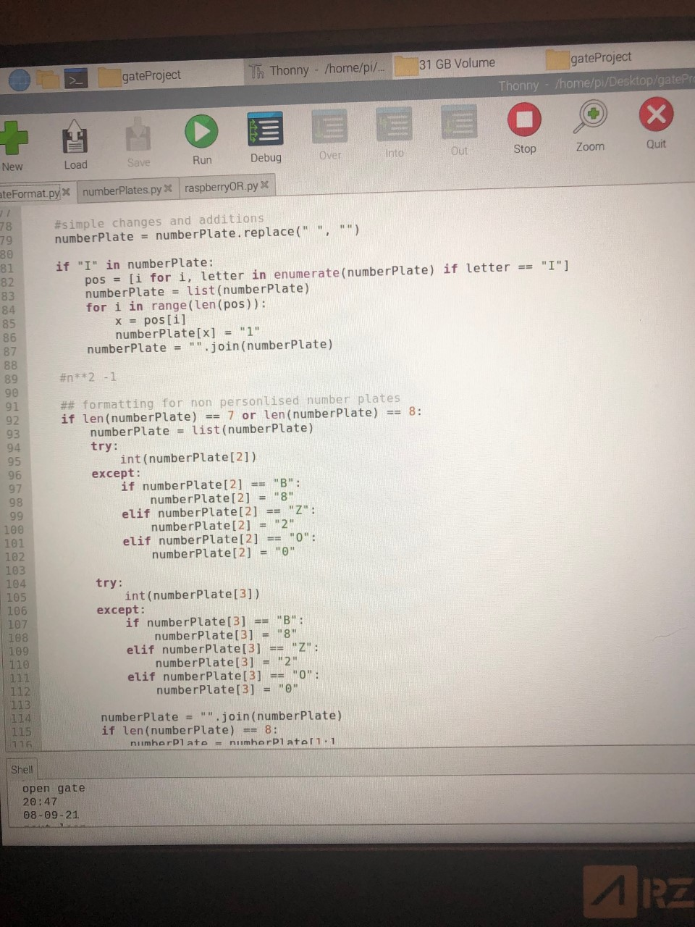

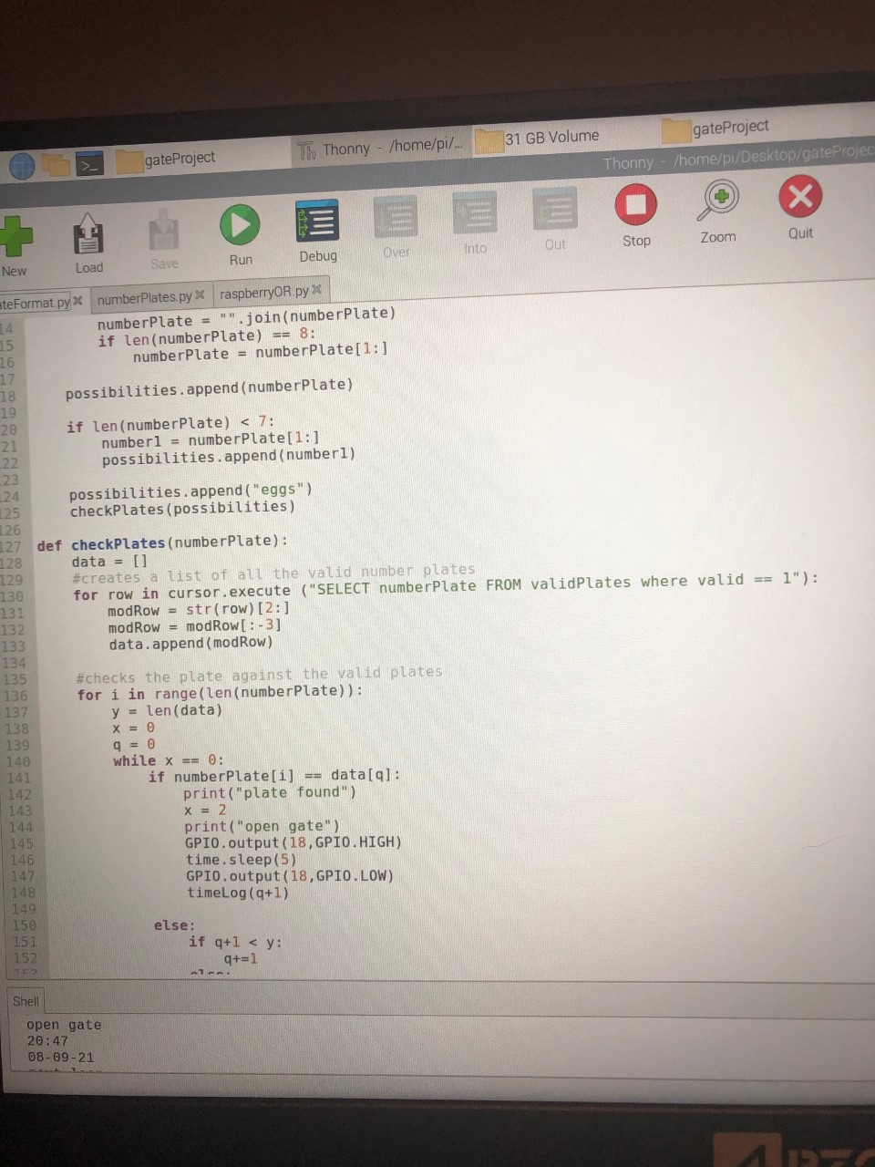

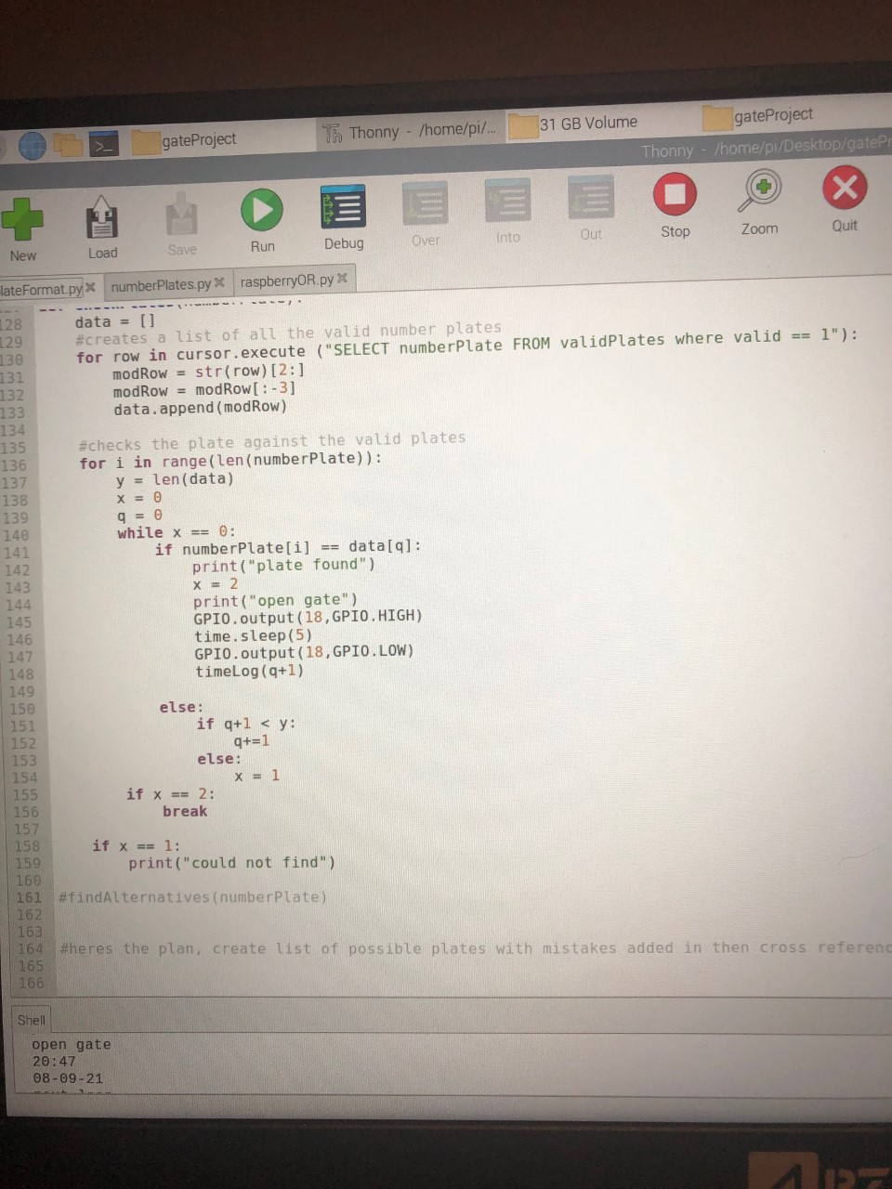

Issues still not solved

There are still a few things I need to fix in this section and that is finding the alternative number plates as I haven’t had the time yet to fully test what the character recognition reads and the typical errors, I also need to sort out the error where the code crops to the car badge rather than the number plate when it is square. Along with these main issues if I have time later, I will retrain the object recognition again so that it works properly, other than that the hardware side of the project is complete, and I can now move onto the user interface side.

### ANPR Side – Final iteration with MySQL Database

Problem

After starting the app side of the project, I realised that the .db database I was originally using was not compatible with the web server, due to this I had to change to a MySQL database for this server. However, this also meant I had to do the same with the ANPR side of the project to ensure compatibility.

Solution

To fix this I had to download a python module before altering the python code as shown below so that it was now MySQL compatible. I also fixed an issue with formatting so when things are deleted the primary key of the now first item in the list is corrected to 1 with the rest following suit.

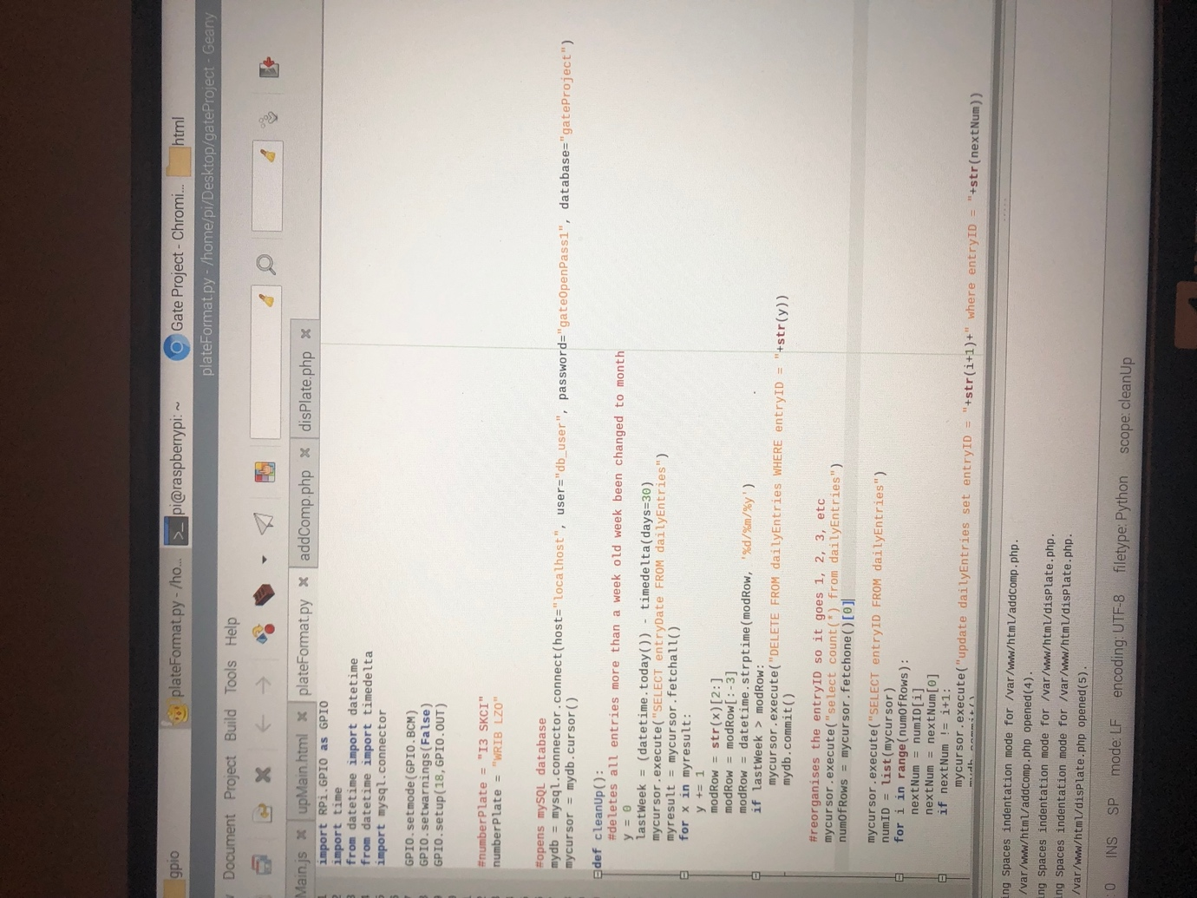

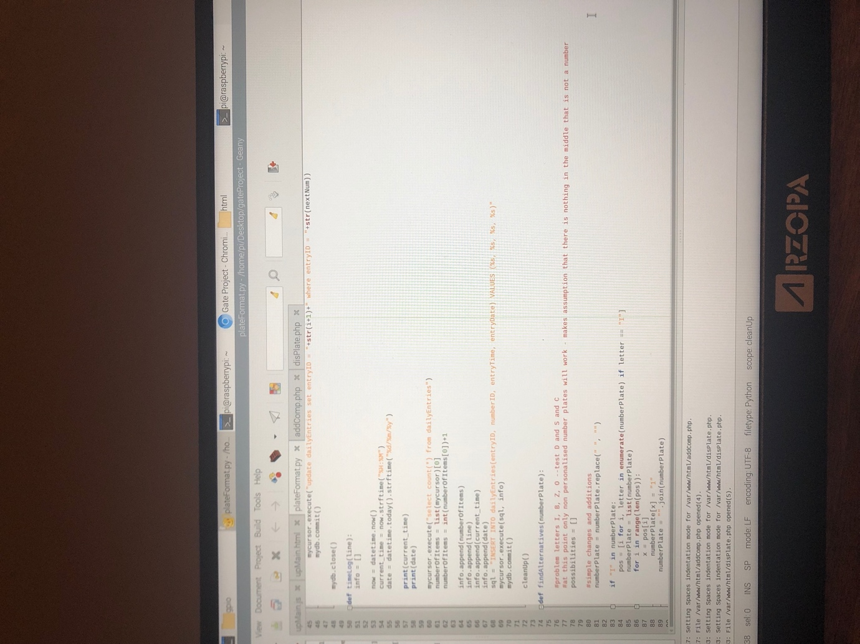

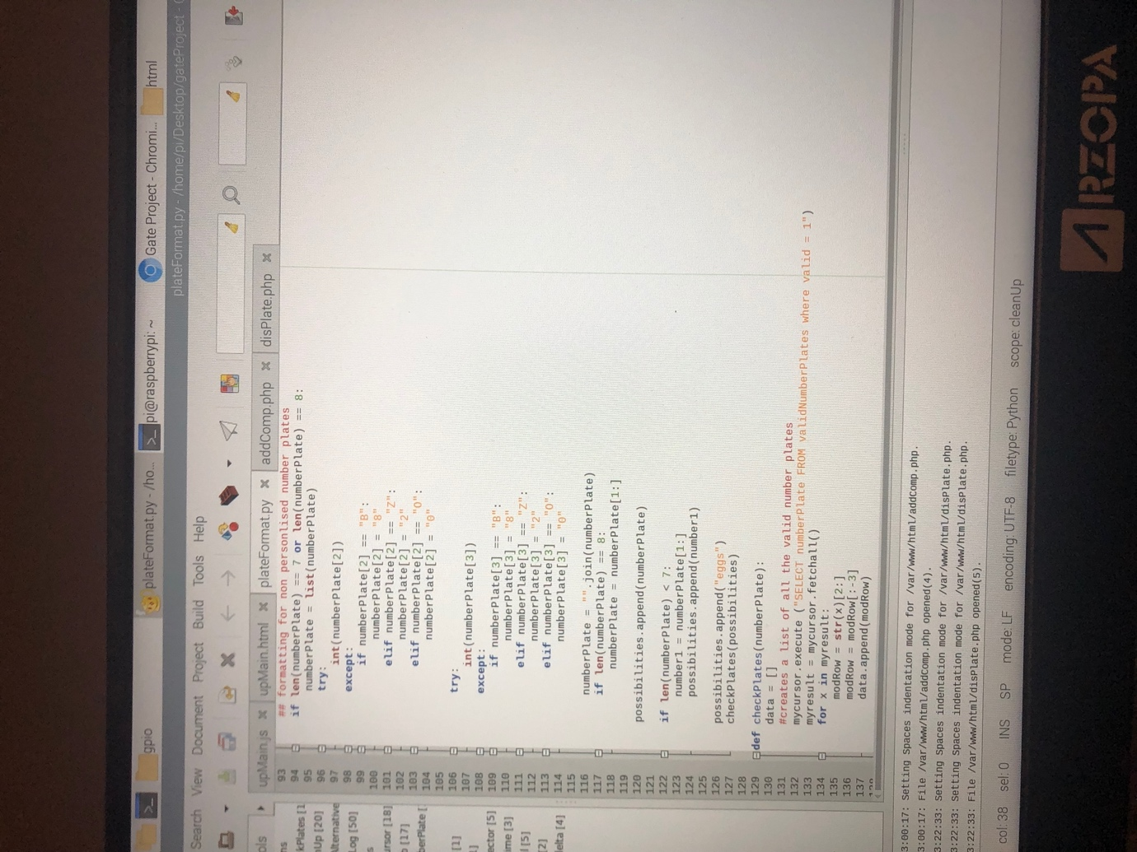

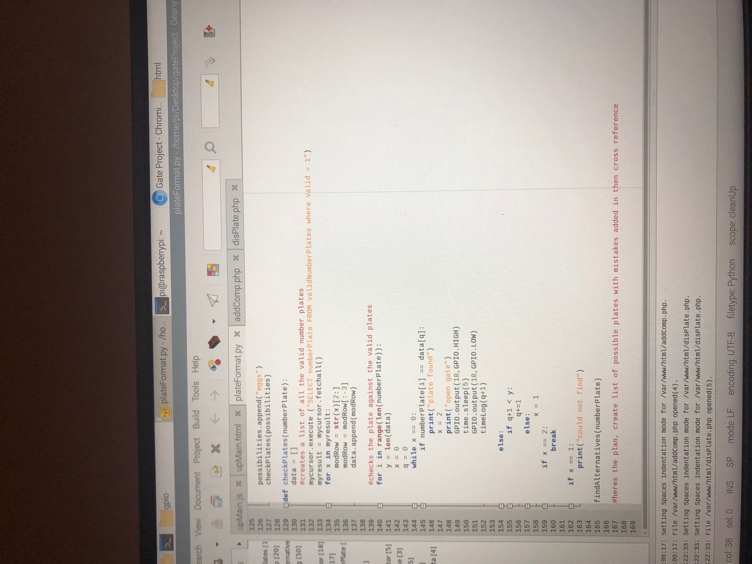

### App Side – Login Module

First Iteration

Started working on the web app login page. At this point I have created a PHP file with embedded html as the main index, this file contains all the content and connects to the MySQL database as I recently found out the .db databases are not compatible with PHP so had to create a new database. I will link this into the ANPR side of the project at a later date. I have also created a CSS file with the formatting and a JavaScript file which gets the contents inside the input boxes and goes red if boxes are empty. There is also a function to show password here.

PHP/HTML file:

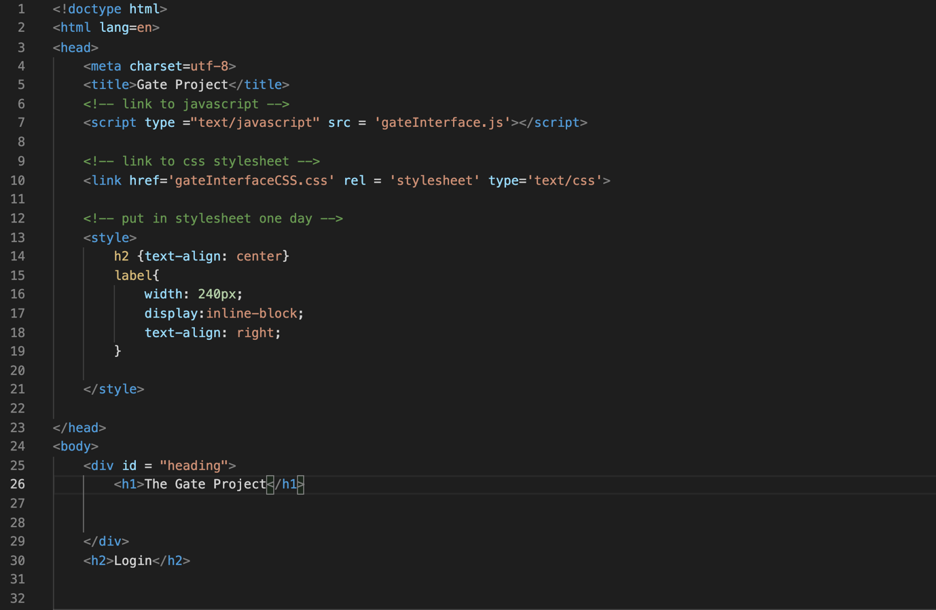

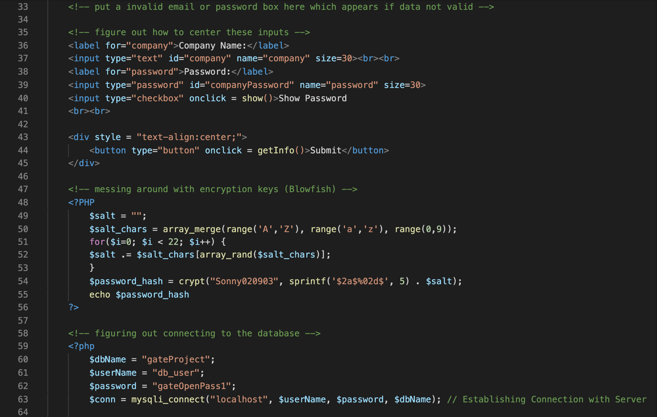

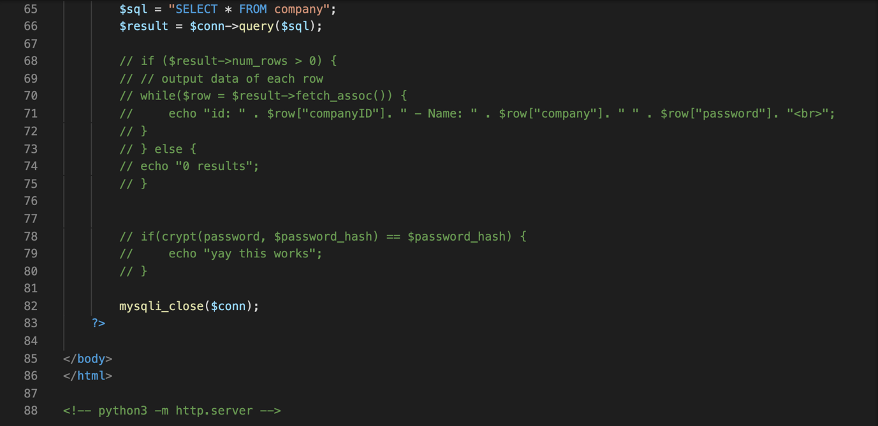

CSS file:

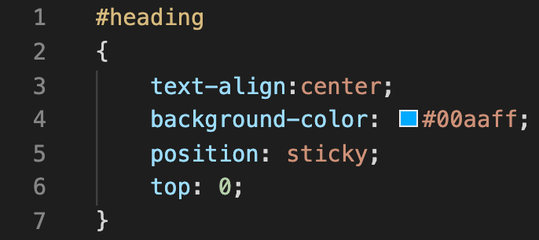

JavaScript file:

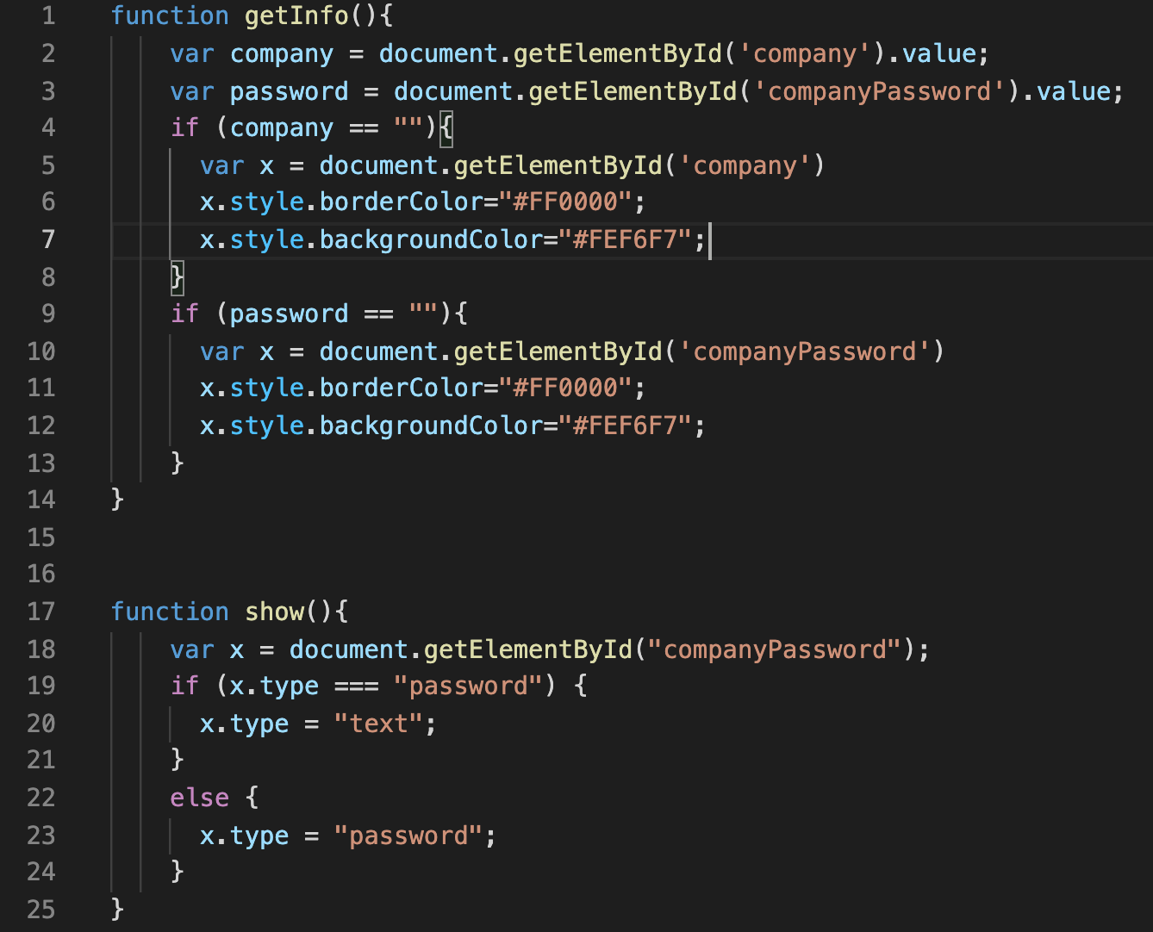

Web View:

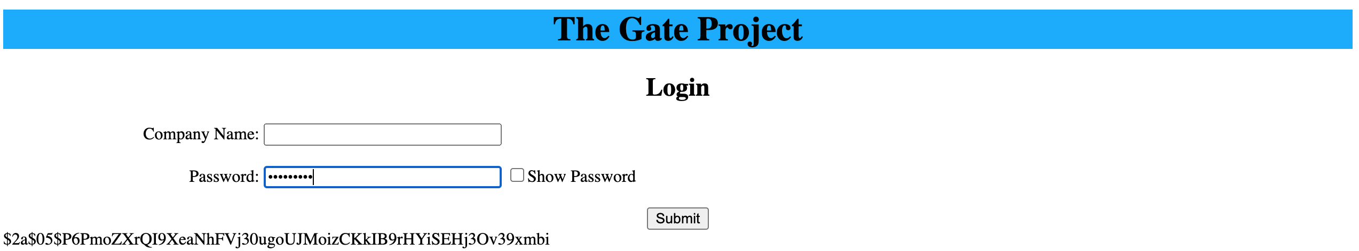

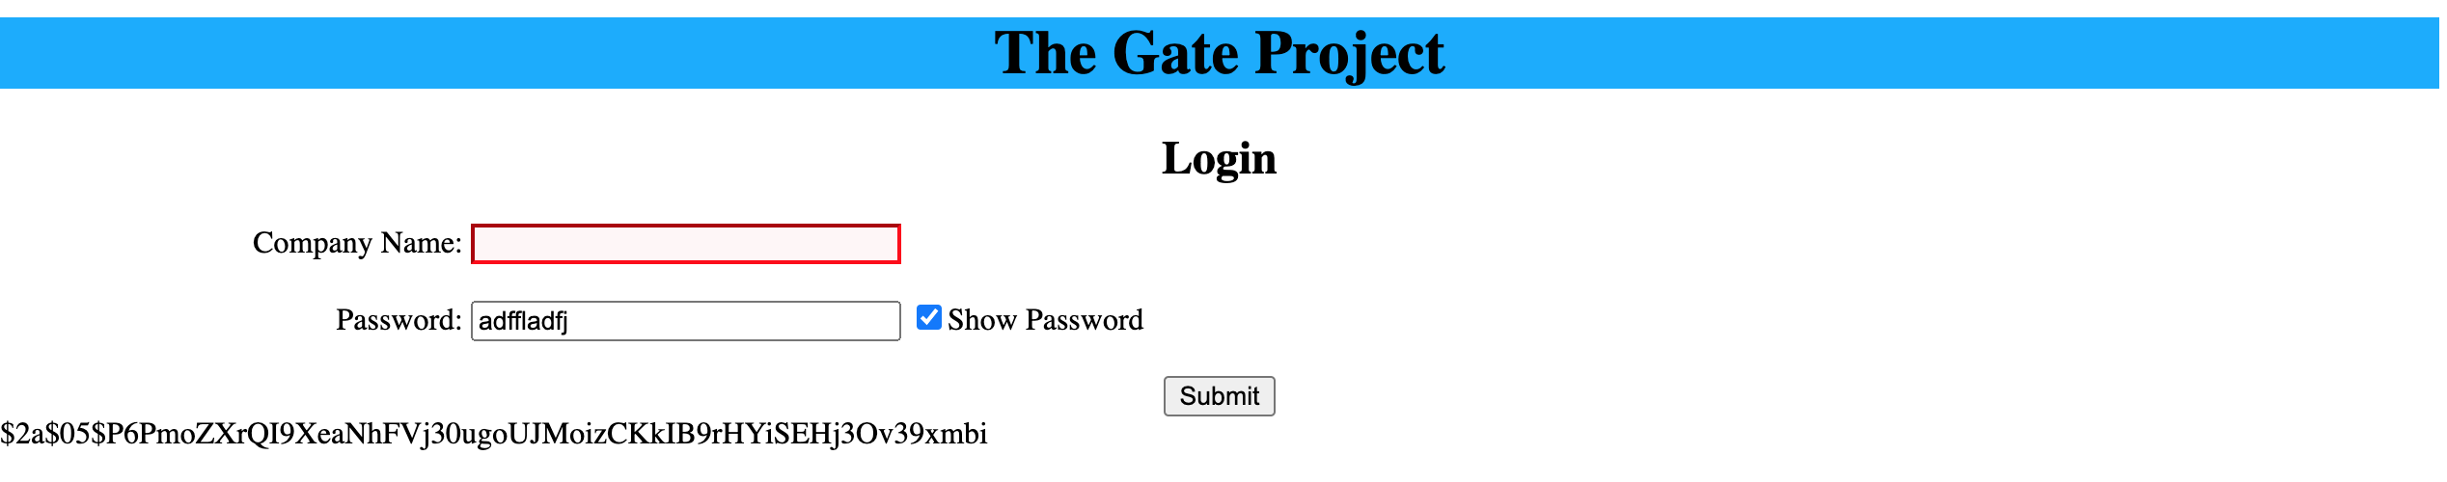

Prototyping comments

As you can see here this iteration of the login page has a working show password button and a working error flag for empty boxes.

Still needs error messages which pop up if it is wrong or if box is empty and to actually perform the function of logging in if the details are correct.

This is the password encrypted and with salt added, ensuring password will be kept secure when sent server side.

### App Side – Final Iteration of login page module

Final comments on module

I finished the login page using an external PHP file for validation, however the page is still quite ugly. I plan to go back once everything is finished and improve its looks. I have also added in encrypted passwords with salt into the database. Passwords are checked against the encrypted ones.

HTML file:

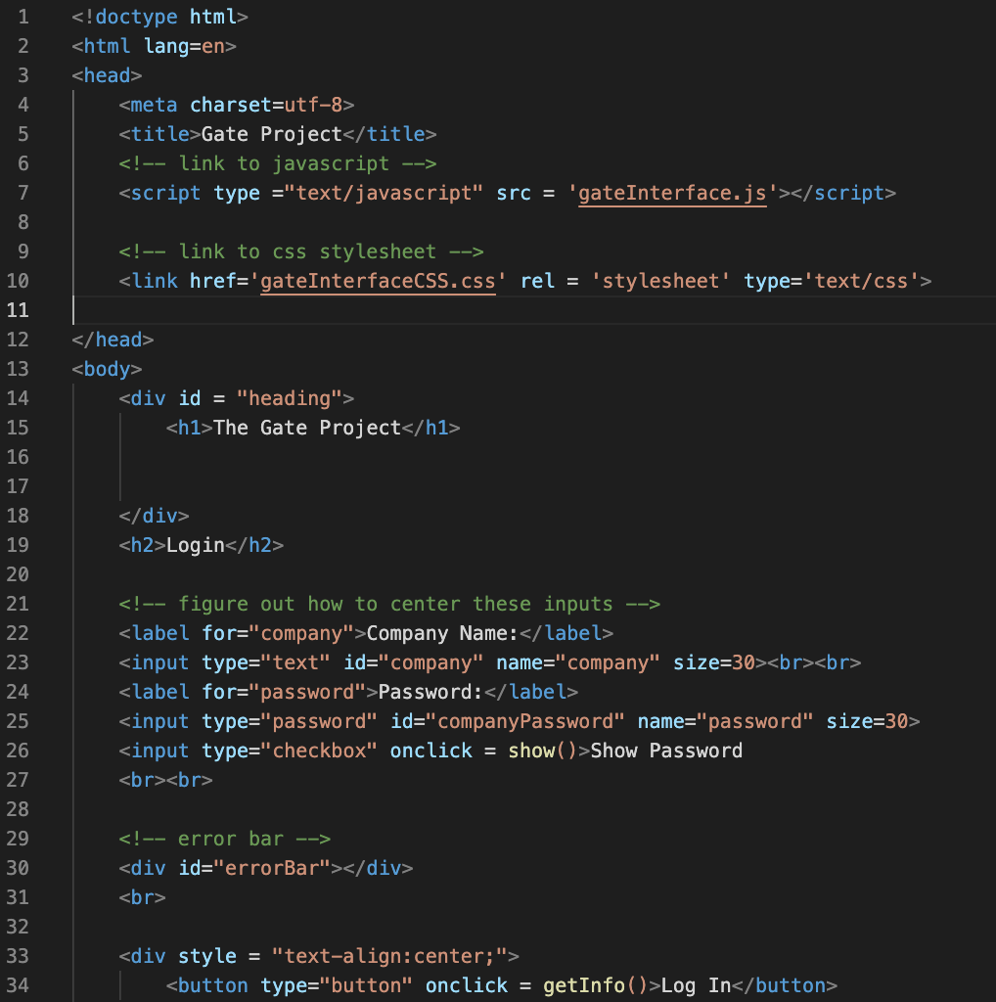

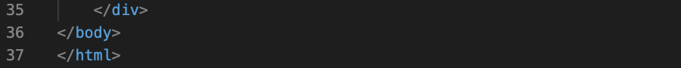

PHP file:

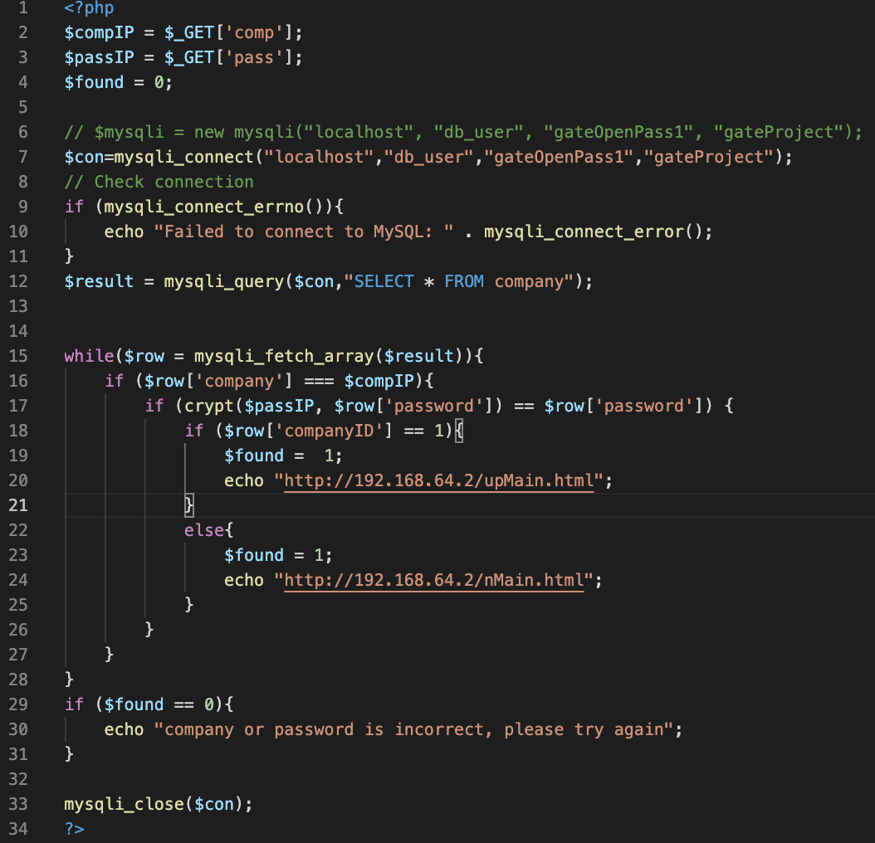

JavaScript file:

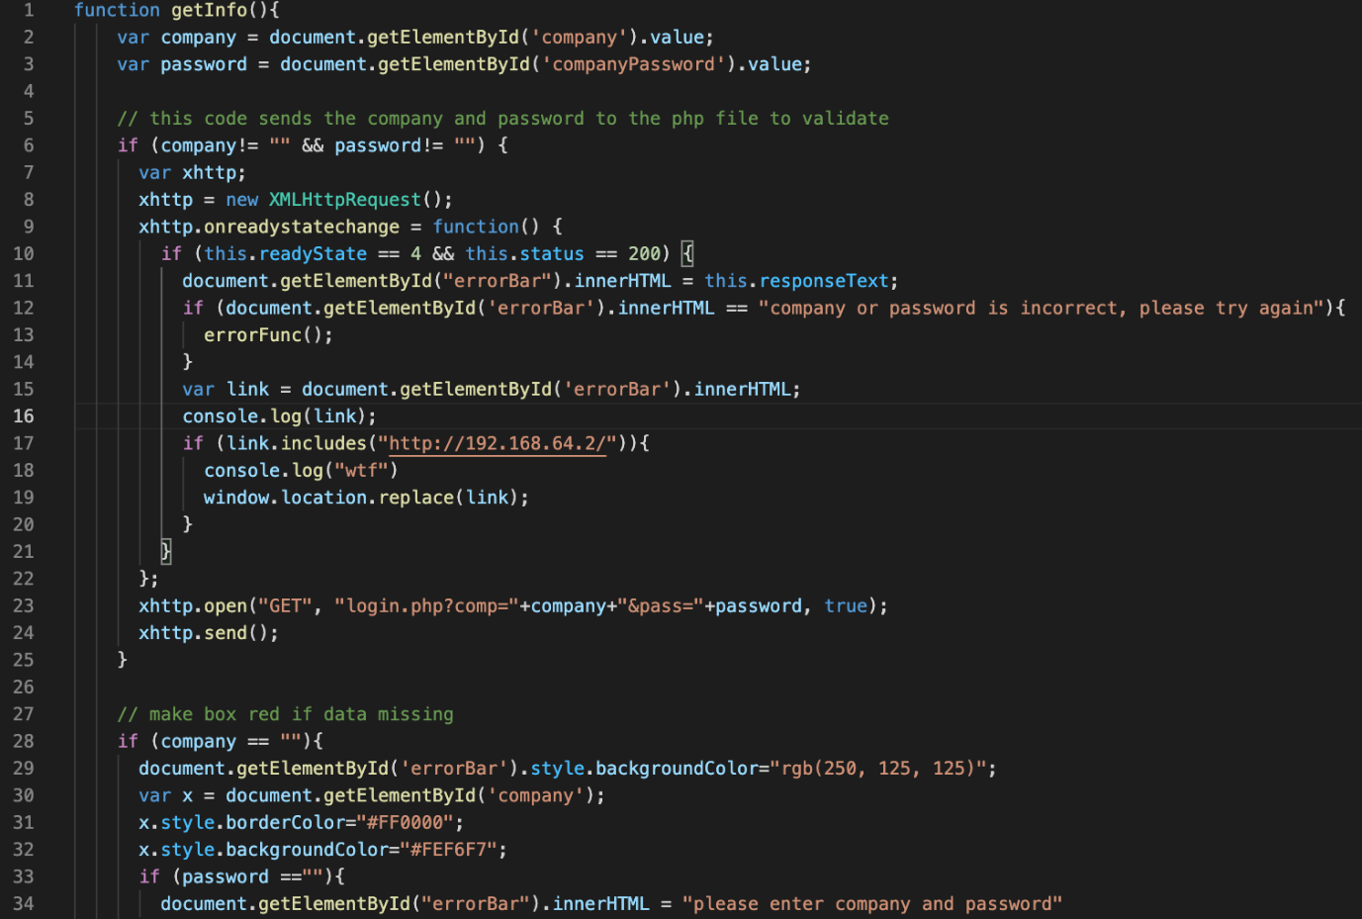

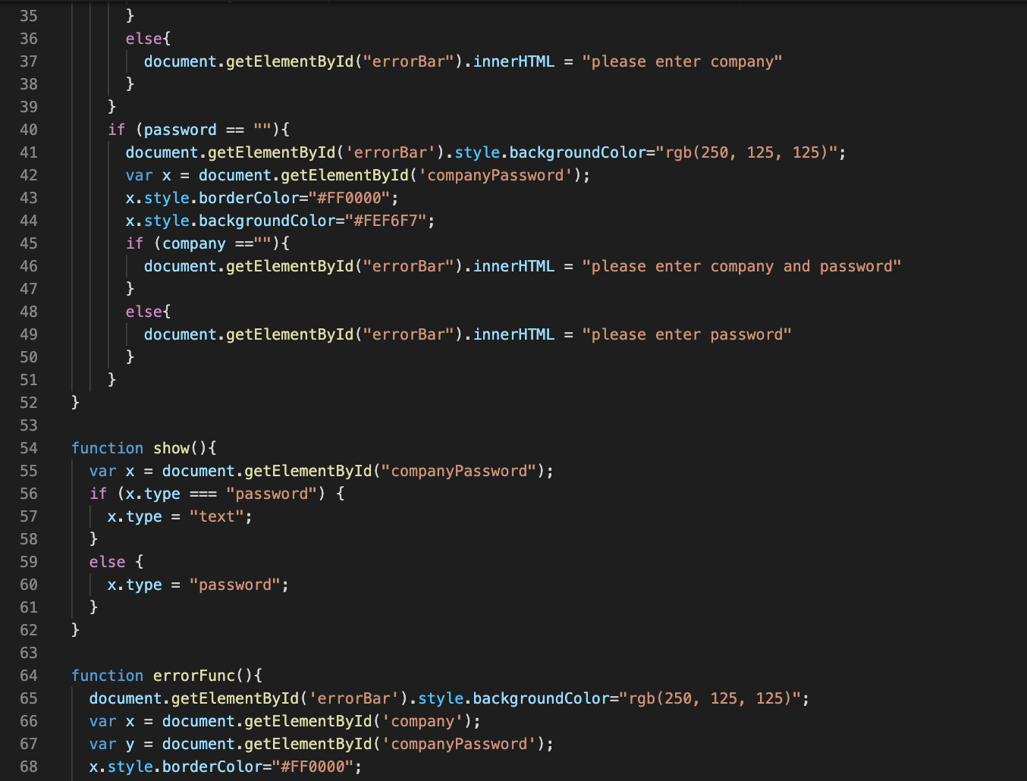

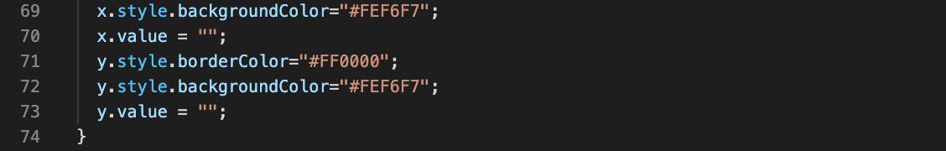

Validation checks done

* Line 6 – presence check for company and password

CSS file:

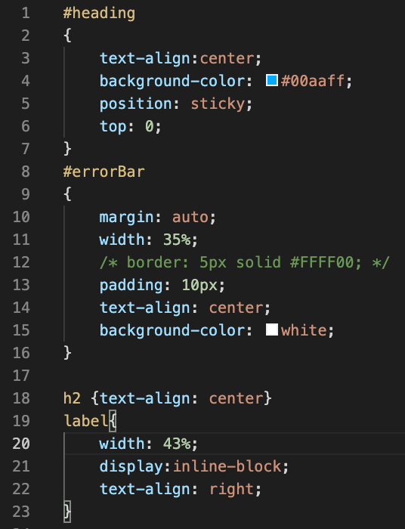

Web view:

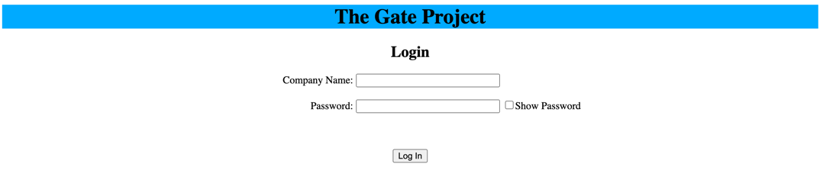

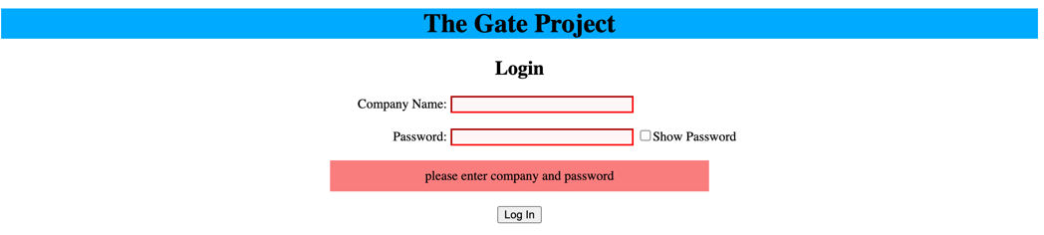

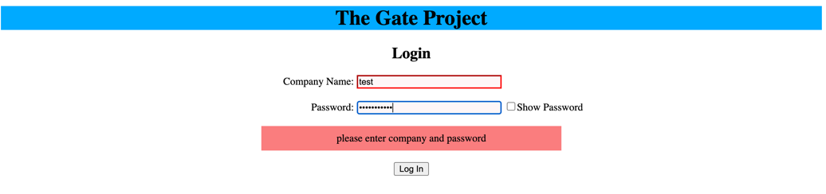

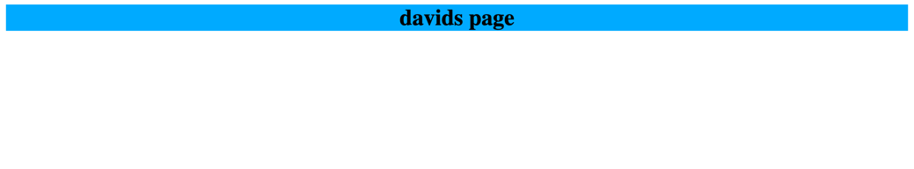

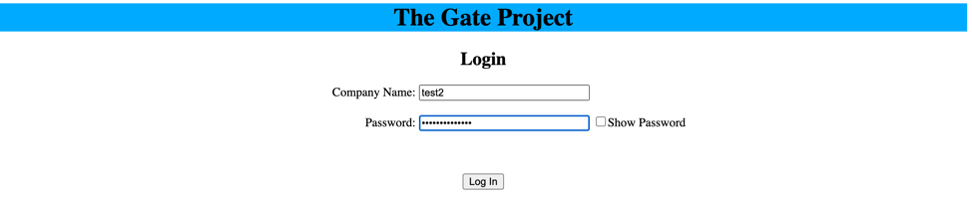

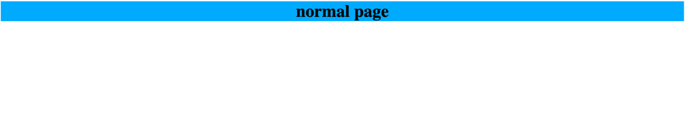

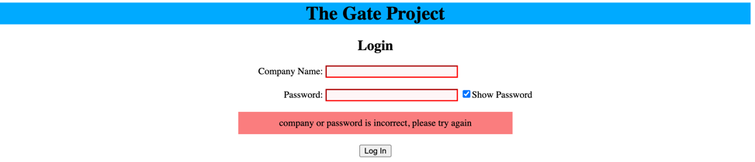

### App Side – Primary Users home screen module

I decided to keep it pretty simple, hence at this point the CSS is quite dull. Decided to just add in the main features required for this section (add company, add number plate and view data). This has been pretty easy with no real issues

PHP/HTML file:

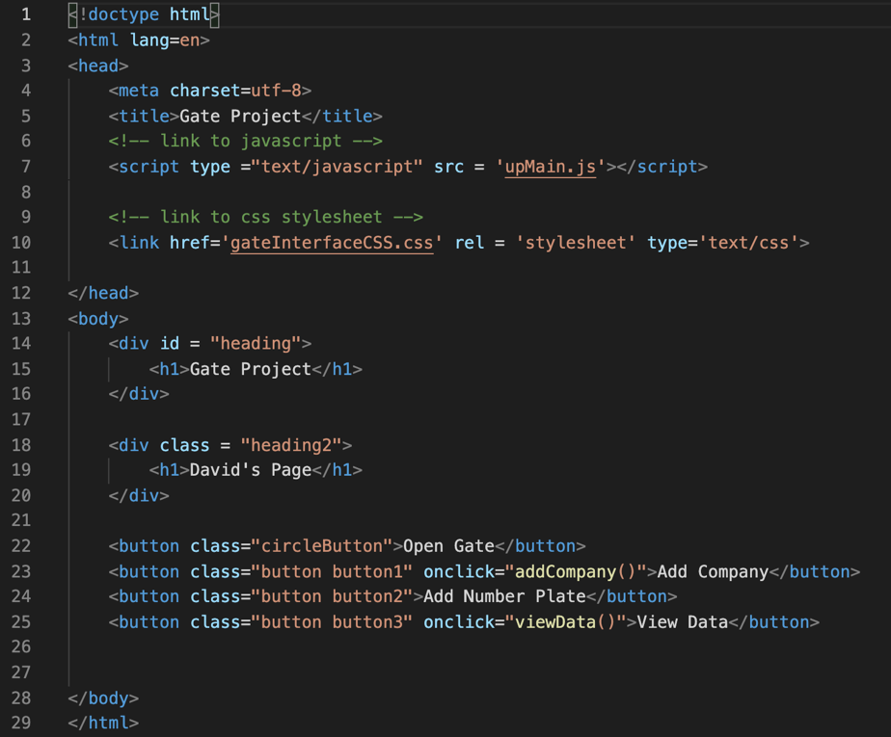

Web view:

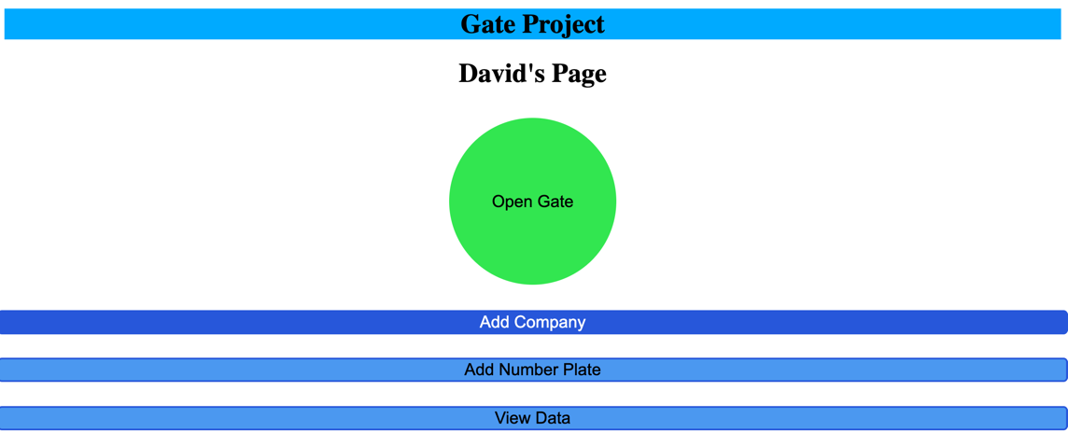

### App Side – Add companies module

This part was relatively easy to code I first set up the page then coded the submit button to call the JavaScript function getInfo() which in turn performs an ajax injection, calling an external PHP document which adds the companies to the database. I also added in a back button. Note all JavaScript and CSS for these pages can be found at the bottom of the primary user section.

HTML file:

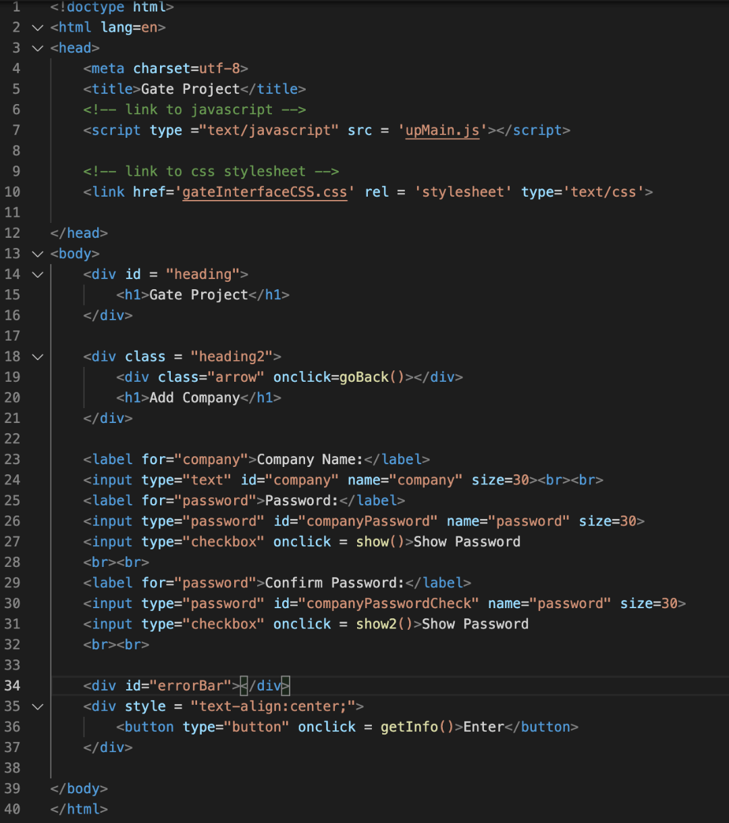

PHP file:

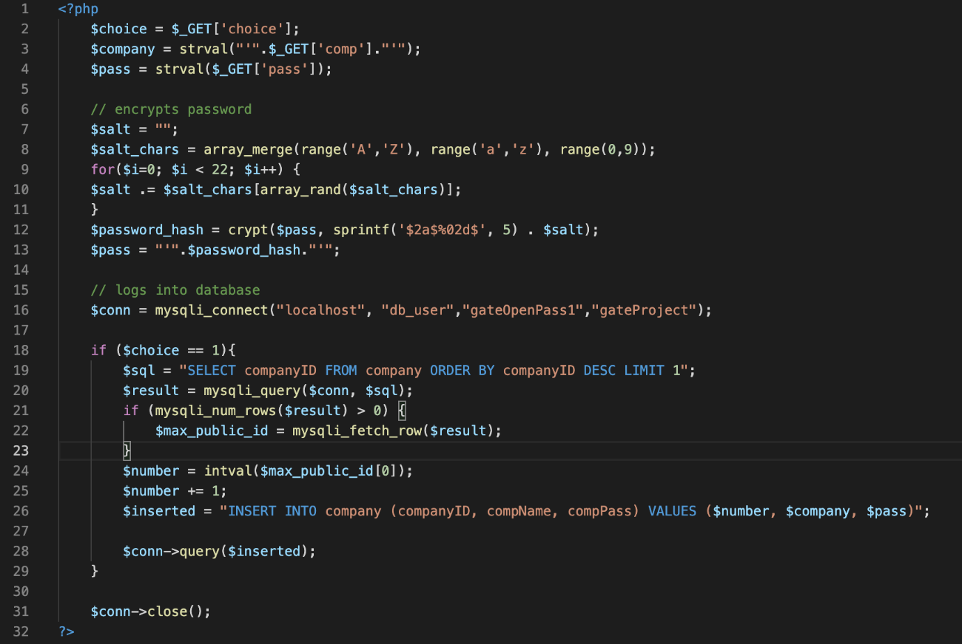

Web view:

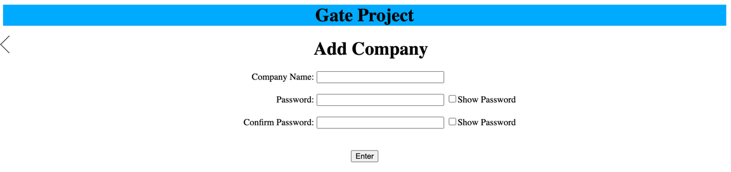

### App Side – View data module

HTML file:

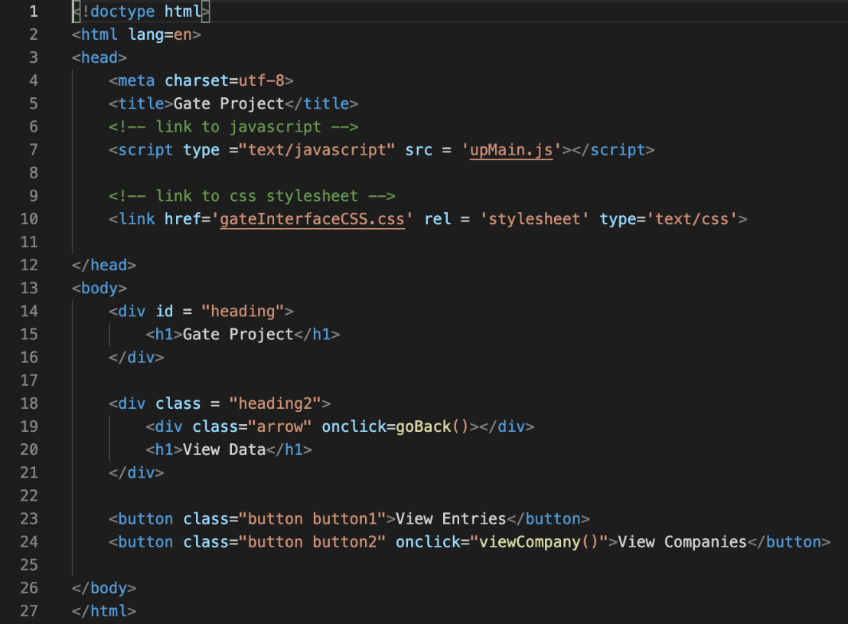

Web view:

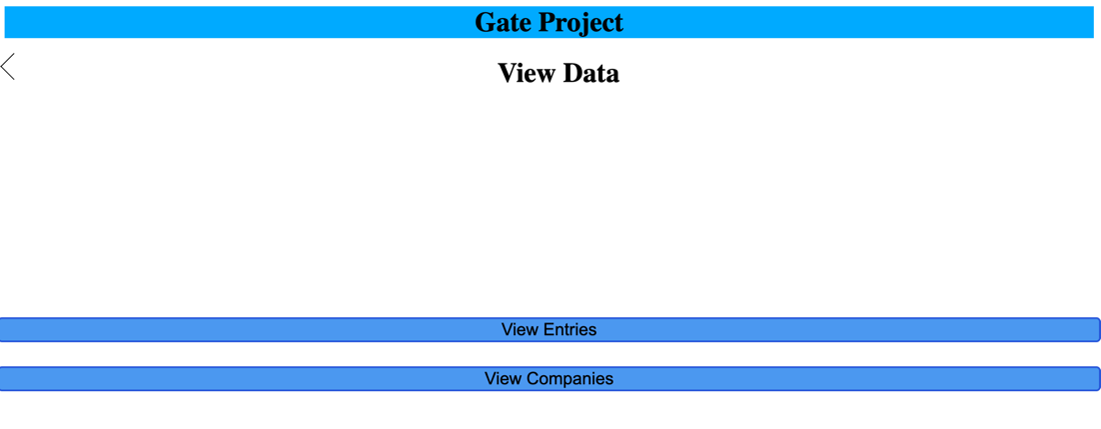

This page was pretty easy to do nothing complicated.

### App Side – View Companies Module

First Iteration

Used an embedded HTML file to code this, none of the buttons work yet, I was simply just working on the structure of the page

HTML/PHP file:

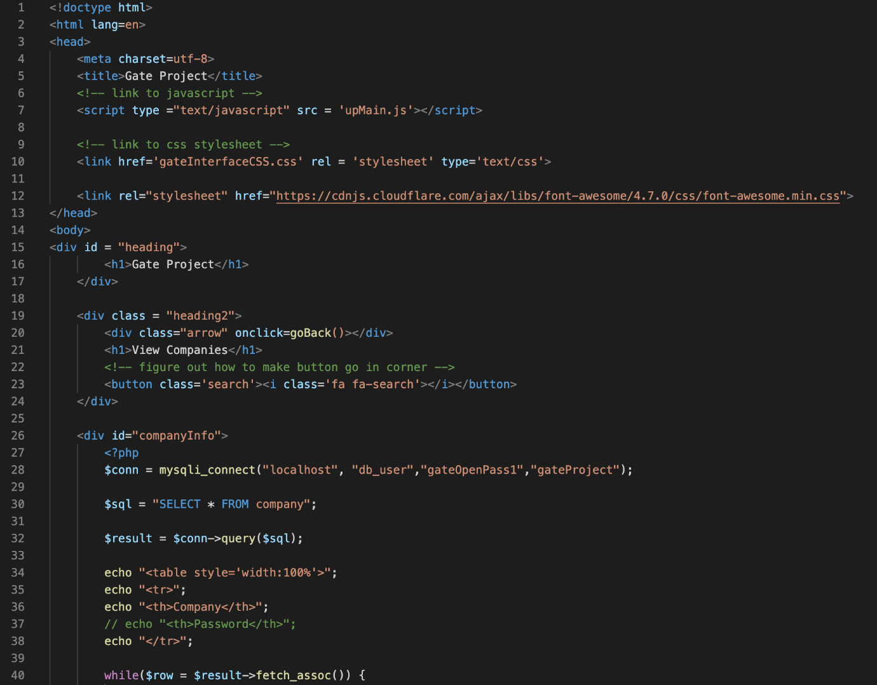

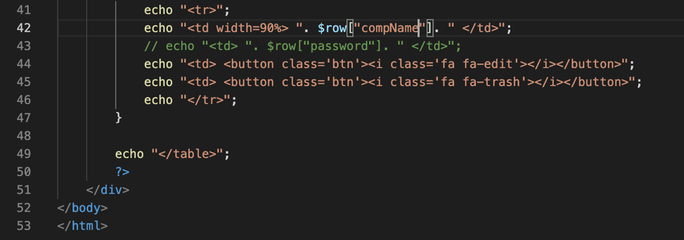

Prototyping comments

Need to fix these buttons in the next iteration as none of them work. I also need to add in the feature where you can view number plates of the company by clicking on the company name.

Web view:

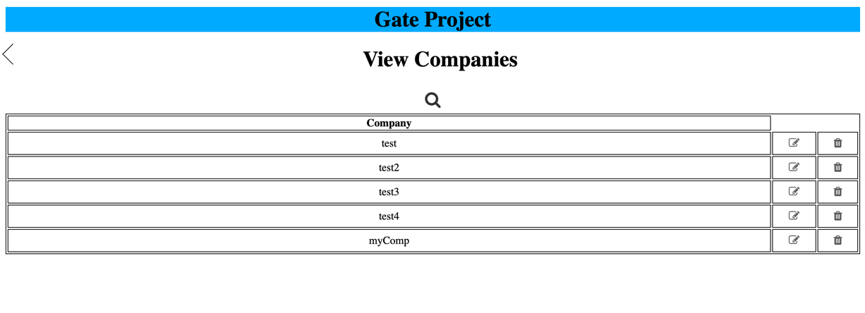

### App Side – Final iteration of view companies module

I added in a sorting feature and a searching feature to make finding companies easier. I also added a delete feature so the primary user can now remove any company except the primary company. Along with this you can also change passwords with the edit button. A final feature I added meant that if you click on a company it will show all number plates within it. I then added in a feature for validating number plates for a company by ticking a check box

PHP file for main part:

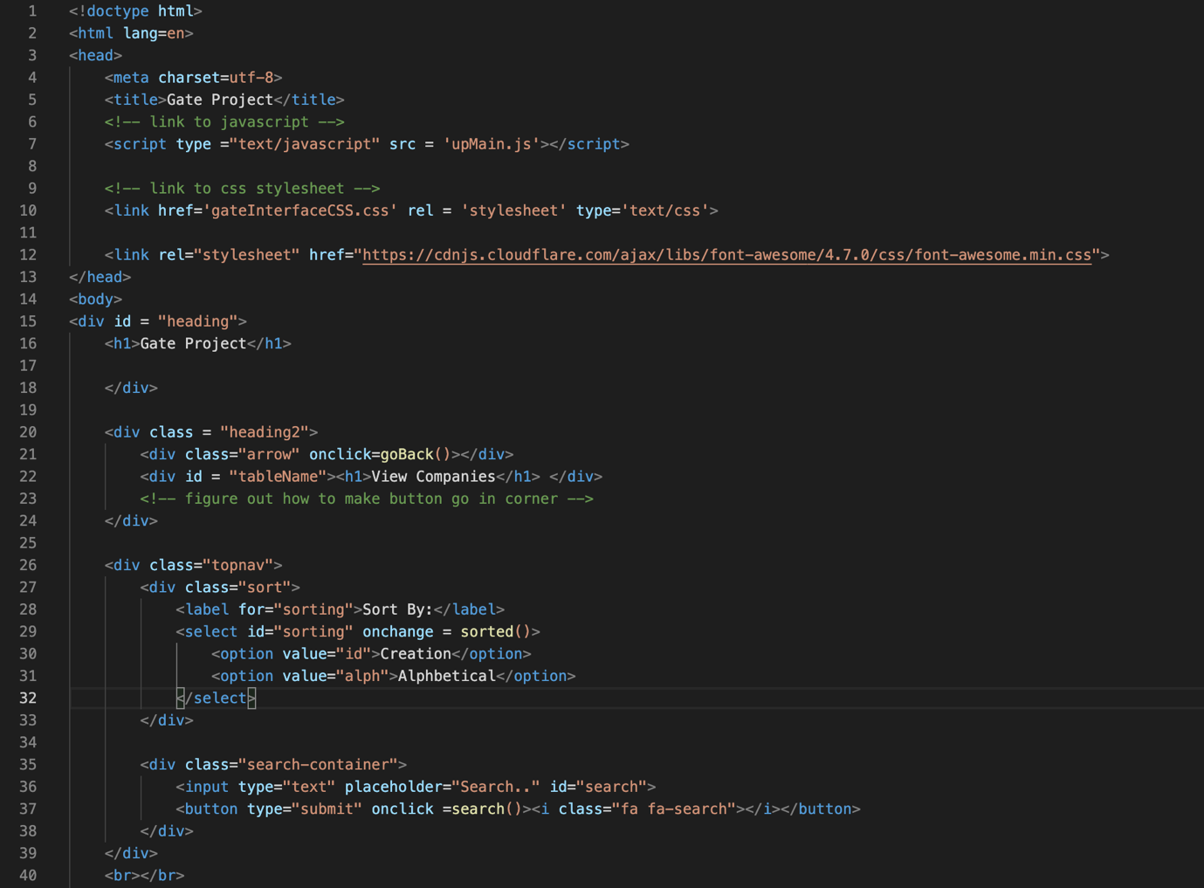

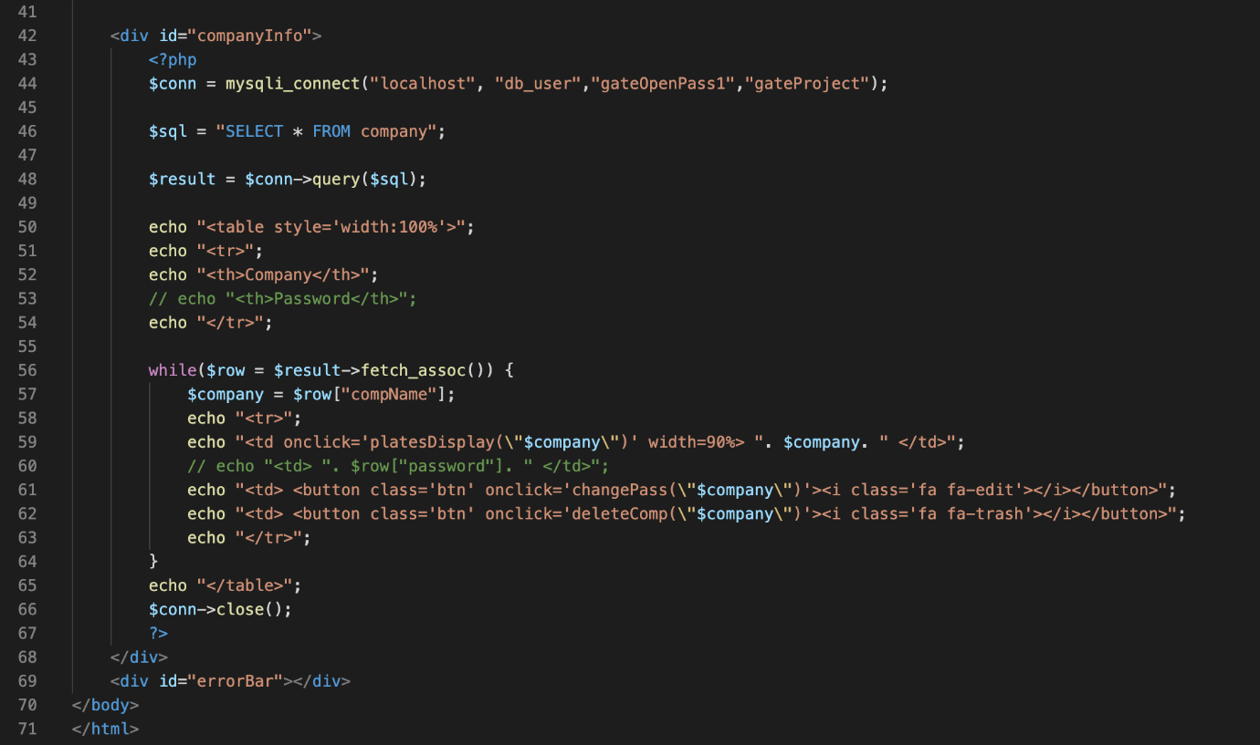

PHP file for showing plates:

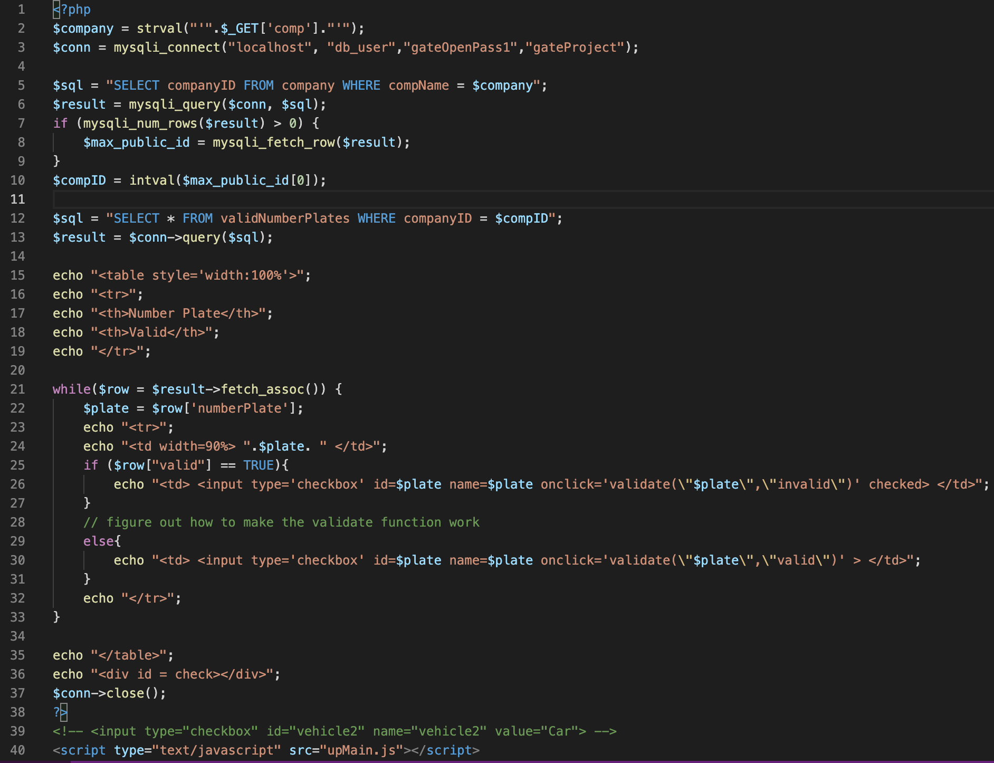

PHP file for searching:

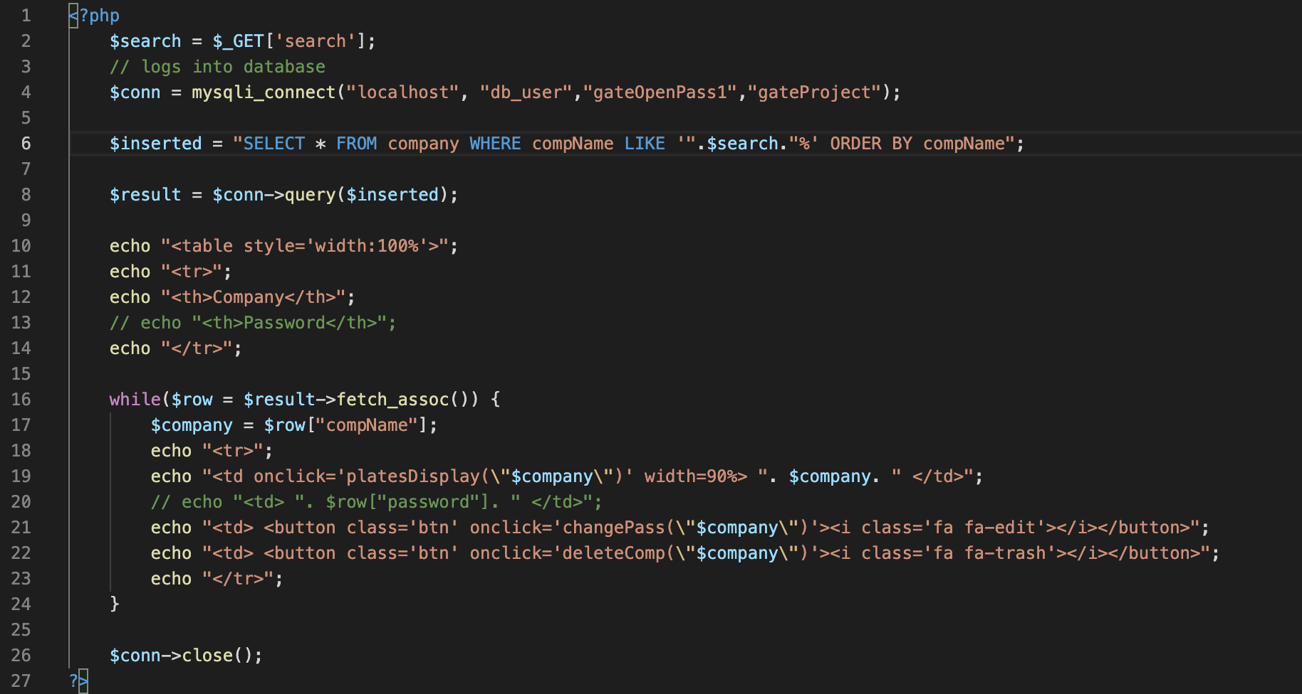

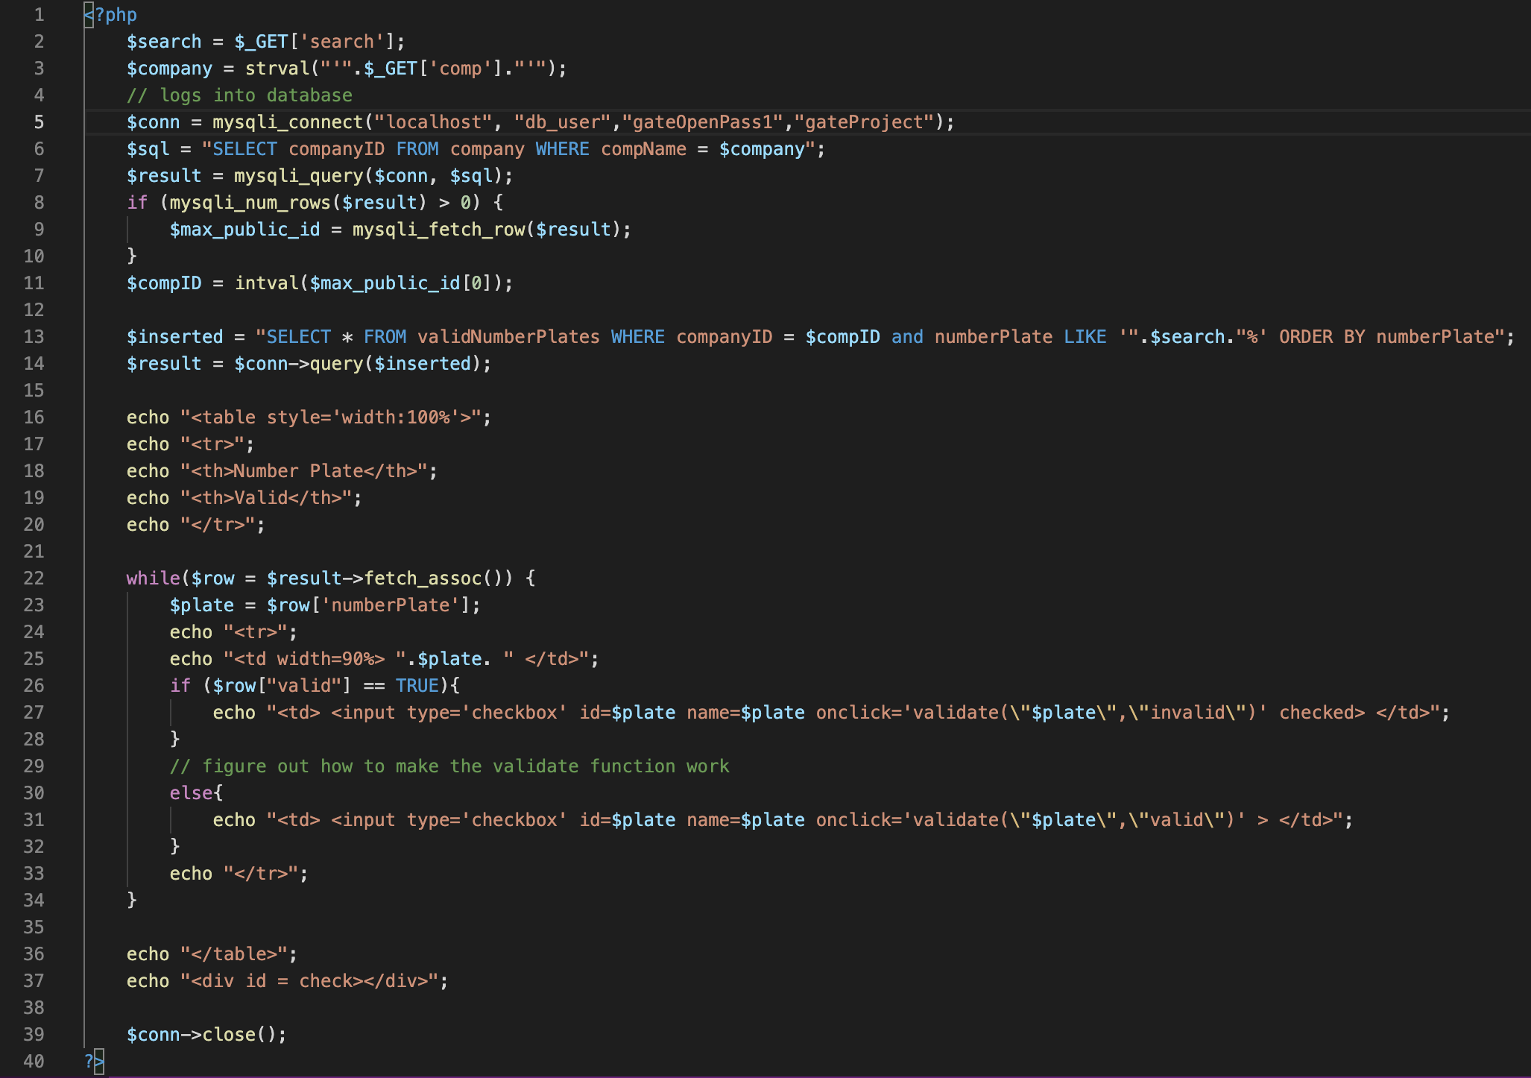

PHP file for sorting:

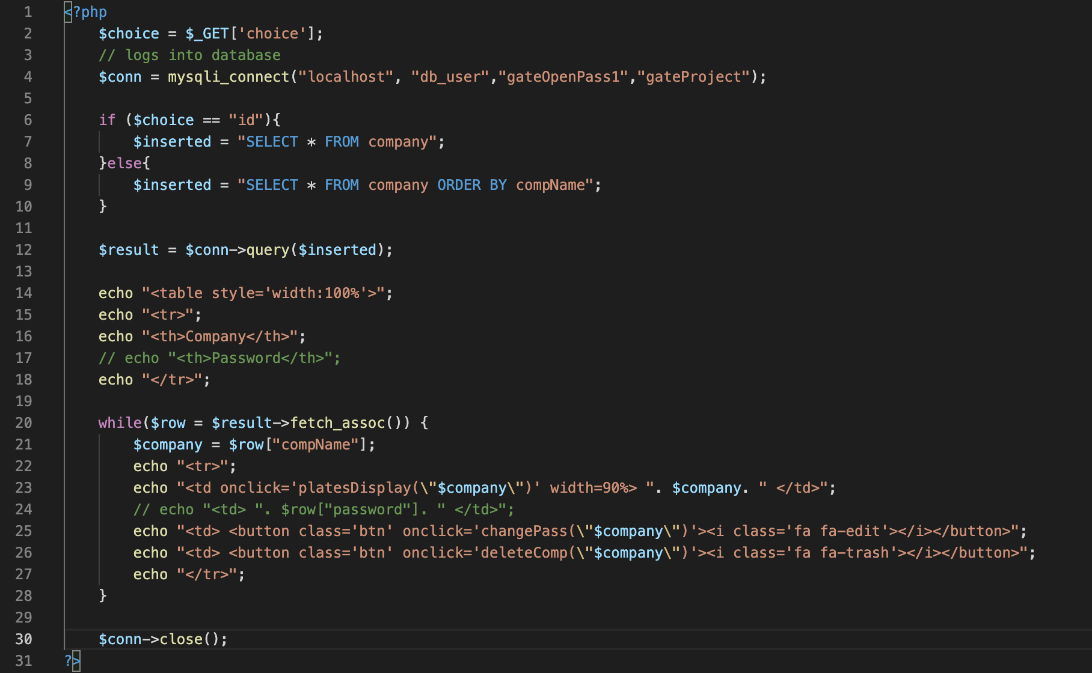

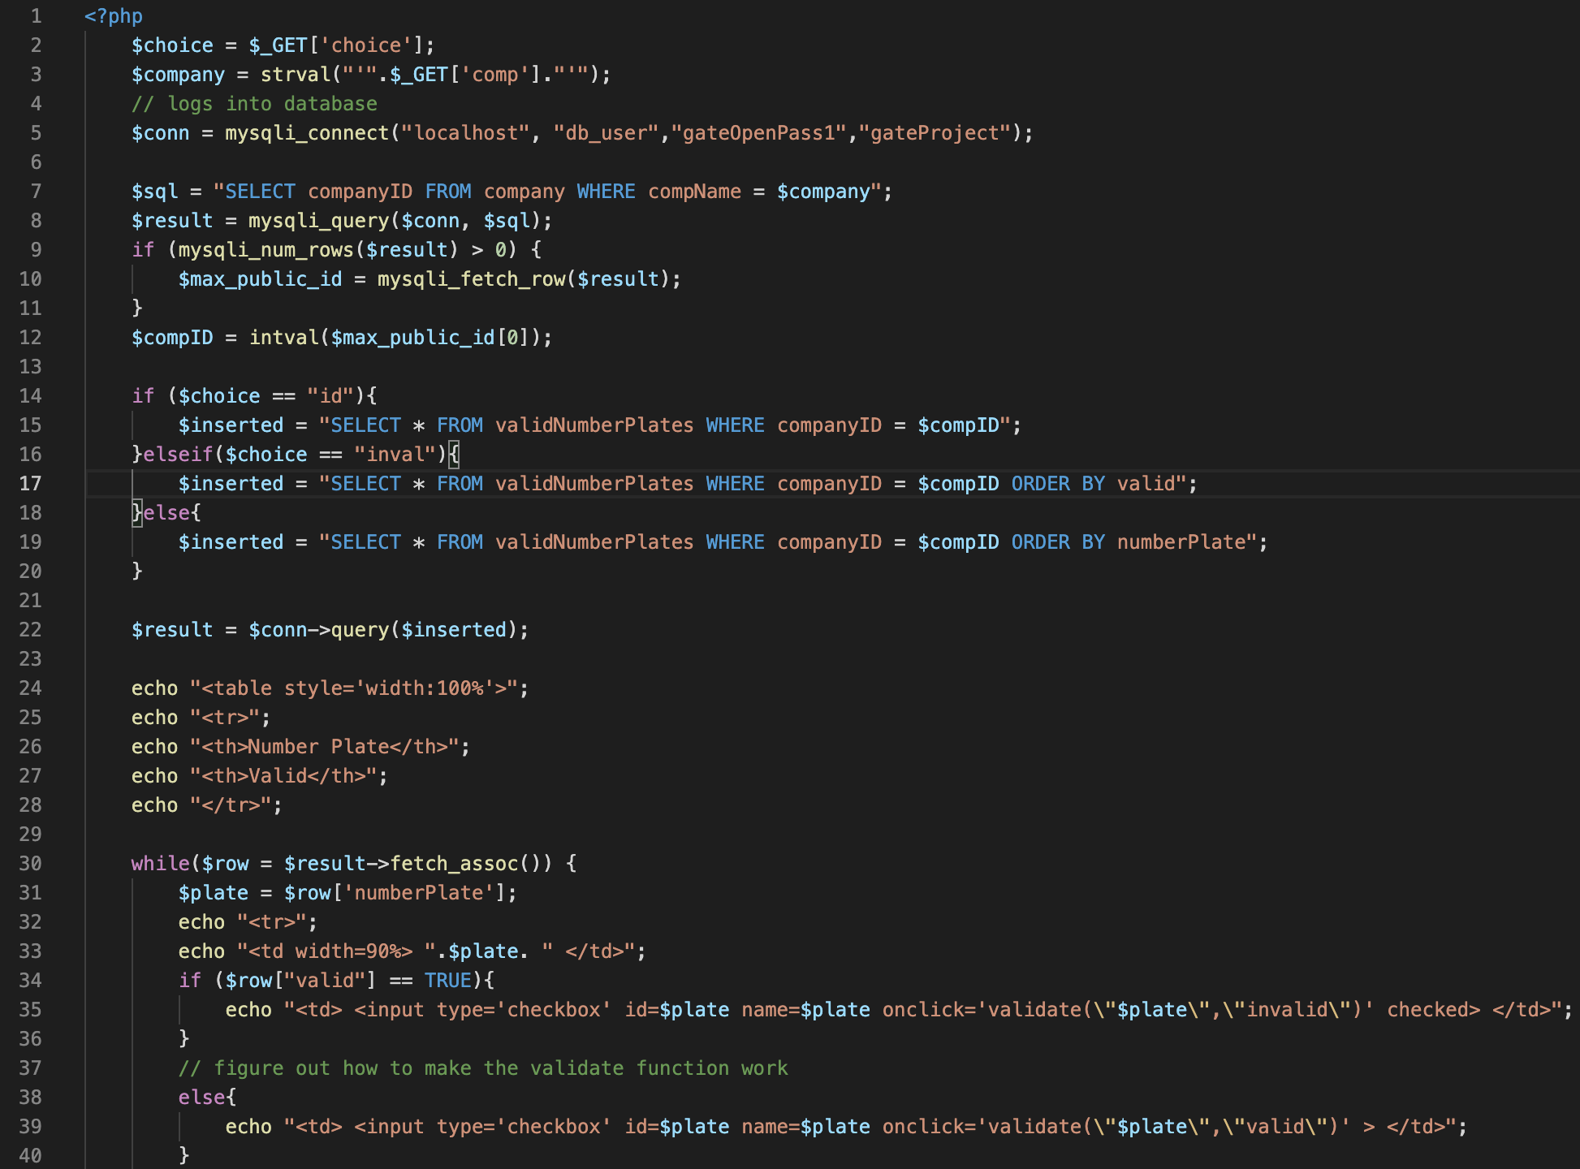

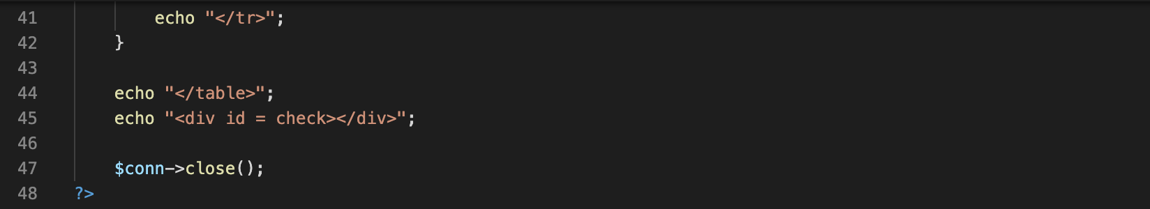

PHP file for deleting:

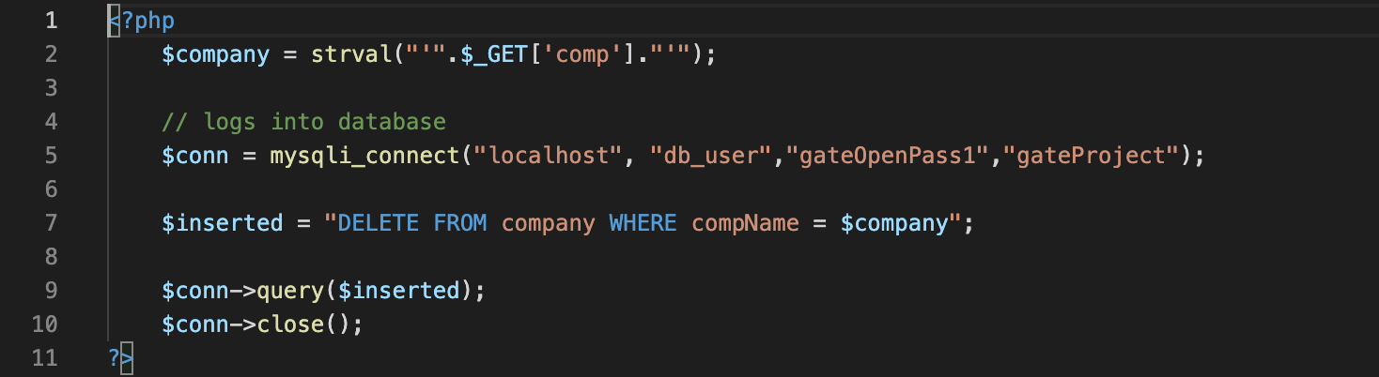

PHP for editing passwords, and PHP for making plates valid is in the PHP file found under the add number plate module.

Web View:

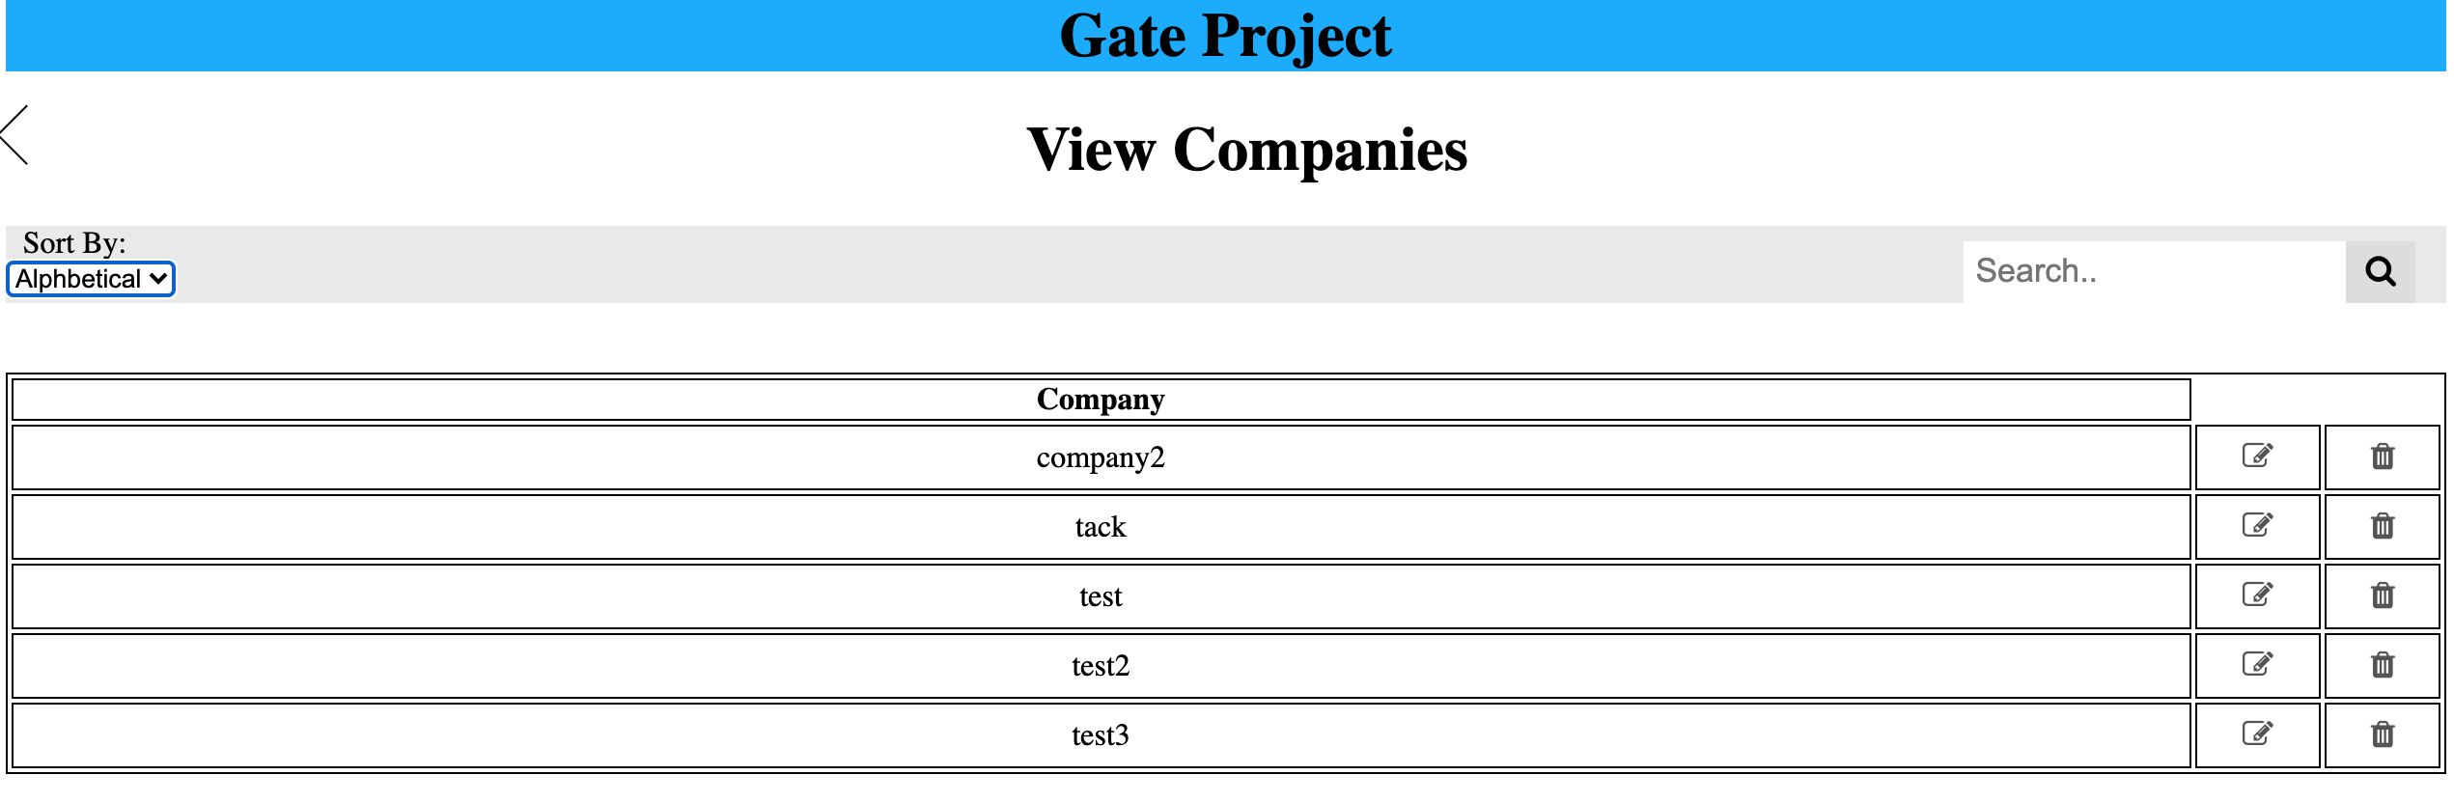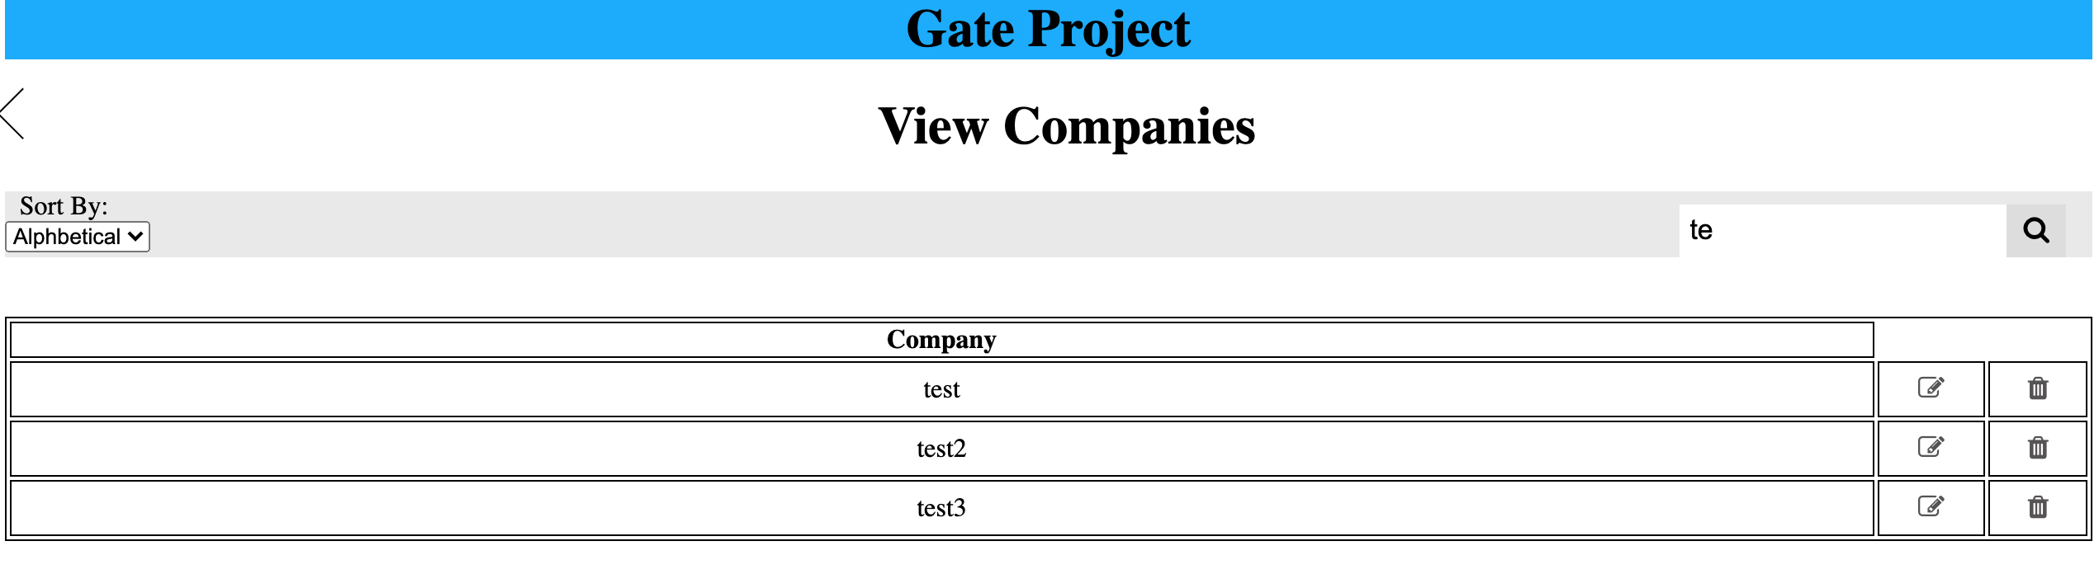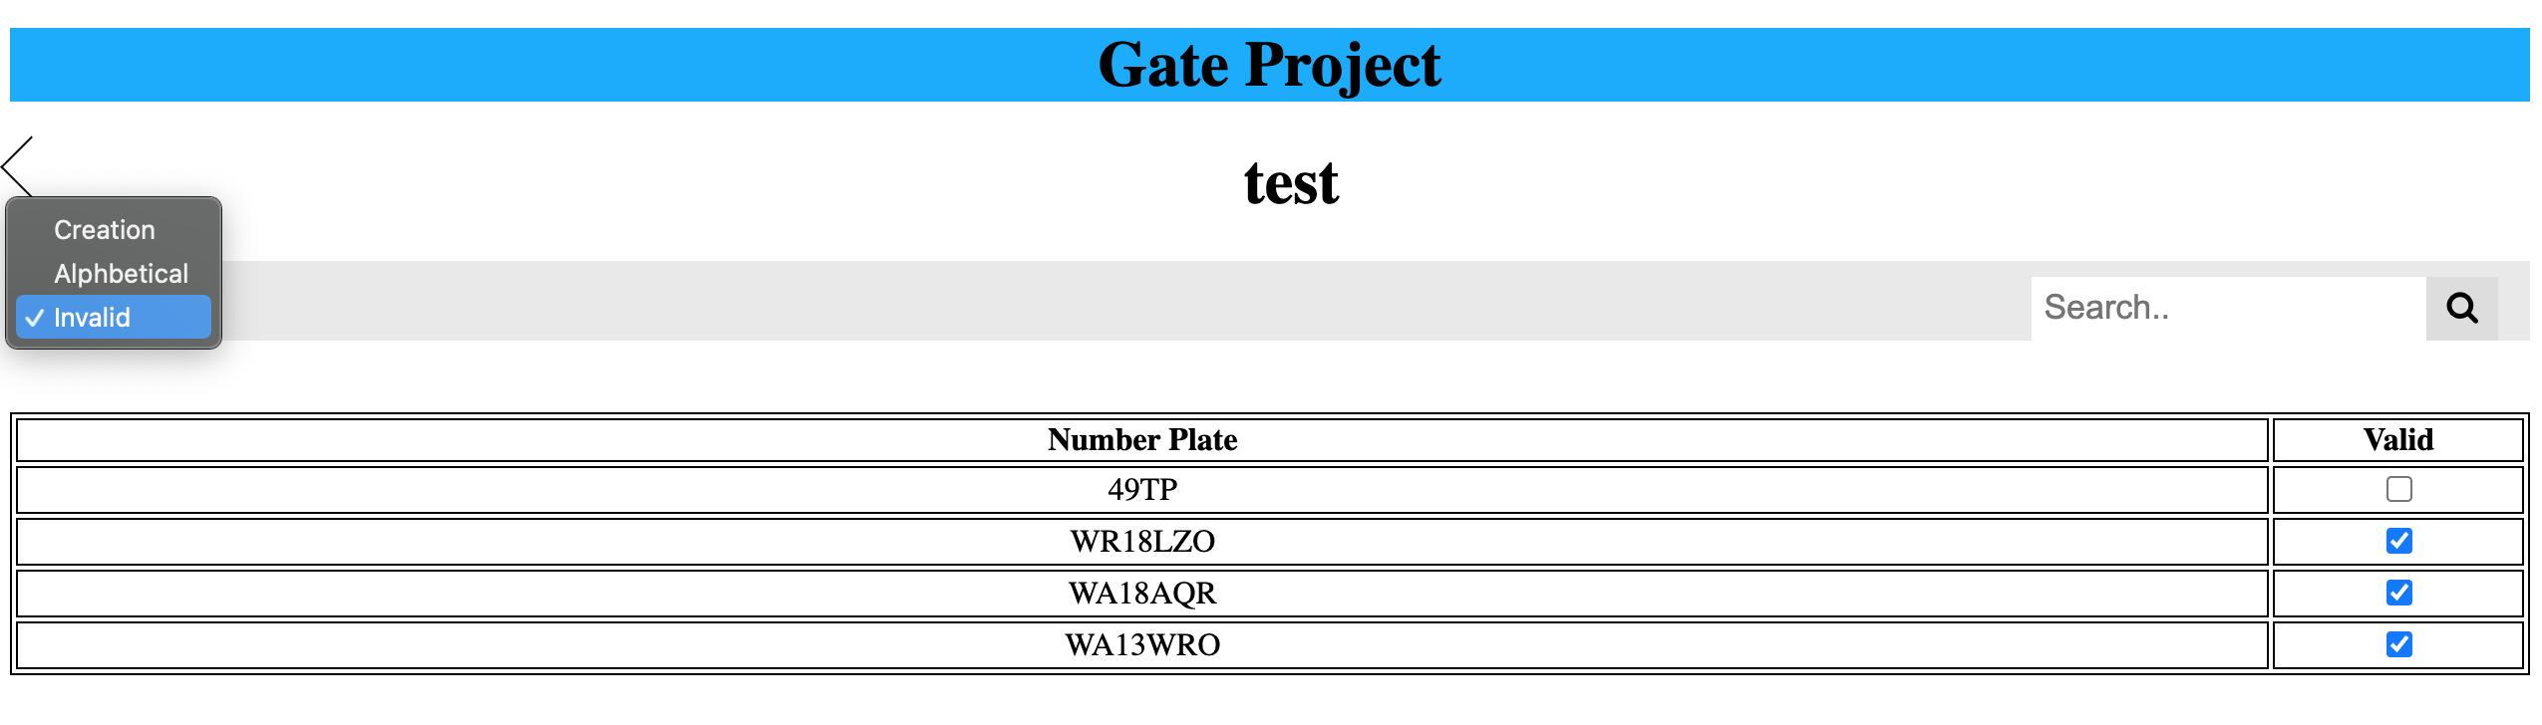

Problems

Due to me coding the database so referential integrity is maintained, deleting a company will either break this referential integrity or more likely delete all entry times for that company. This is a major issue as the primary user may recognise this company as an issue, e.g., if they are stealing, and may decide to delete them from the database to ensure they cannot continue doing this. However, in doing so this may delete the evidence of them entering the site, making it harder to link the company to the theft.

Solution

Later when time limitations are no longer an issue, I will need to test this to firstly ensure referential integrity is maintained and then I will need to code an archive entries database where the company name is saved rather than its primary key so it cannot be lost if the company is later deleted. This archive should be updated upon company deletion along with a weekly update to this archive. It should also delete data after 6 months rather than the usual 7 day loop the daily entries database runs off.

### App Side – Add number plate module

This page pretty much adds a number plate to a company. Weak points in this are the fact that a mistyped company will cause an error and number plates must have the space in the middle removed to work.

HTML file:

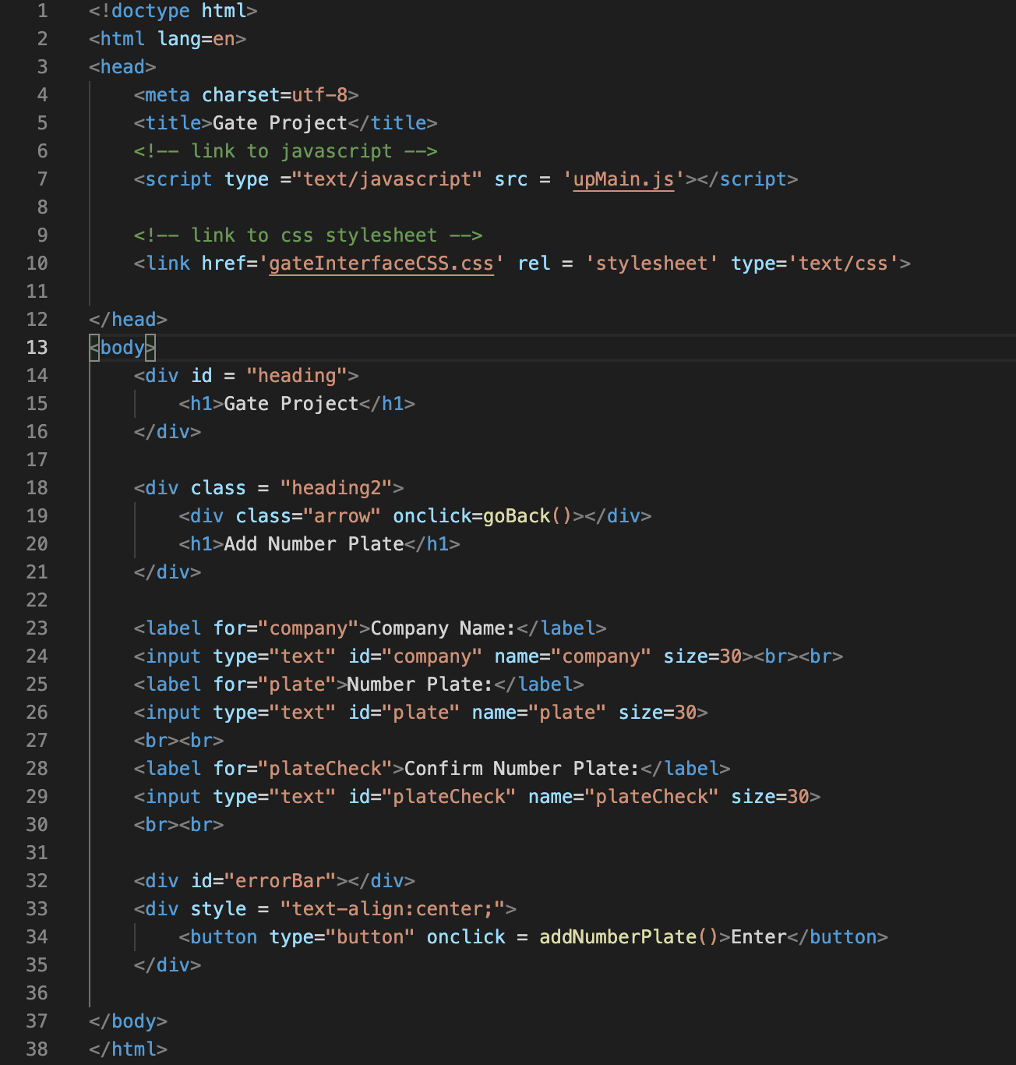

PHP file:

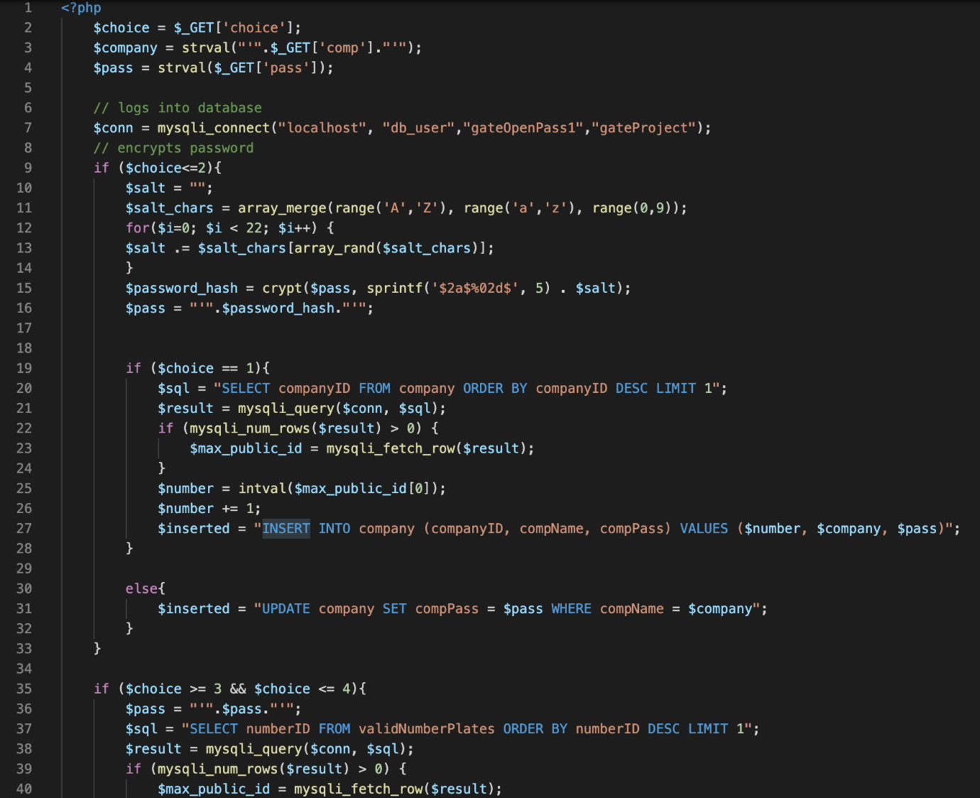

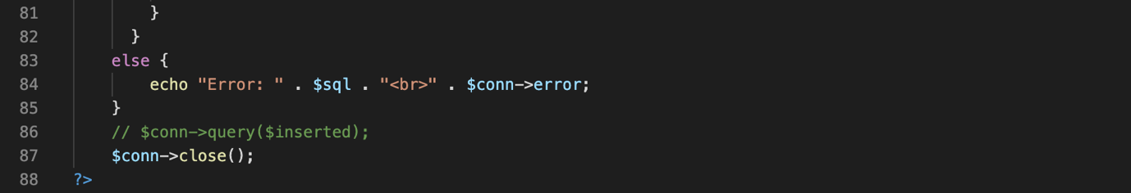

Web view:

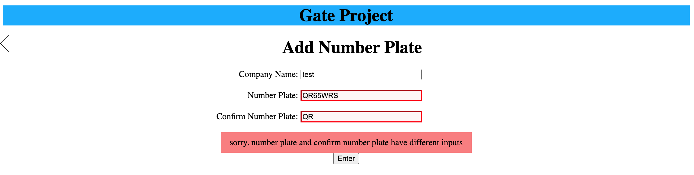

### App Side – View entries module

To code this section, I first moved all the code app side code onto the raspberry pi and created a server in apache2. However, after accidently turning of the pi’s power while the server was running, I came across an issue where the server will simply not start. After a while I examined the ports being used by the raspberry pi and found that the 8080 port was already in use, hence the Apache server could not use it. This was due to me having already installed a different server which was taking priority over the port, so I stopped this server and the Apache one started working.

Due to the gate project no longer being used at David’s site due to the prices of electronic gates I have not paid for a domain name and have instead kept the server local. Also due to time limitations I have not made the CSS look very nice on the page, but I will likely go back and improve this to put in my coding CV.

I created a view entries page with a similar format to the view company page, showing the number plate (or showing the gate was opened through the app), company, time and date. However, this page is unordered, and sort and search button do not work.

HTML/PHP file:

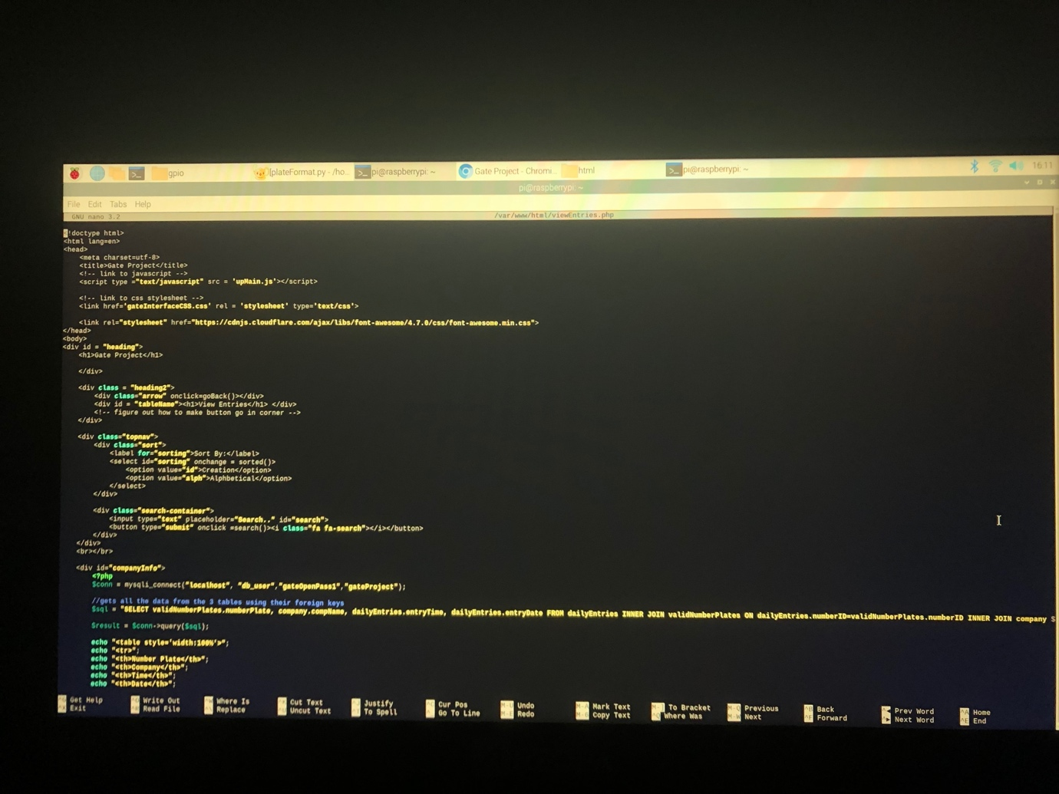

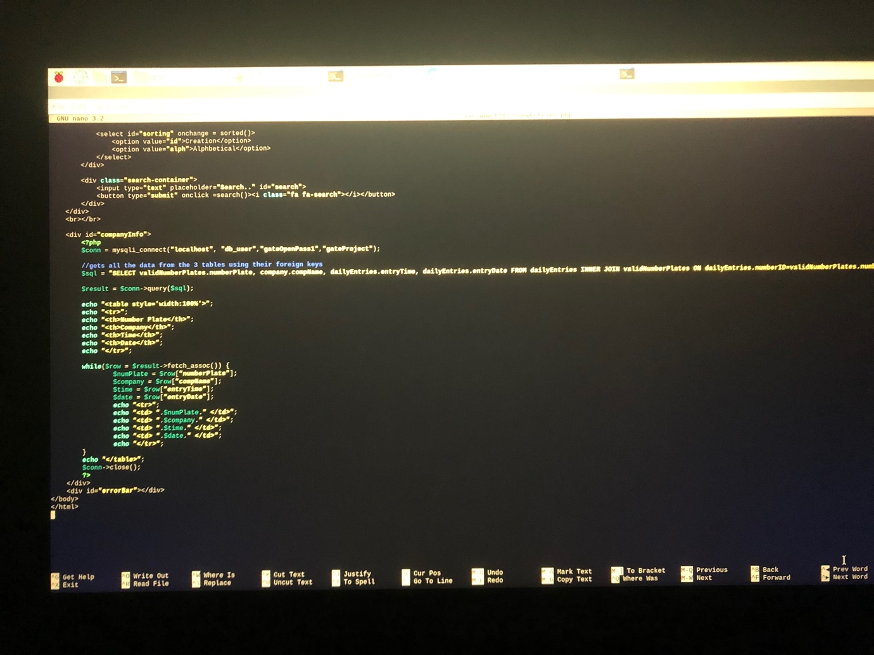

### App Side – View entries final iteration

First, I added in some code so that the view entries page would not display app1 and would instead display App Entry when used

HTML/PHP file:

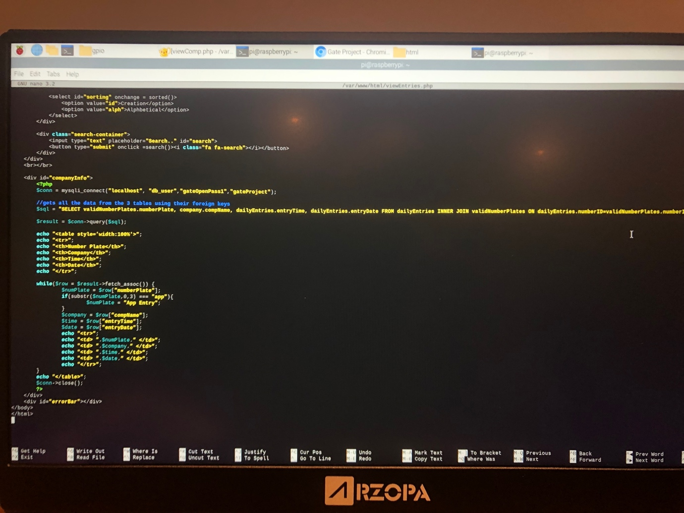

Changed the viewEntries.php page so that if something is searched for it will call the appropriate functions, the same goes for sorting. I also changed the formatting, so it now displays the most recent entry first.

HTML/PHP file:

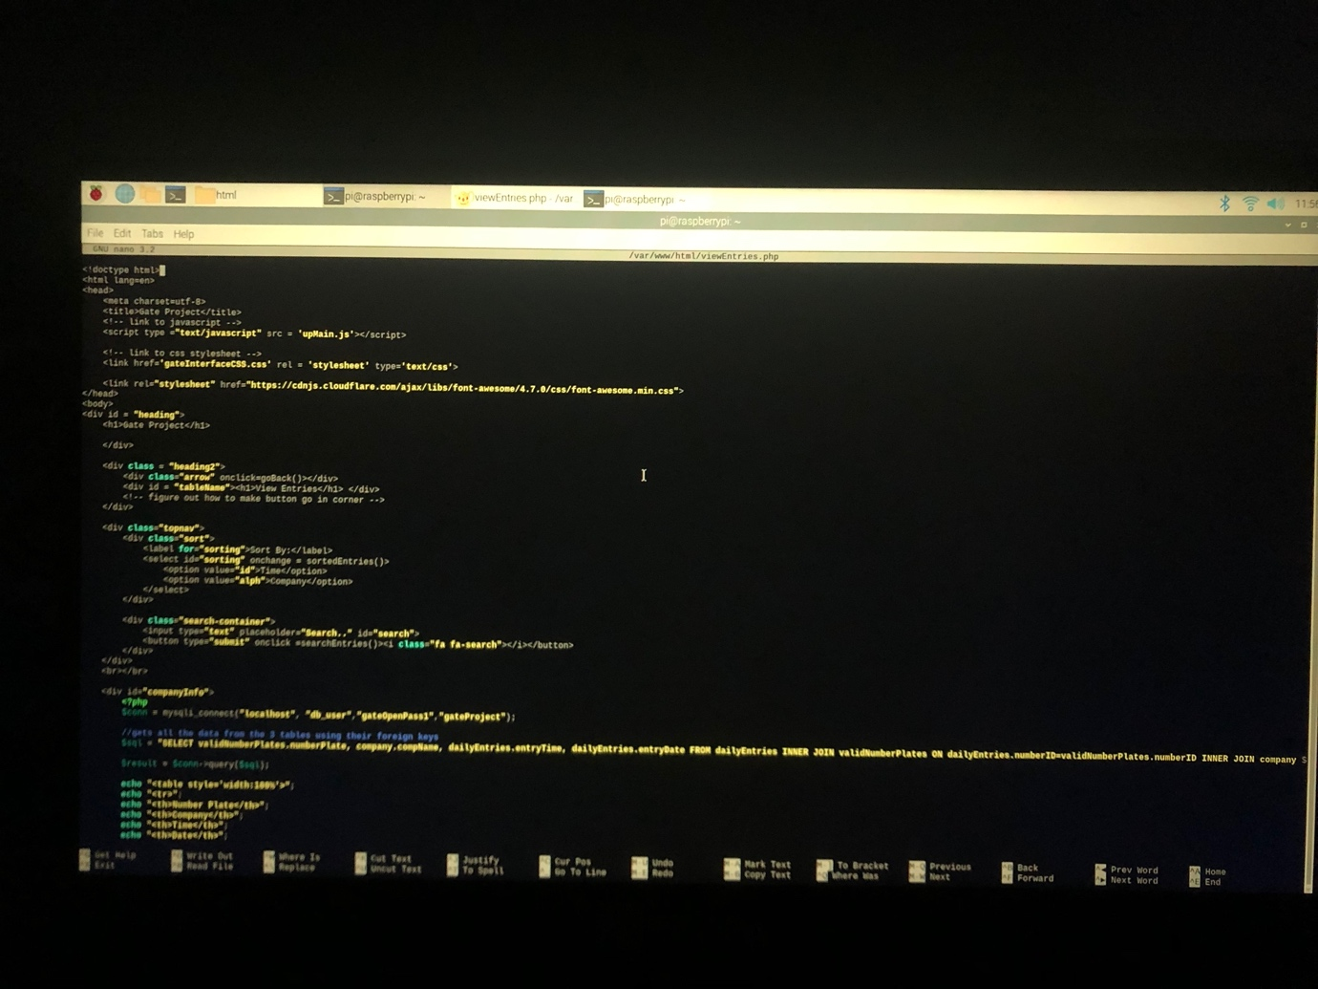

Sort entries PHP file:

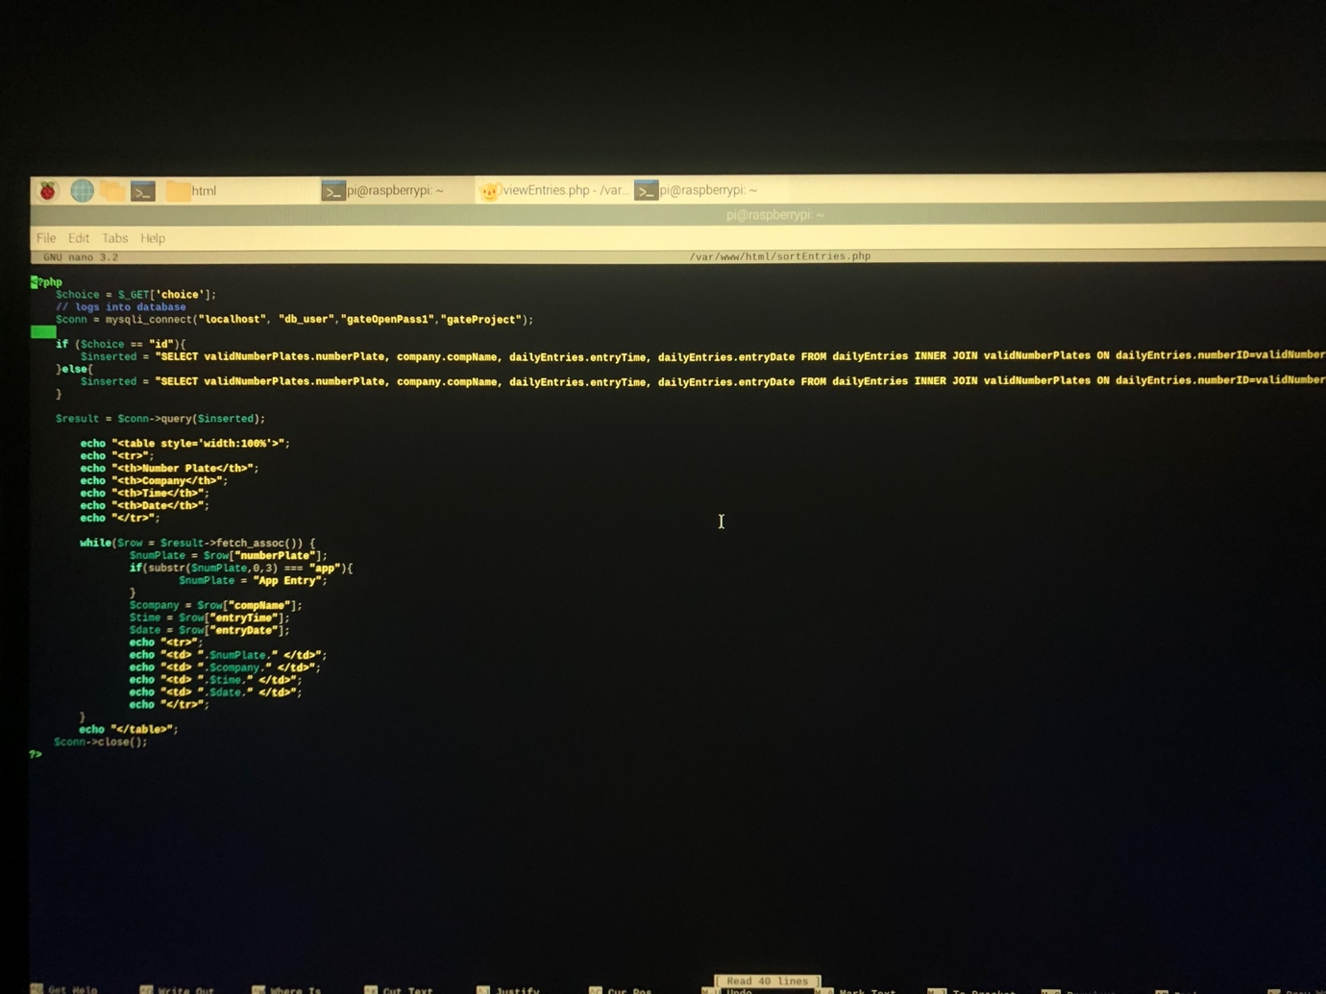

Search entries PHP file:

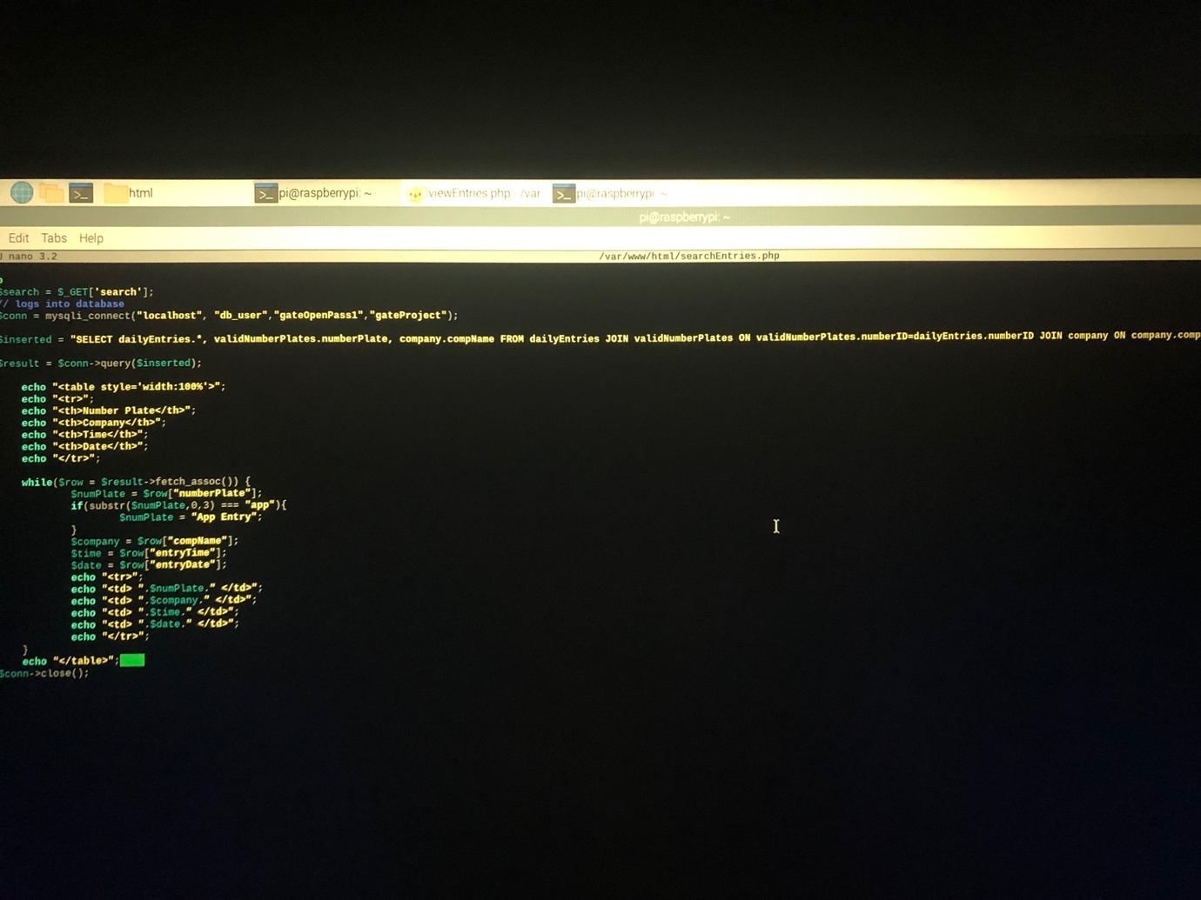

JavaScript for sort and search functions file:

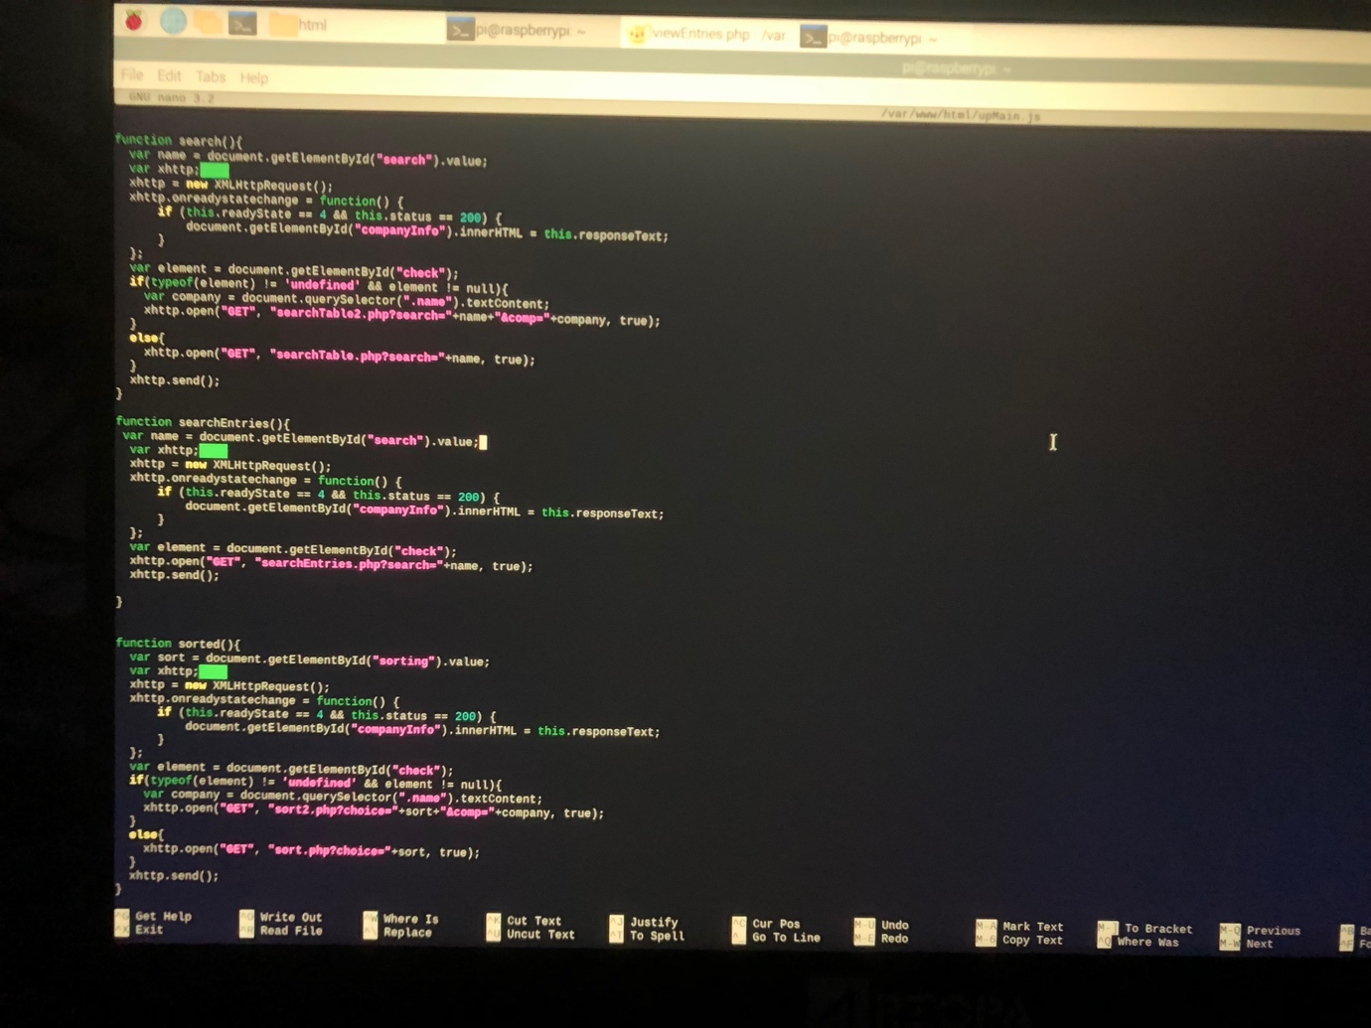

Web view:

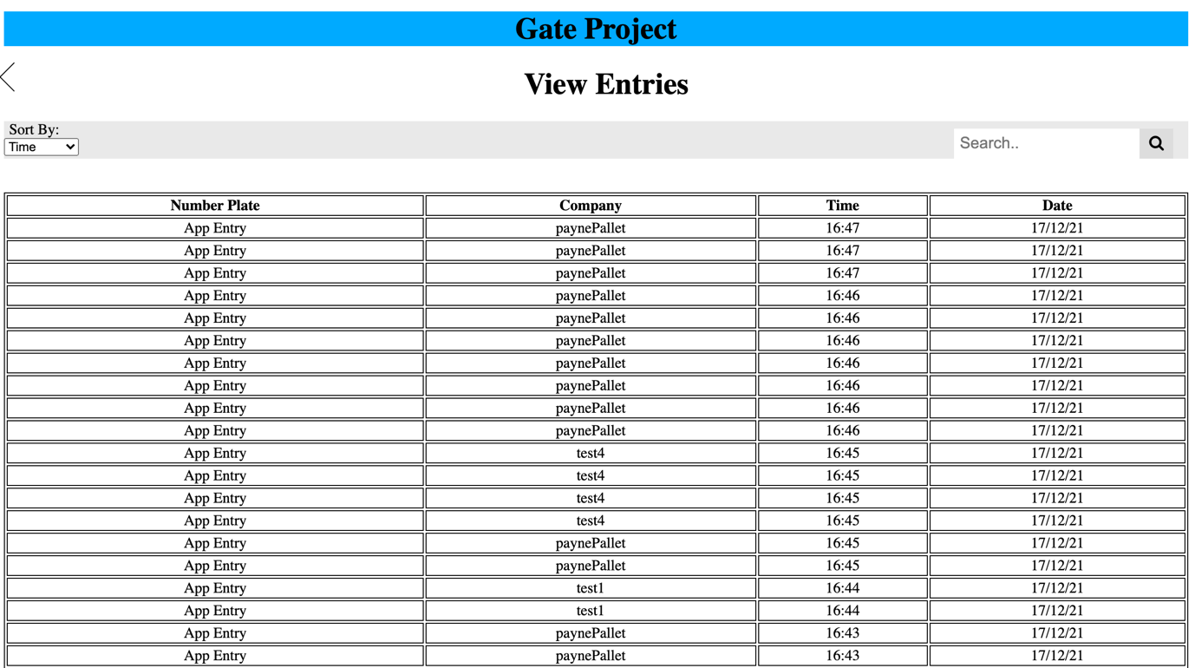

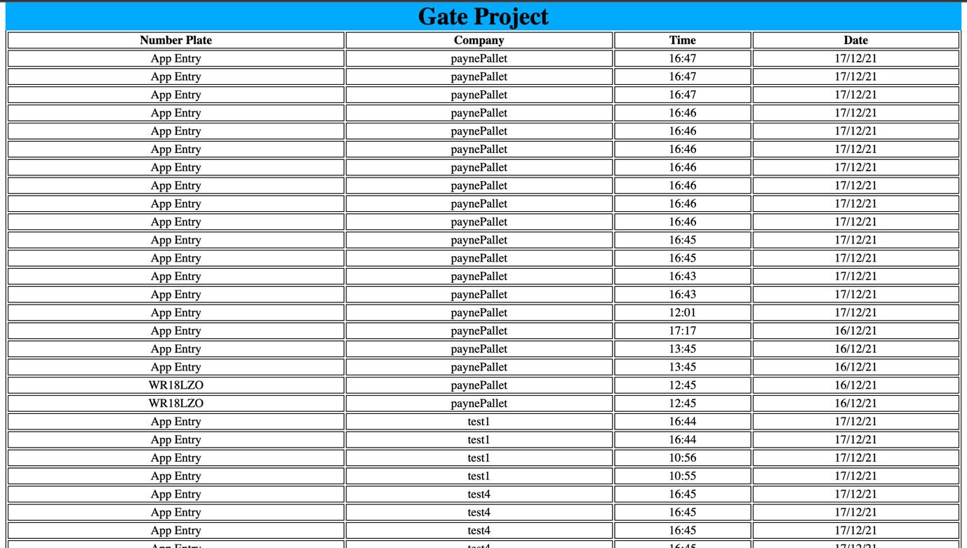

### App Side – Open gate module

Added in some code to the upMain.html page so clicking the green button will call the JavaScript function which calls the php script to turn on the LED (gate) and log the entry under the user. At this point it only works for David’s page

PHP file:

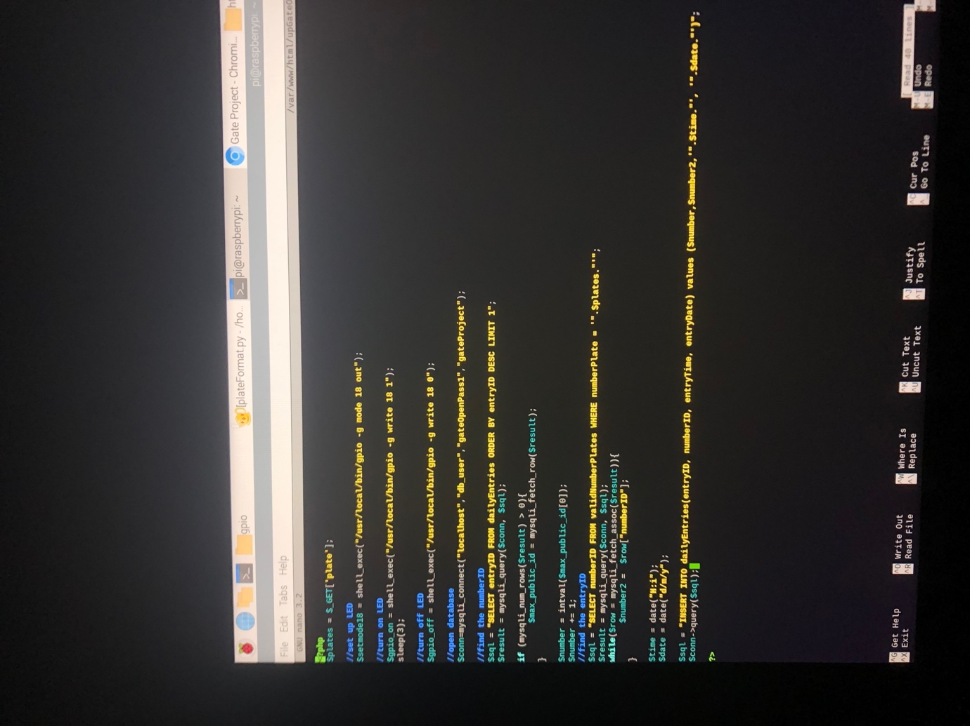

To ensure opening the gate through the app would still link to the relevant company I added in some code which would create a unique entry ID of the app + the company’s primary key. To do this I added in a section of code to the add company module.

PHP file:

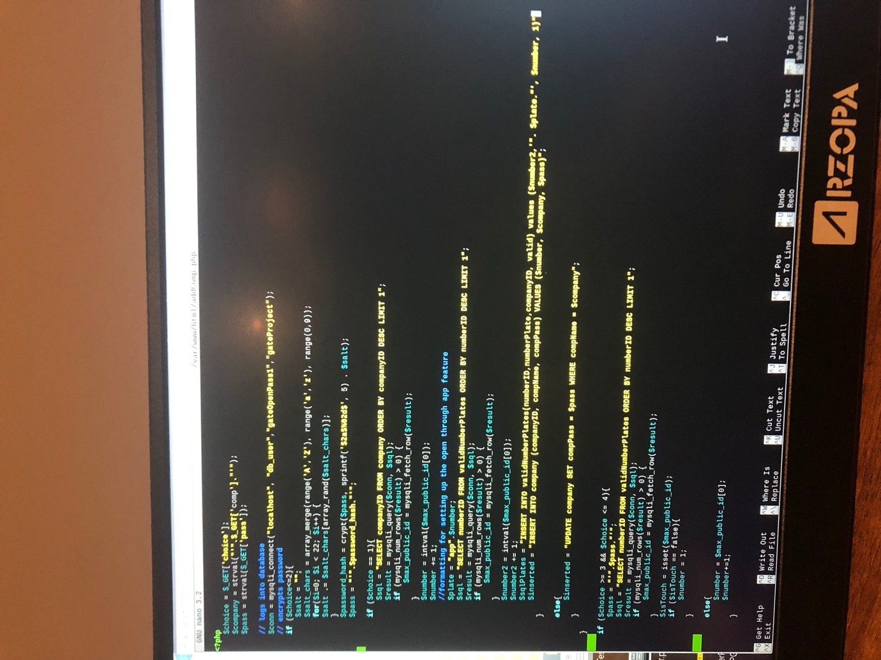

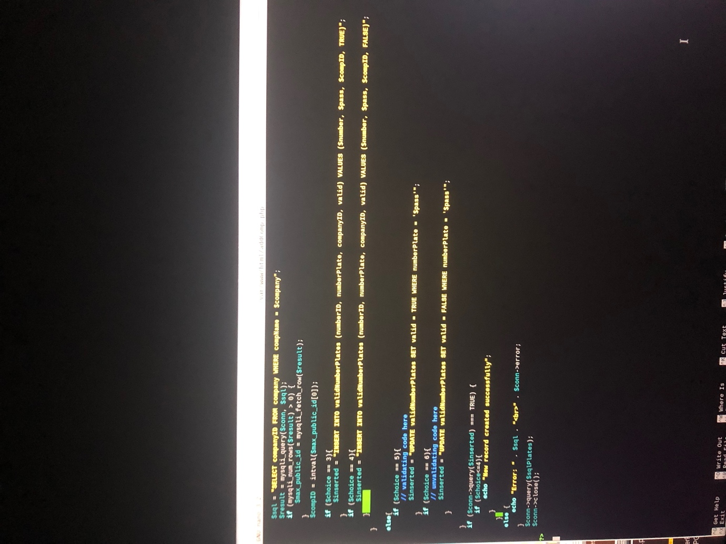

I then changed the code on the display number plates section of the view companies module so that it hides the unique app entry from the end user to ensure they do not invalidate it.

PHP/HTML file:

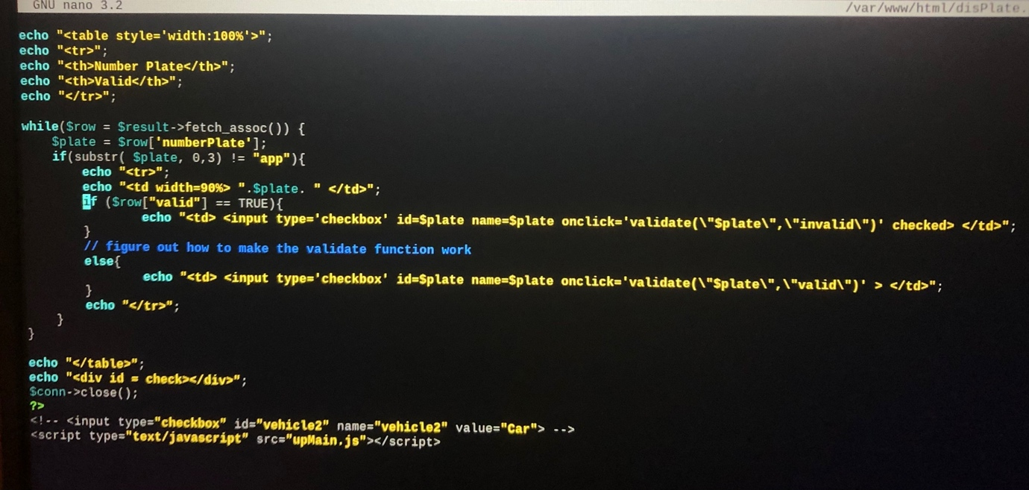

Getting it working for the other users

To ensure the correct app ID was used for secondary users I added in some code to the login page so that the metadata of the company that logged in would be stored in the URL.

JavaScript file:

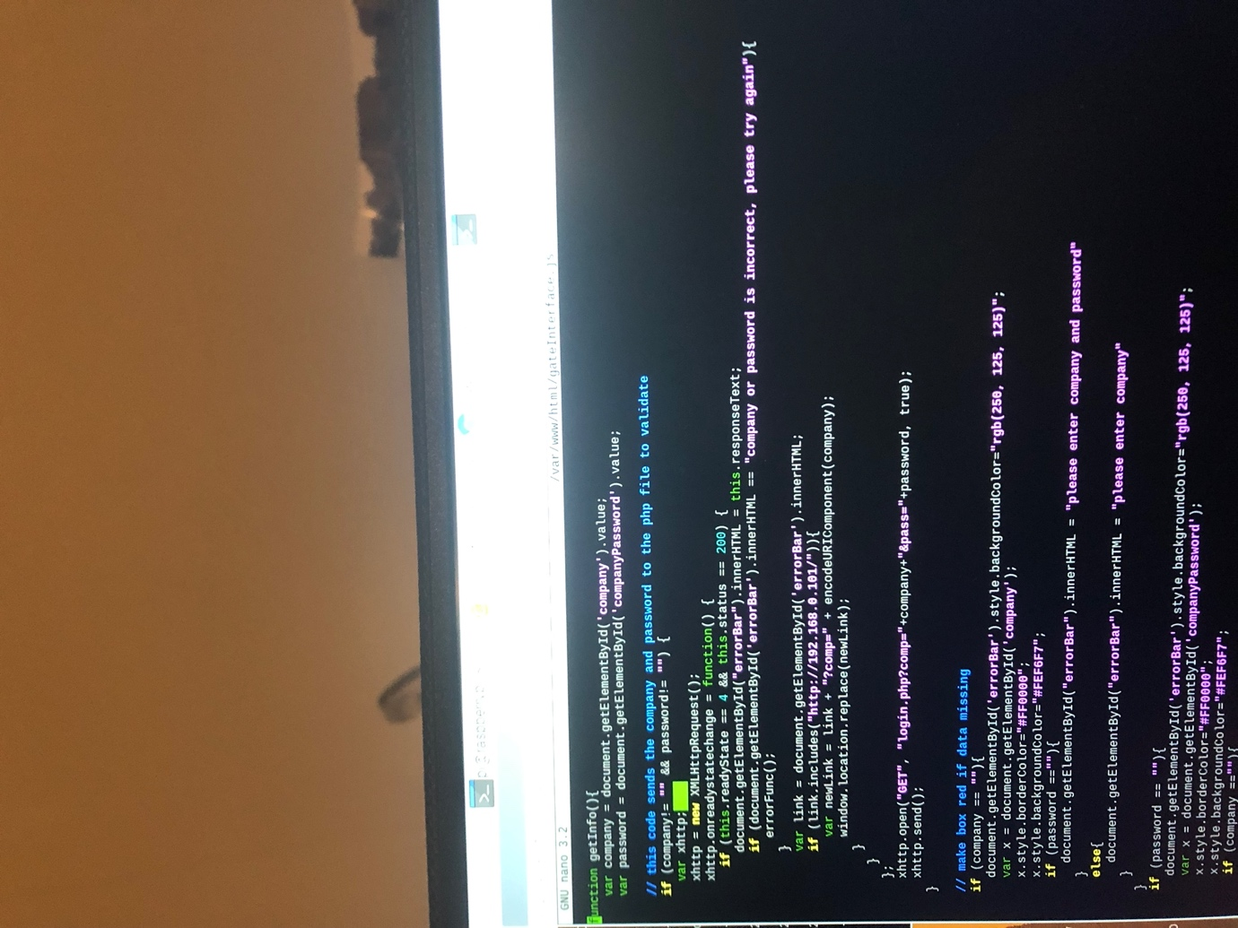

I then had to code some more JavaScript to extract the data from the URL upon button click. I also added in some code the PHP file responsible for opening the gate so that it would now also work for the secondary users.

PHP file:

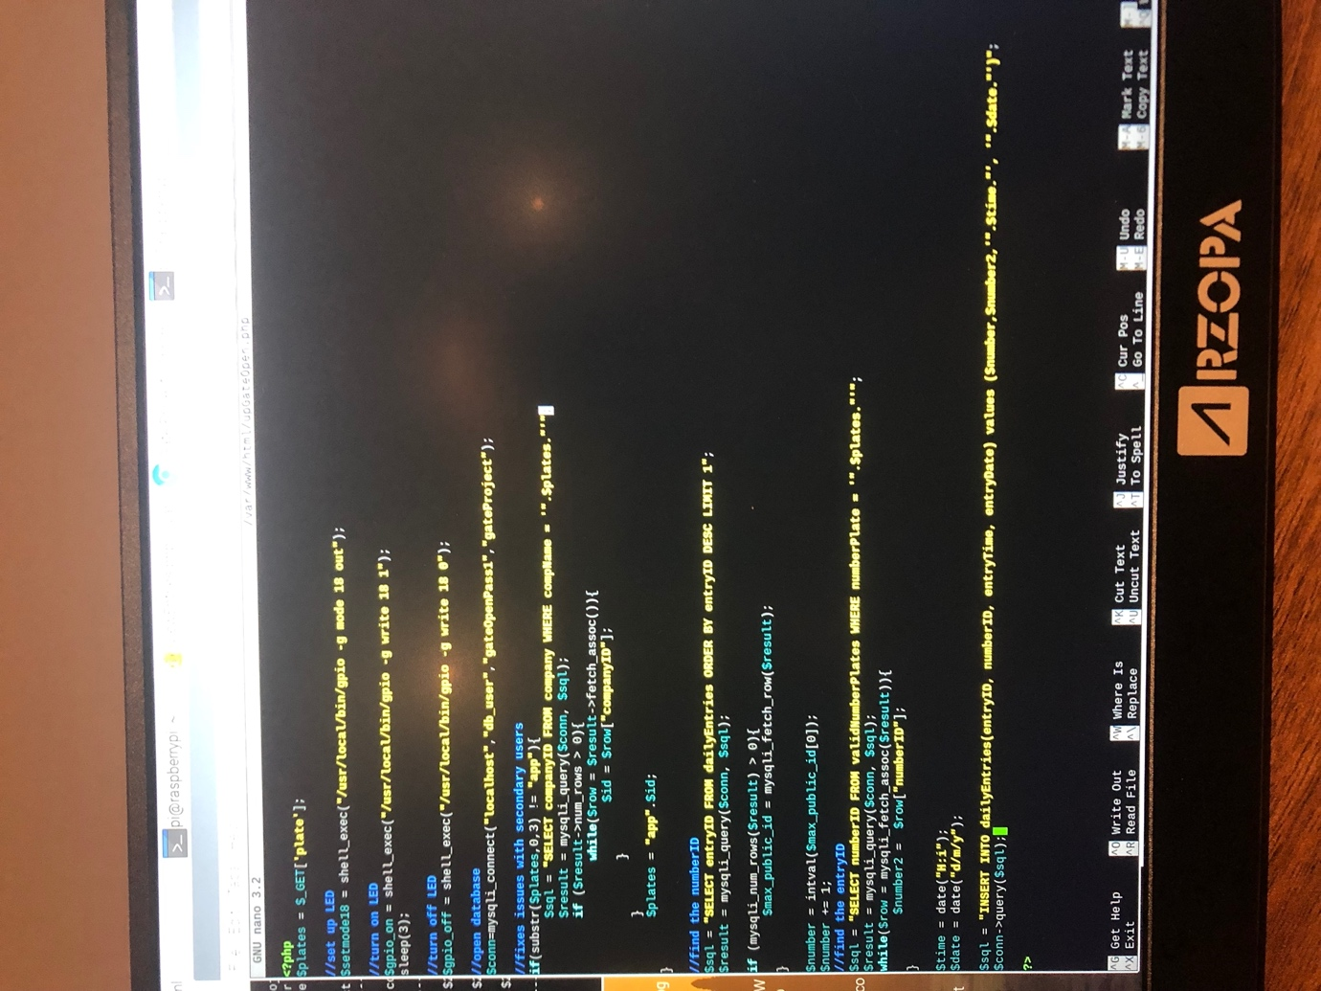

JavaScript file:

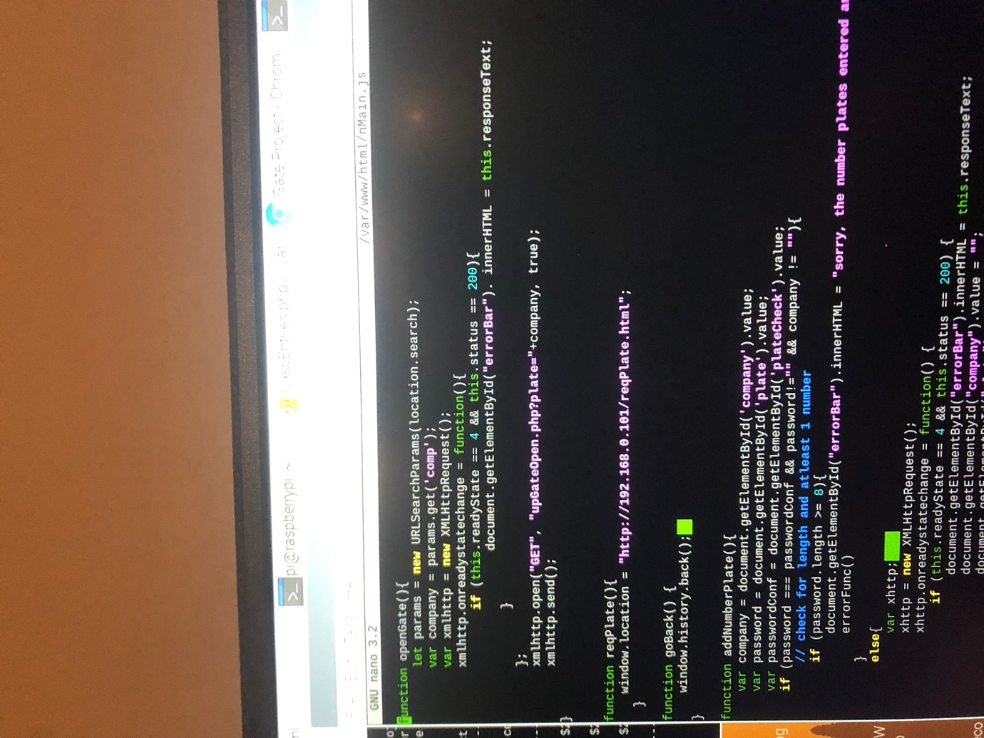

### App Side – JavaScript for primary users page

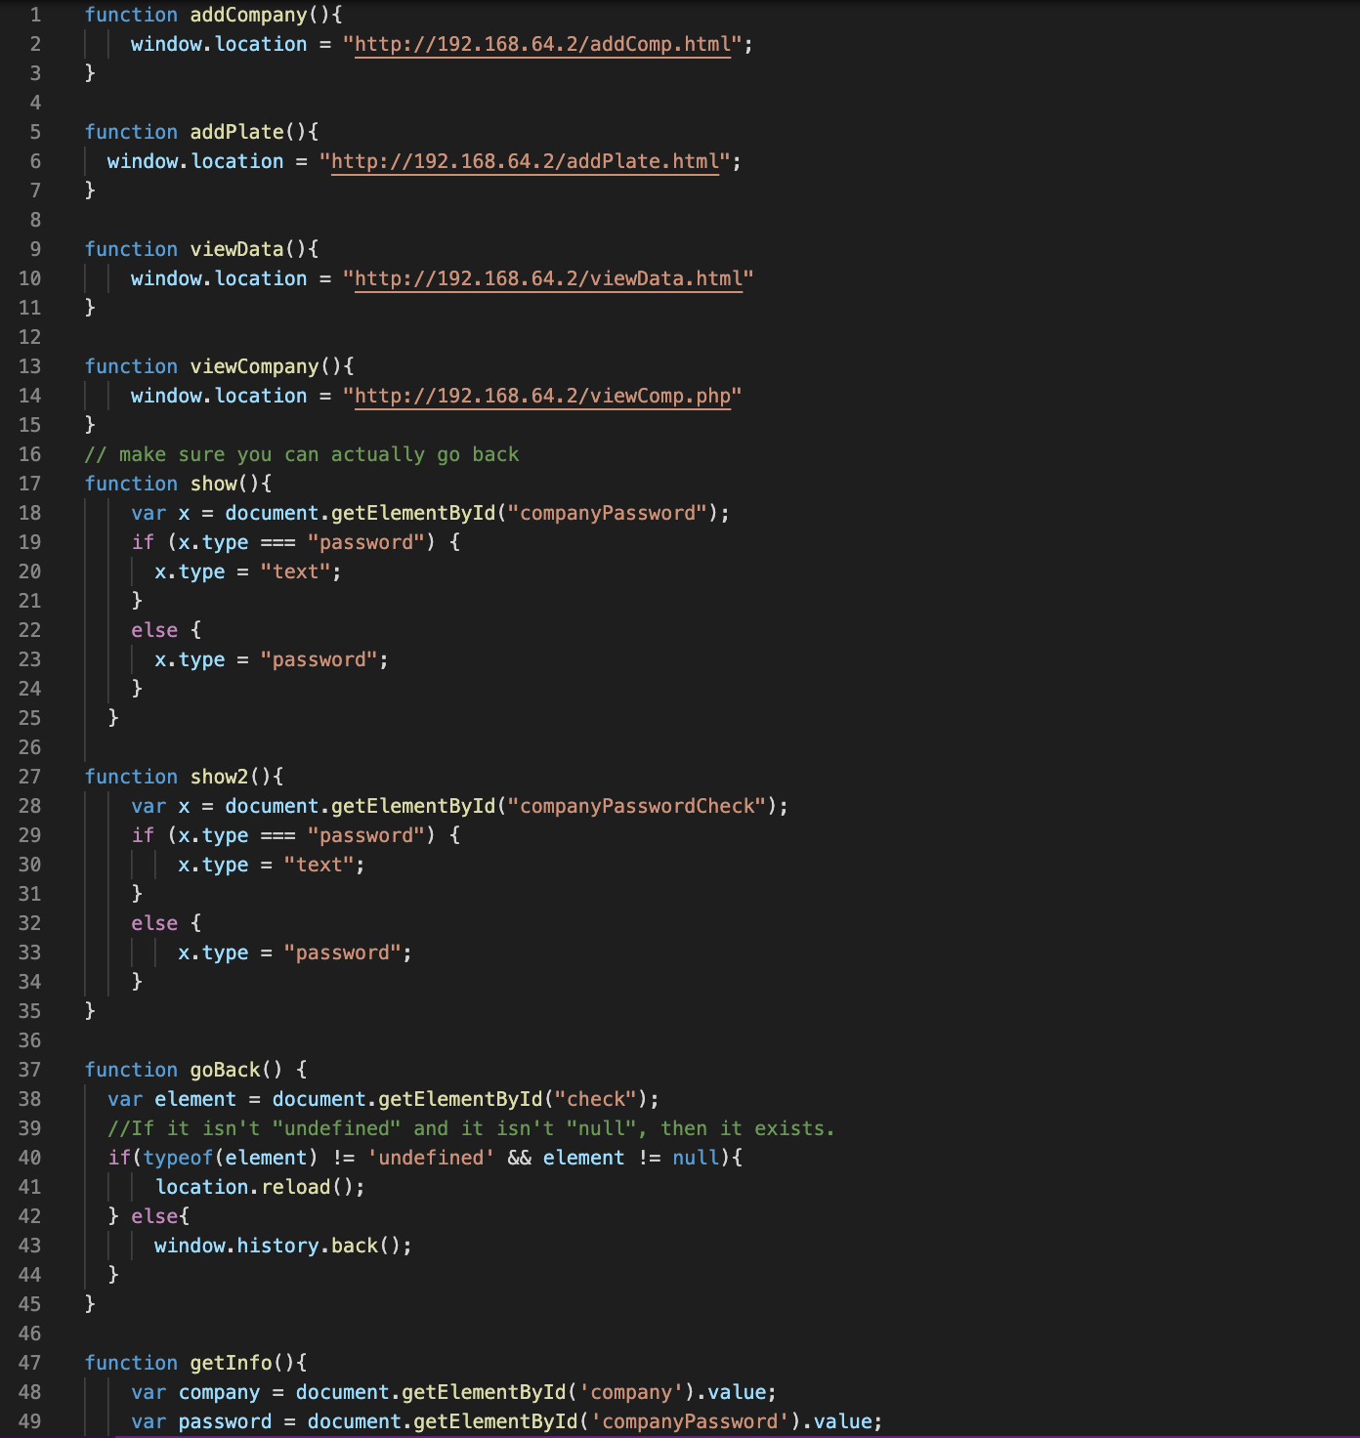

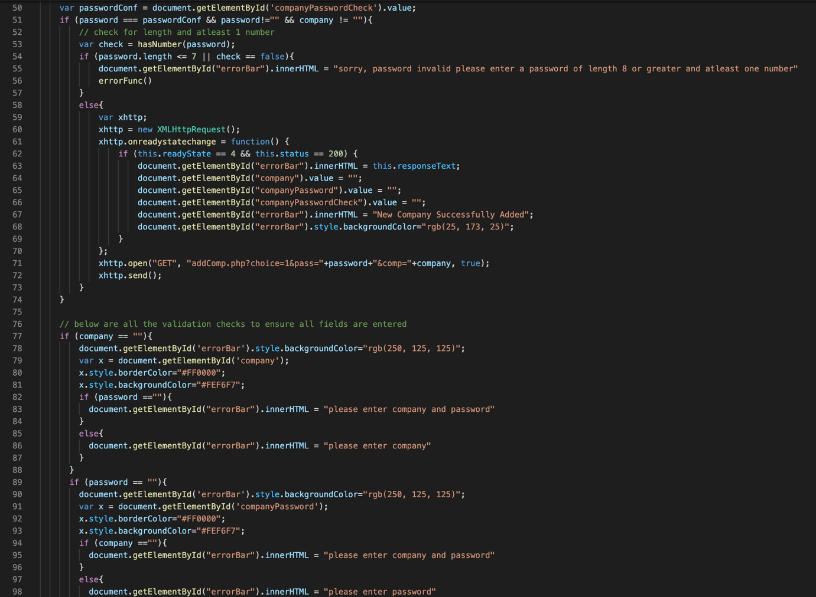

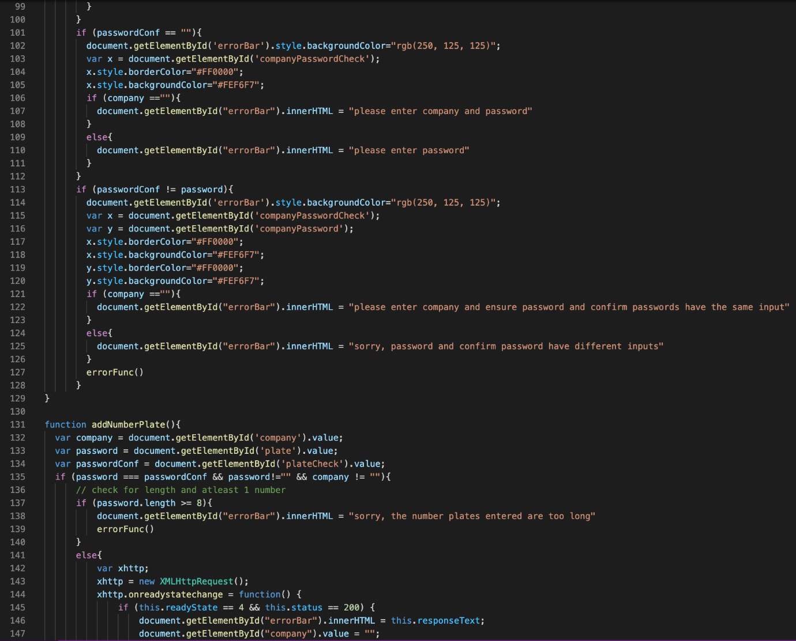

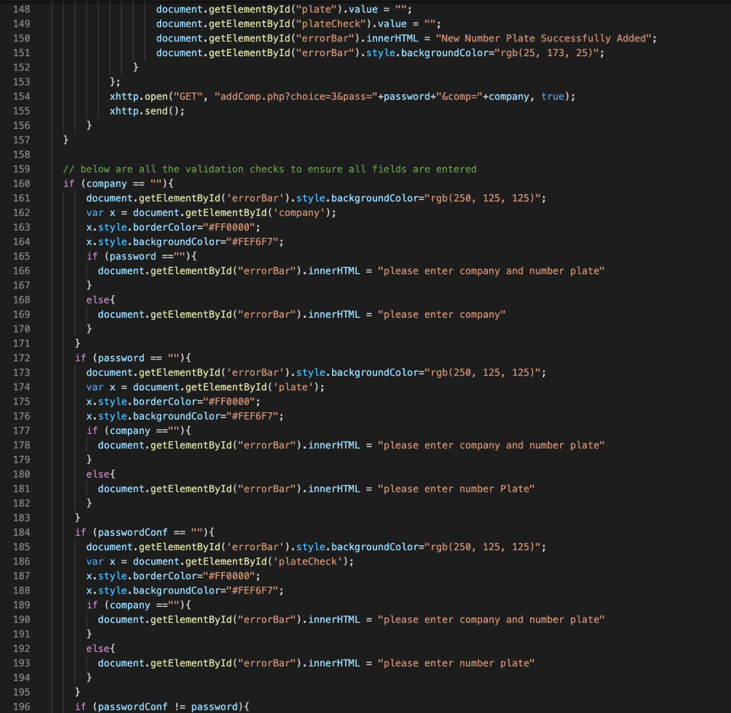

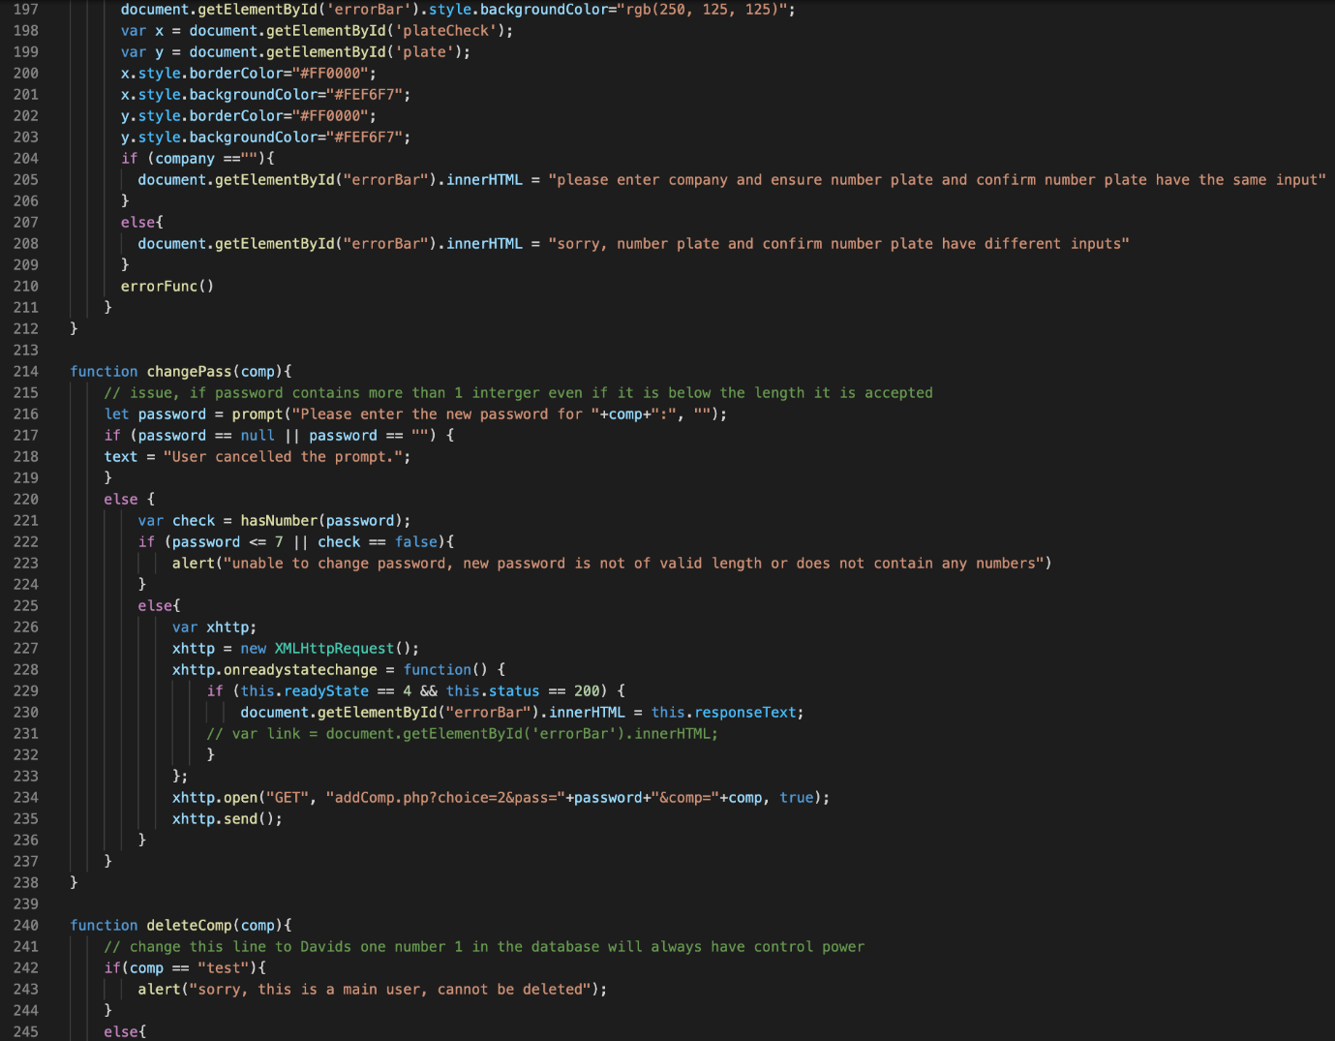

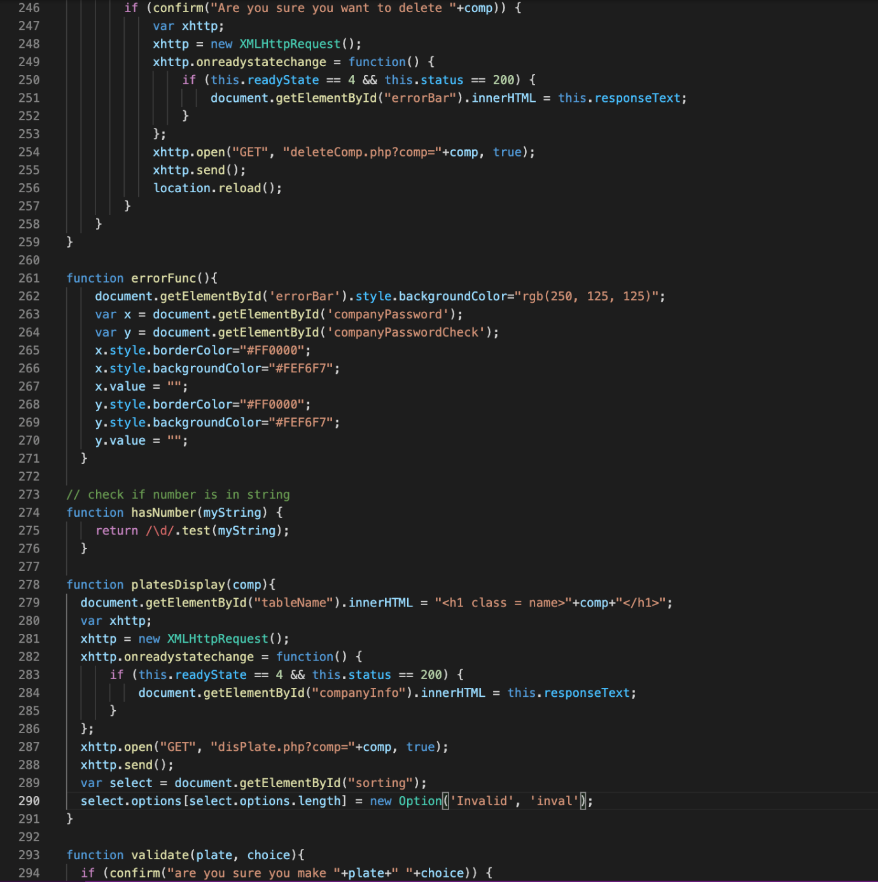

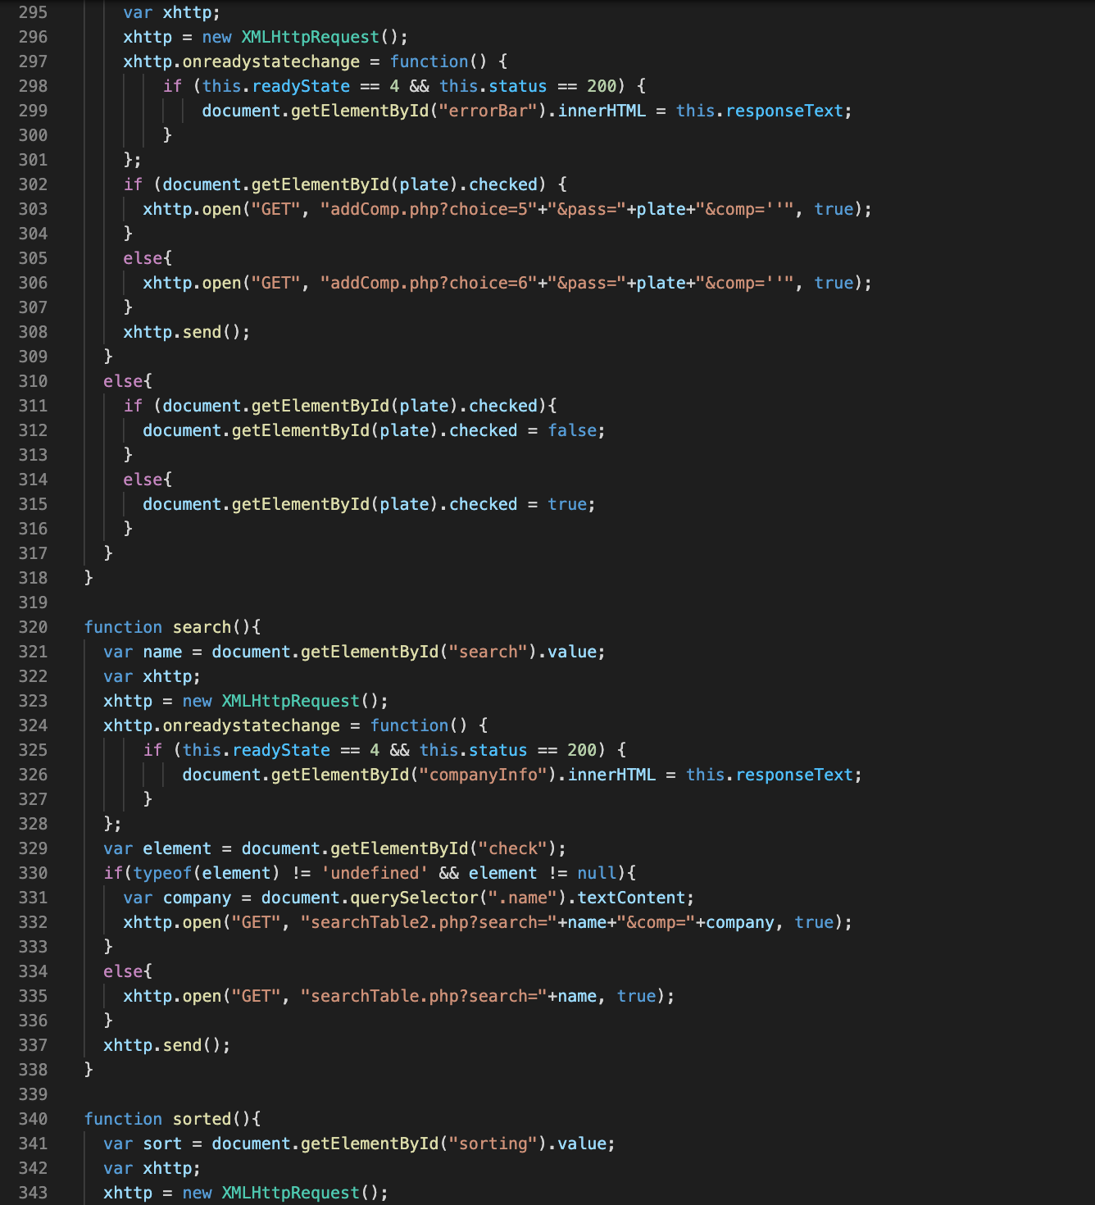

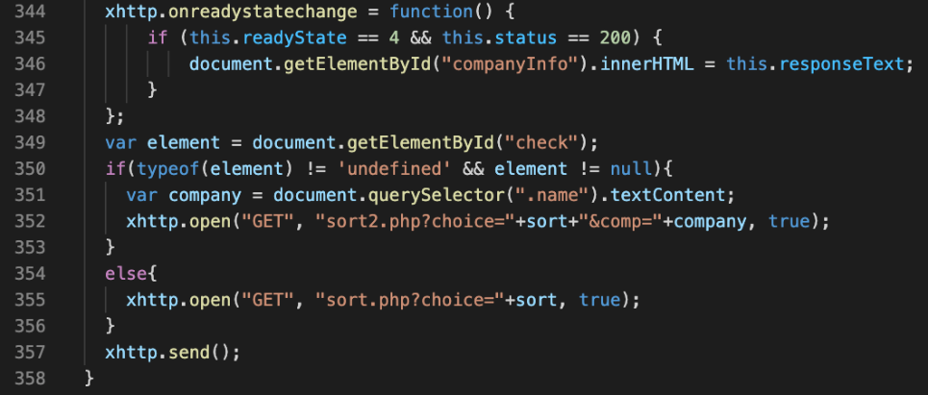

Validation checks

* line 51 – presence check for password and company
* line 54 – length check for password
* line 135 – presence check for number plate and company
* line 137 – length check for number plate
* line 217 – presence check for password
* line 222 – length check for password

### App Side – Secondary users home screen module

This is a pretty simple page to make it was mainly copying the code from the primary user page then removing some key features

HTML file:

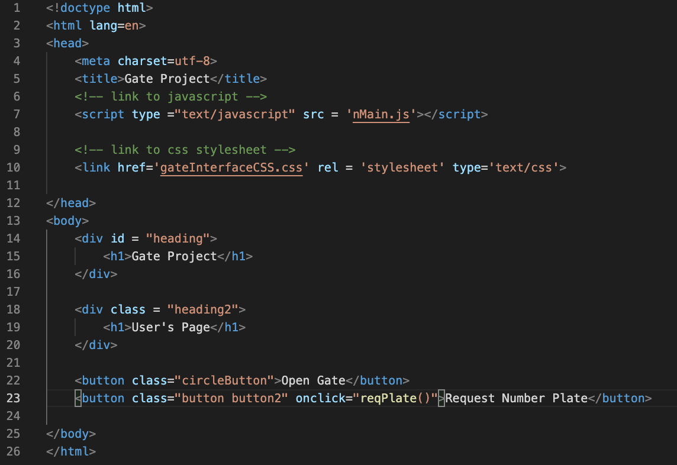

Web view:

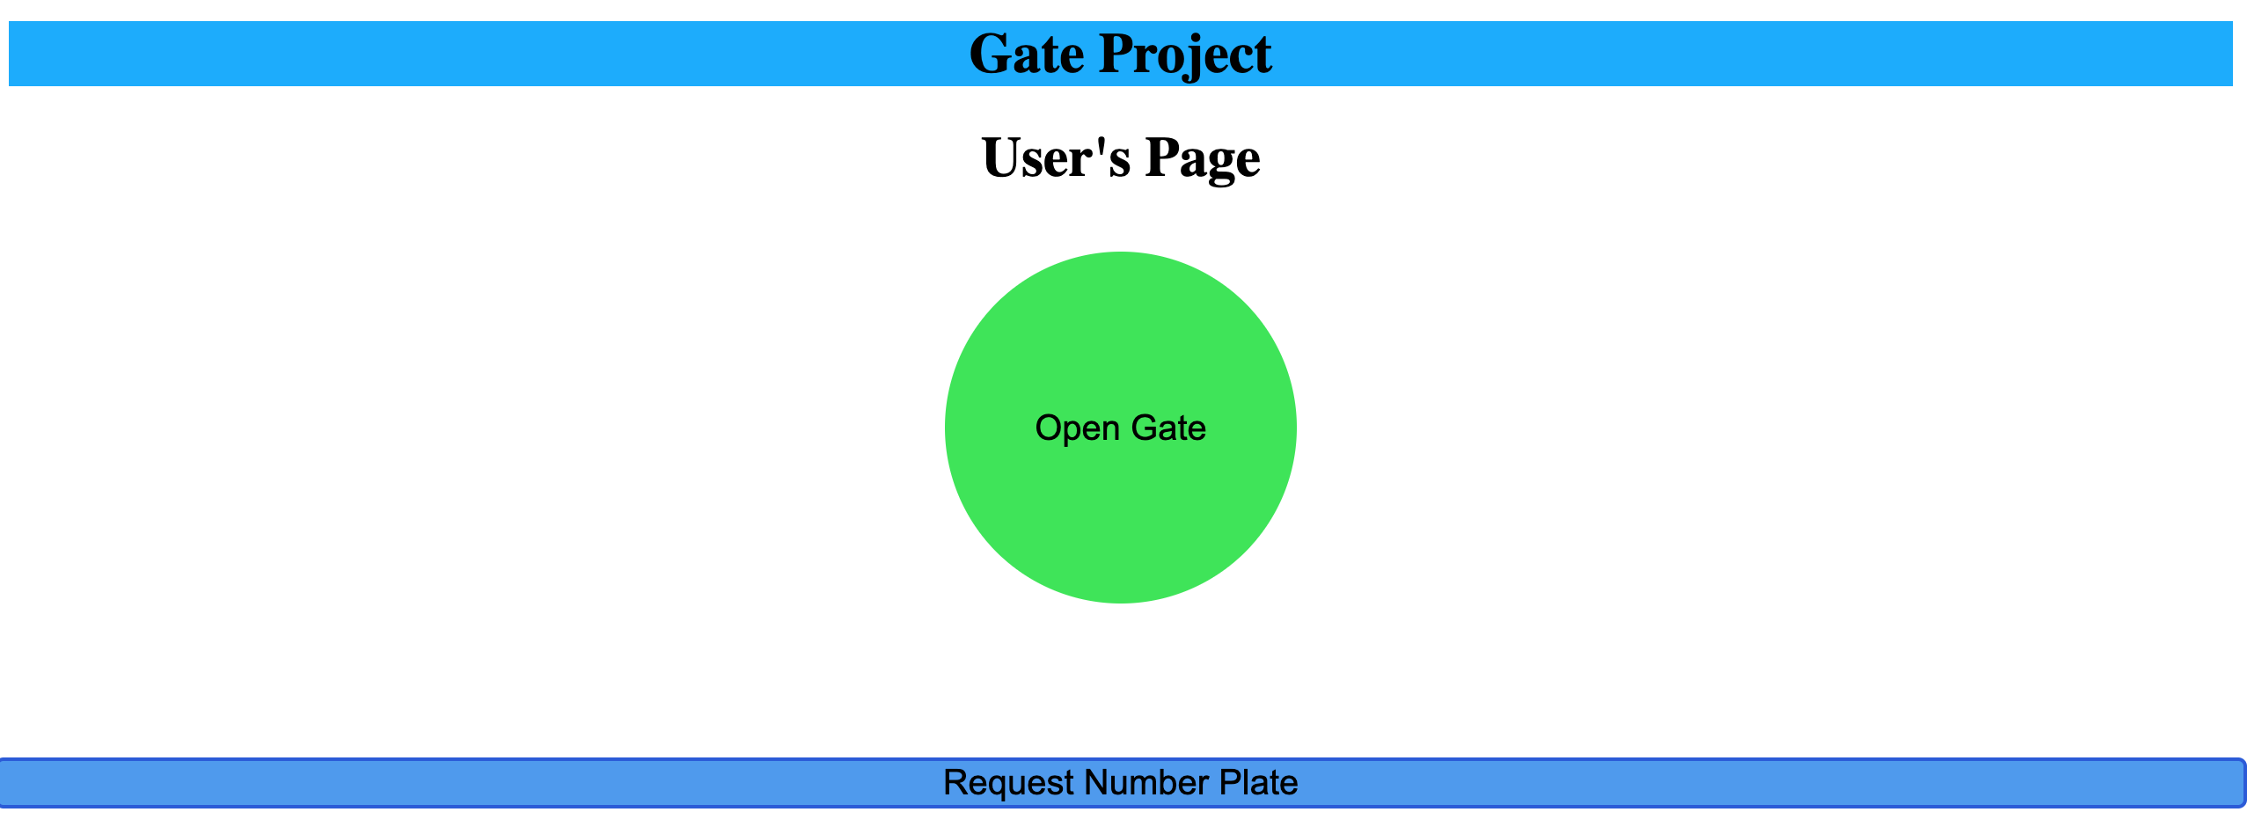

### App Side – Request number plate module

Again, this was just rehashing code from the primary users module

HTML file:

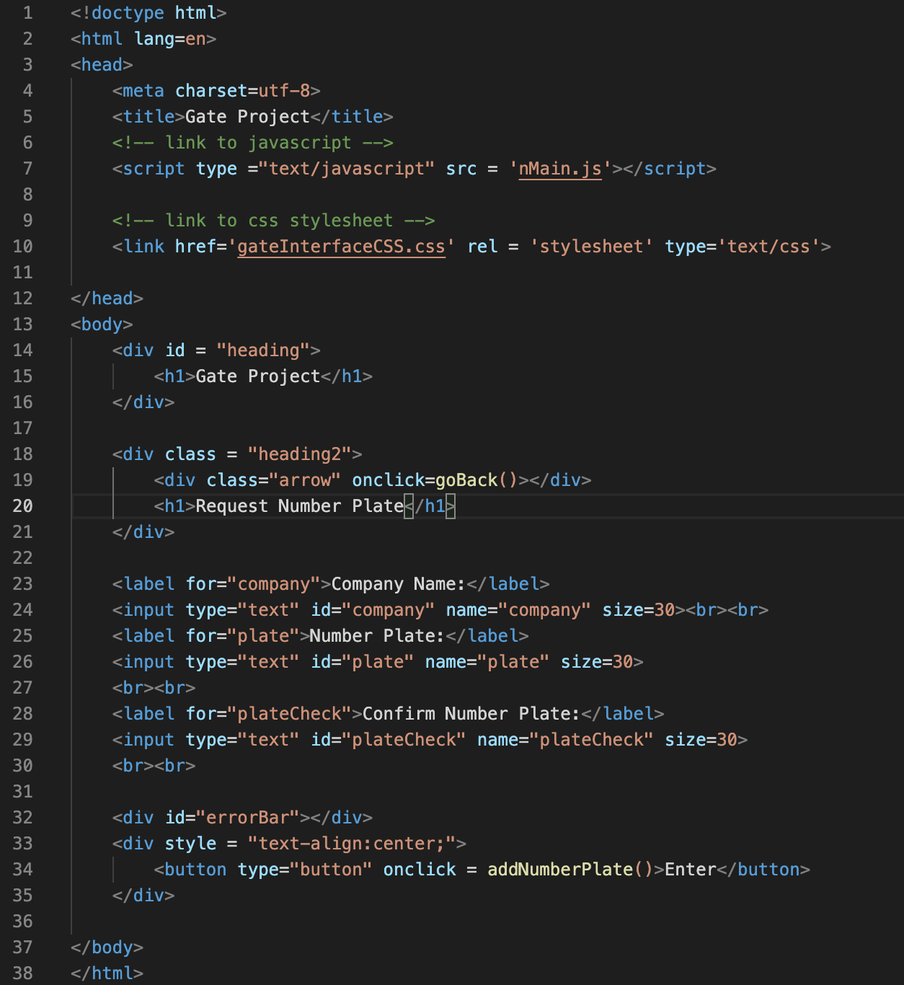

Web view:

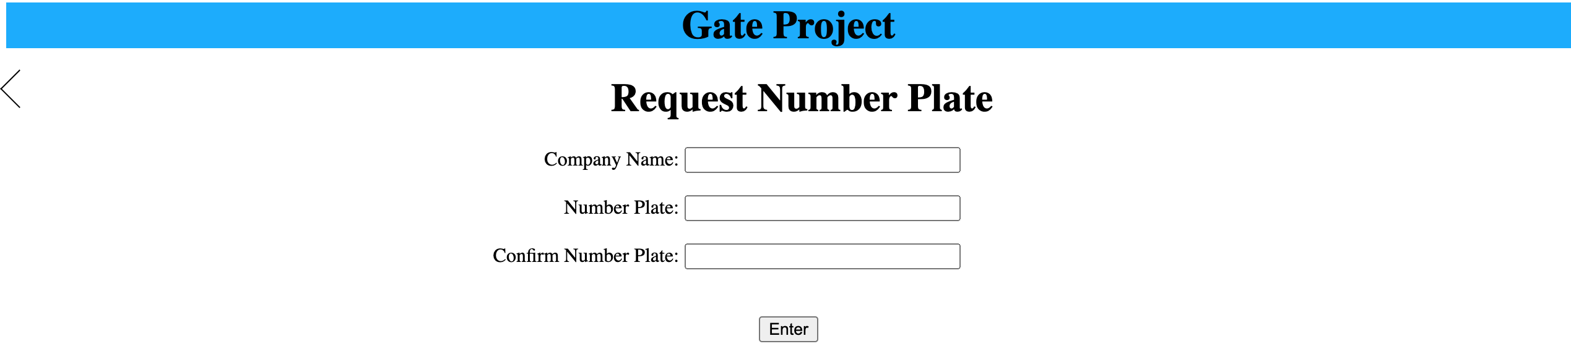

Things I need to change

Due to this page being created before I coded in a section to the login page which stored the company name as metadata in the URL I still have a company name line in request number plate module. This is now unnecessary and leaves room for human errors where a typo may mean their number plate is never actually sent to the primary user. When I am no longer under time pressure I should come back to this section and remove this option to choose a company.

### App Side – JavaScript for secondary users

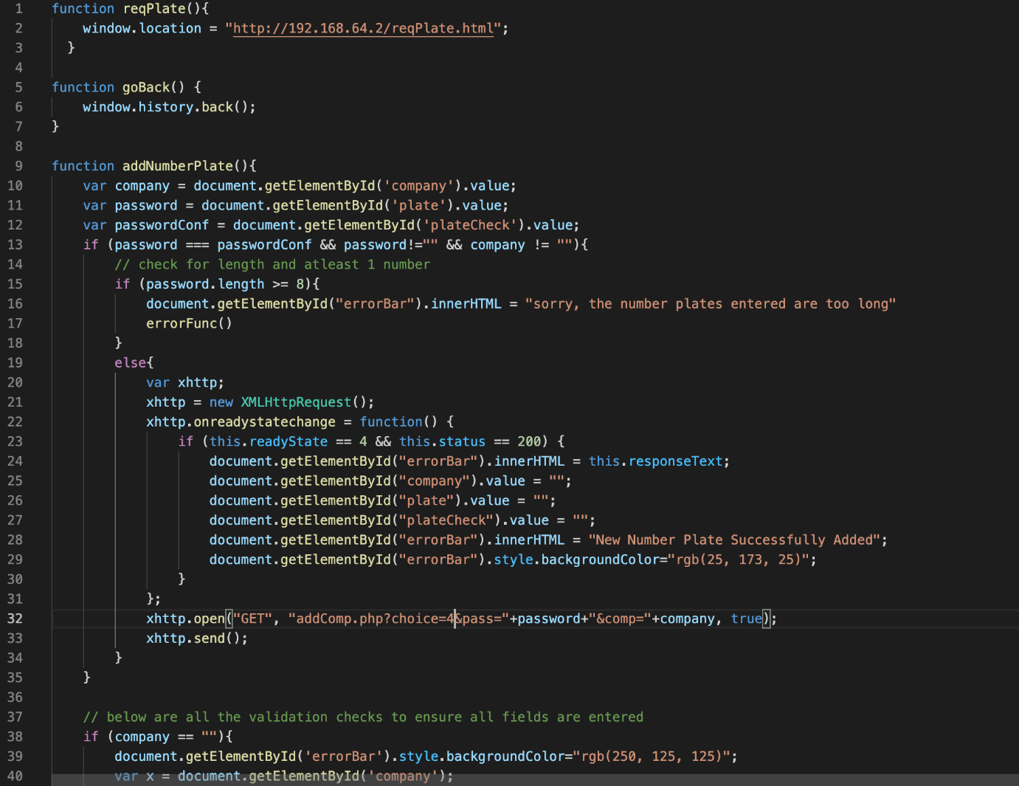

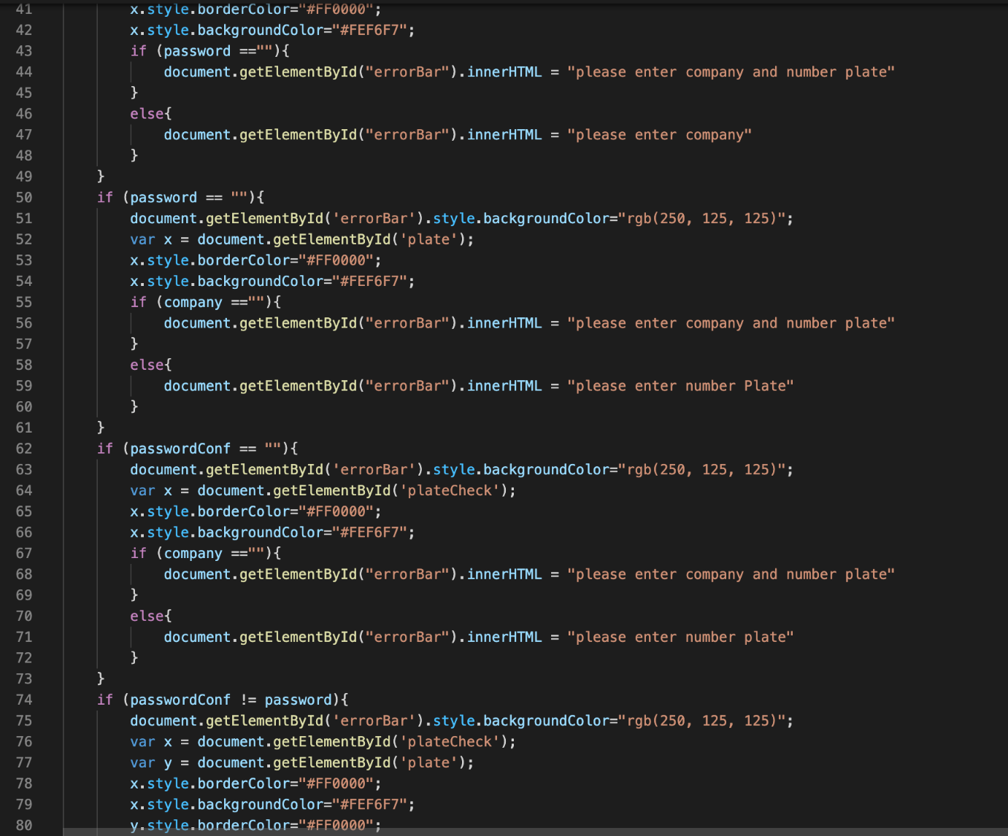

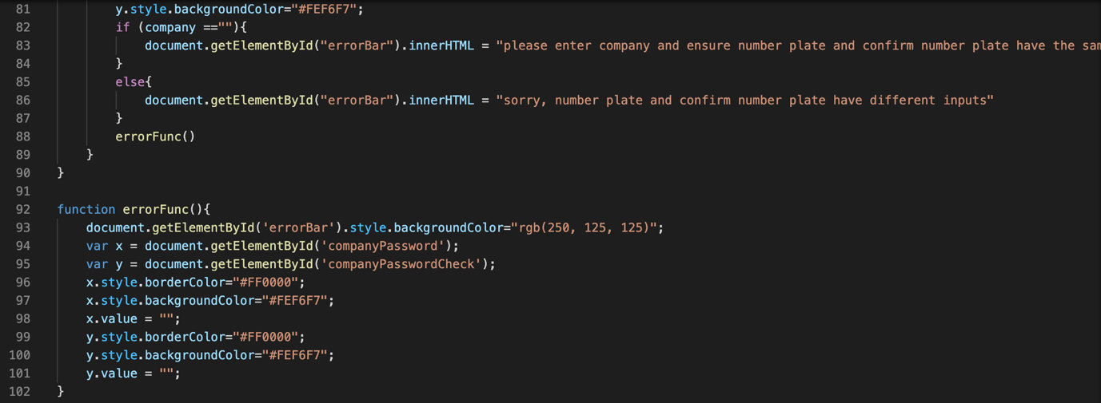

Validation checks

* line 13 – presence check for company and password
* line 15 – length check for password

### App Side – Full CSS for all pages

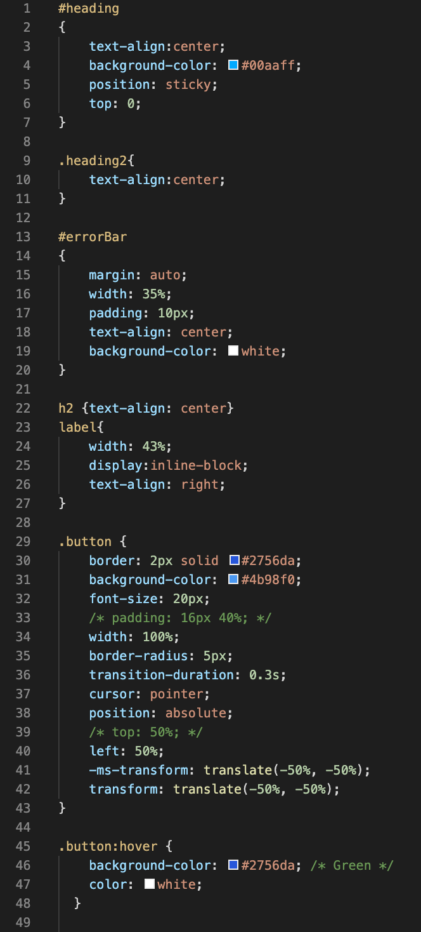

This is the top bit of the page that says, ‘Gate Project’, which can later be changed to a more suitable name when finalised. Line 5 ensures that on pages such as view entries this part stays on the page even as you scroll down.

Code formatting the blue buttons in which you traverse the pages with.

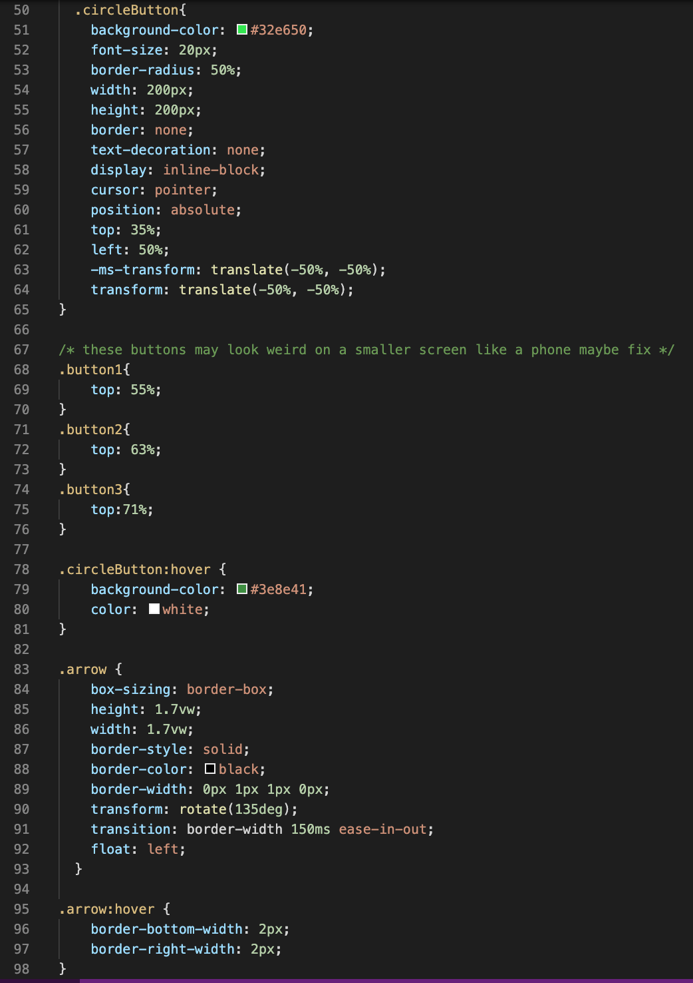

This is the circular button in the middle of the screen used to open the gate

Arrow is the code for the back button. It is two perpendicular lines rotated 135 degrees to appear like an arrow.

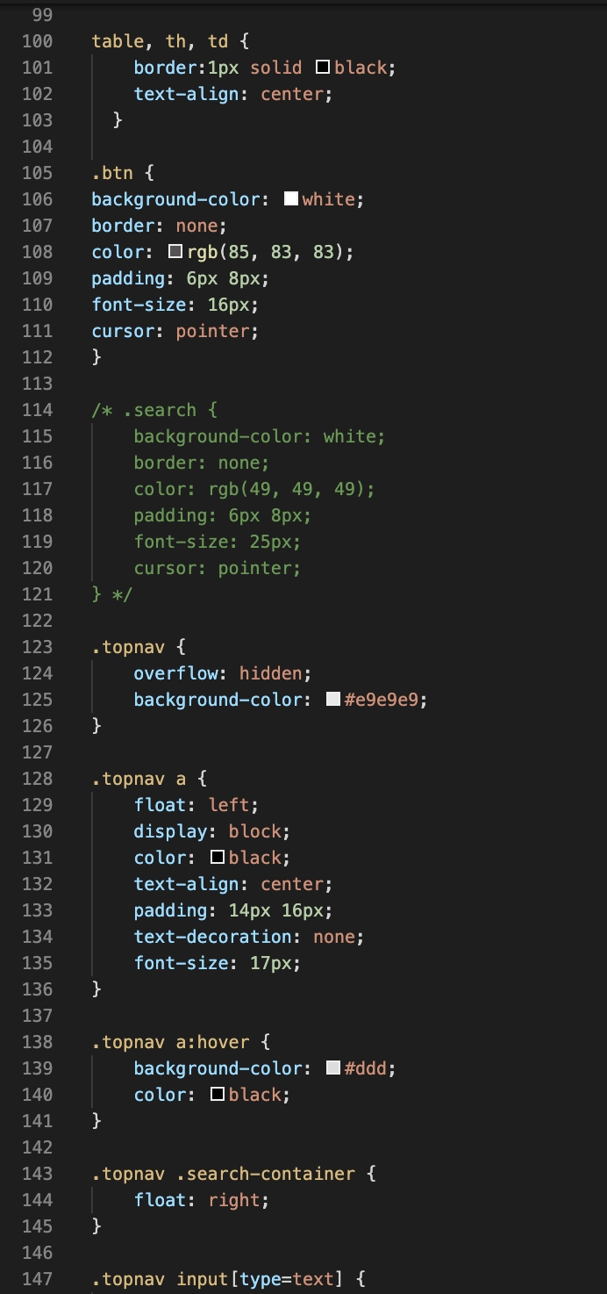

Topnav is the search button at the top of the page which is used to find certain names in the database.

This is the CSS for the submit button on all pages. Line 111 turns the mouse into a pointer which is useful as it emphasises the fact it is a working button.

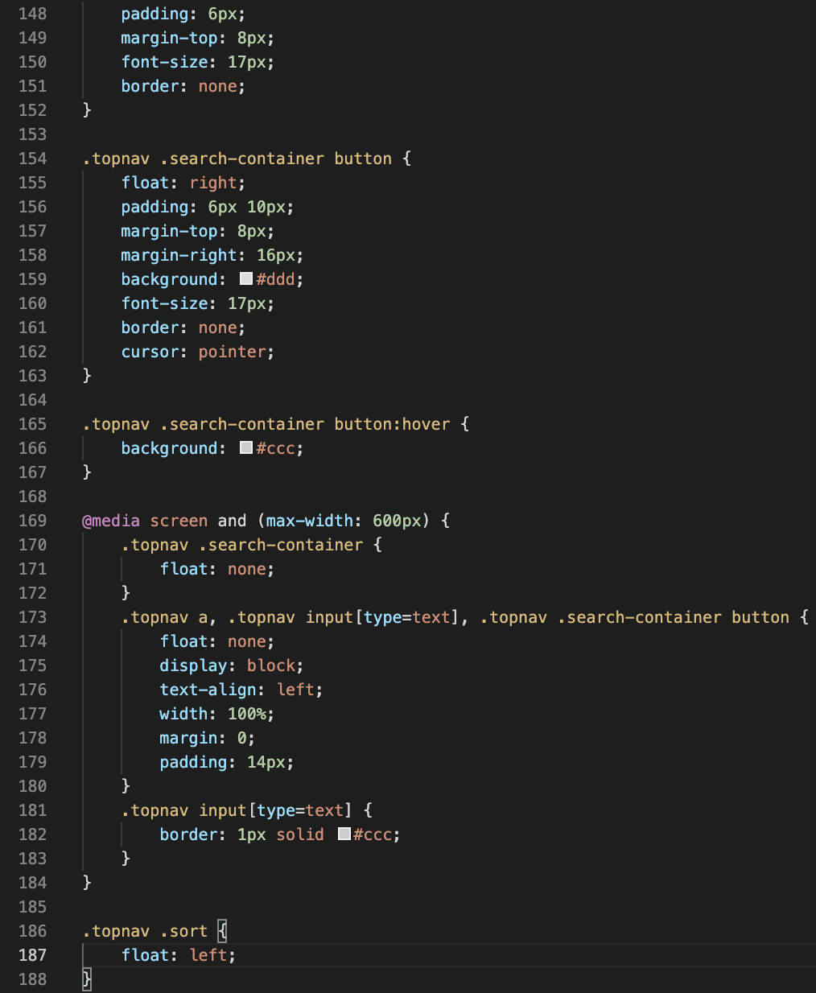

## Testing to Inform Development (10 marks)

Running the main tests myself

|  |  |  |
| --- | --- | --- |
| Test Number | Test Descriptions | Pass/Fail |
| 1 | Check company inputted in login is valid | Pass |
| 2 | Check password inputted in login page is correct | Pass |
| 3 | Adding a new number plate | Pass |
| 4 | Open gate through the app | Pass |
| ~~5~~ | ~~Delivery slot time and date are entered (assuming it is 12:00pm on 4~~~~th~~ ~~March 2021)~~ | Removed |
| 6 | David adding new company | Pass |
| ~~7~~ | ~~David views delivery slots~~ | Removed |
| 8 | David views daily entries | Pass |
| 9 | David changes order in which daily entries is displayed | Pass |
| 10 | David searches for a specific entry | Pass |
| 11 | David views companies | Pass |
| 12 | David deletes company | Pass |
| 13 | David edits company password | Pass |
| 14 | David searches for company | Pass |
| 15 | Viewing all number plates for a company | Pass |
| 16 | David changes the order in which company number plates are displayed | Pass |
| 17 | David searches of a company number plate | Pass |
| 18 | David makes a number plate valid | Pass |
| 19 | David makes a number plate invalid | Pass |
| ~~20~~ | ~~Delivery alerts are turned off~~ | Removed |
| ~~21~~ | ~~David selects specific company alerts~~ | Removed |
| ~~22~~ | ~~When notifications are on David is notified for new number plates and deliveries~~ | Removed |
| ~~23~~ | ~~Gate can be opened for deliveries~~ | Removed |
| 24 | Gate opens when vehicle is at the gate | Partial Pass |
| 25 | Camera detects when vehicle is present | Pass |
| ~~26~~ | ~~When button on gate is pushed code runs~~ | Removed |
| 27 | When a picture of a number plate is taken a string of it is made | Partial Pass |
| 28 | When a vehicle is at the gate the character recognition loop is only ran an appropriate number of times per image | Fail |
| 29 | App can be accessed on other devices other than the raspberry pi if they are on the local server | Pass |
| 30 | Entries are deleted after a month of being held on the server | Pass |
| 31 | Company can log in and are directed to the appropriate home page | Pass |
| 32 | Foreign number plates can enter the site | Fail |
| 33 | Cannot delete primary user | Pass |

Proof of tests 1 and 2

**First Iteration:**

Failed. This code did not go to another page if correct, instead would just print an encrypted version of the data below the submit button.



**Final Iteration:**

Entering the normal test data

* Company: Payne Pallet Inverters
* Password: Sonny020903



* Company: Test1
* Password: ZoomerZach2001



Entering the erroneous test data (wrong password)

* Company: Payne Pallet Inverters
* Password: W4rongPass



Entering the erroneous test data (wrong company)

* Company: TestCompany5
* Password: Password1



All these tests worked at expected and so I have decided to pass them

Proof of test 3

**Final Iteration:**

Entering the normal test data

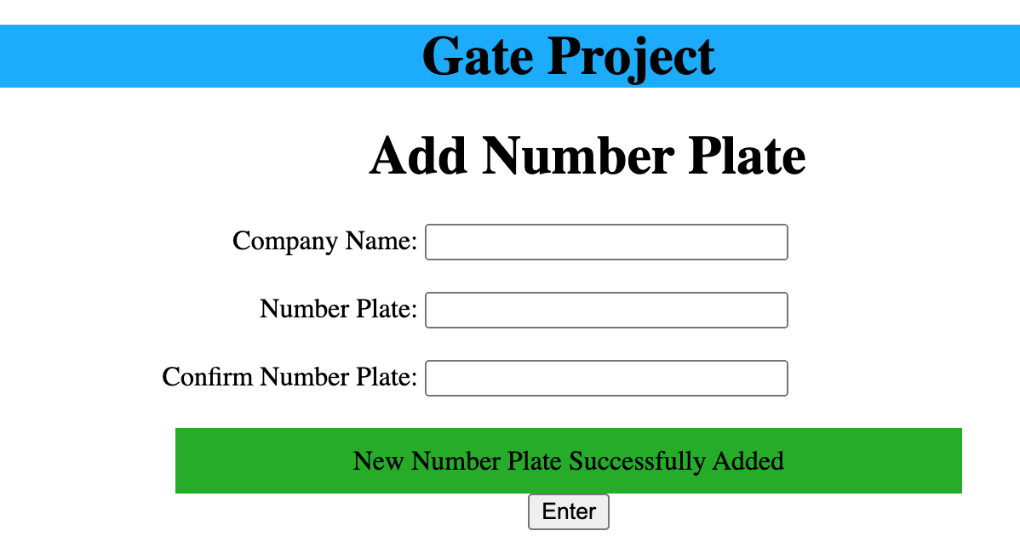

Entering the erroneous test data (number plate too long)

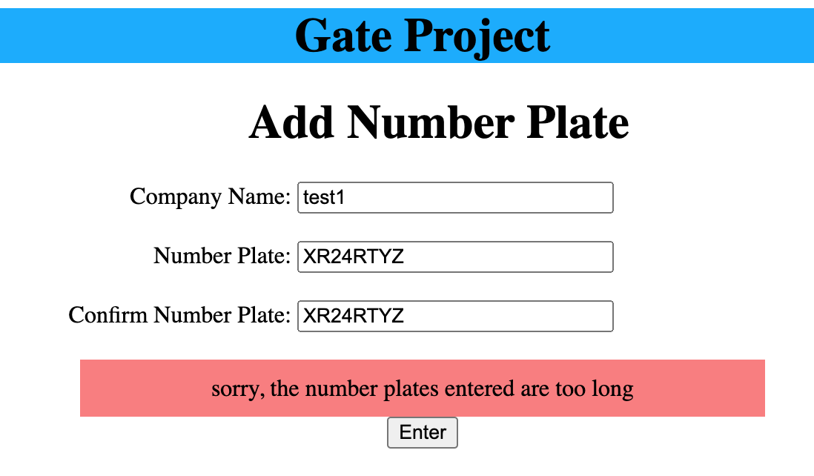

Entering the erroneous test data (different inputs)



Overall, these tests performed as expected so have passed.

Proof of test 4

**Final Iteration:**

Opening using primary user

See primaryOpen.MOV

Opening using secondary user

See secondaryOpen.MOV

Proof of “gate opening” from view entries page



This works for both primary and secondary users and so I have passed it. Note both where opened on my mac to prove the server running on the raspberry pi works.

Proof of test 6

**Final Iteration:**

Entering the normal test data

* Company: Test7
* Password: GoodPass123

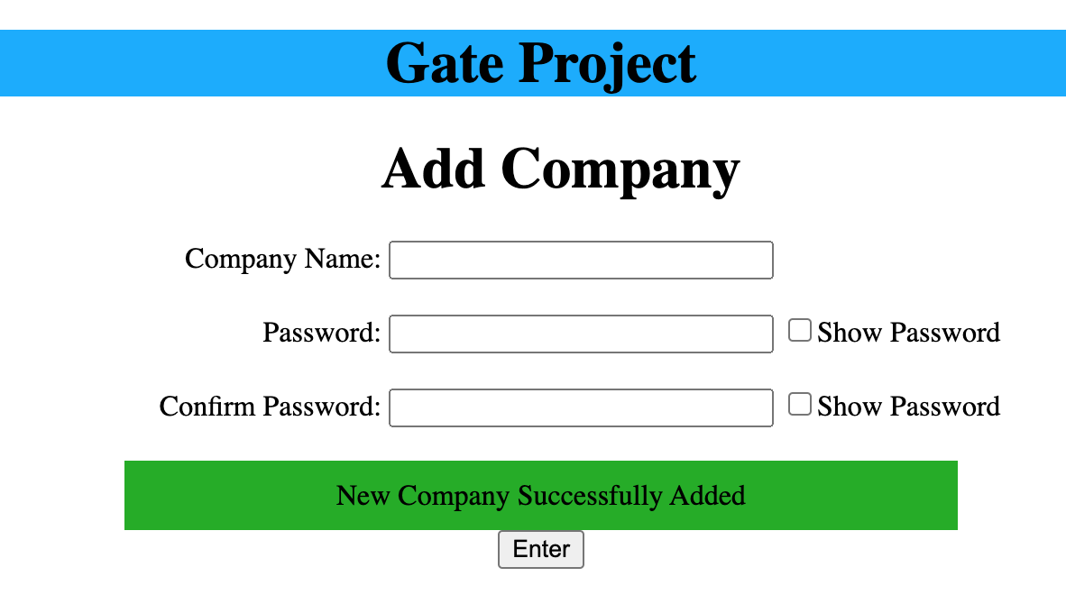

Entering the extreme test data

* Company: Test8
* Password: Password1

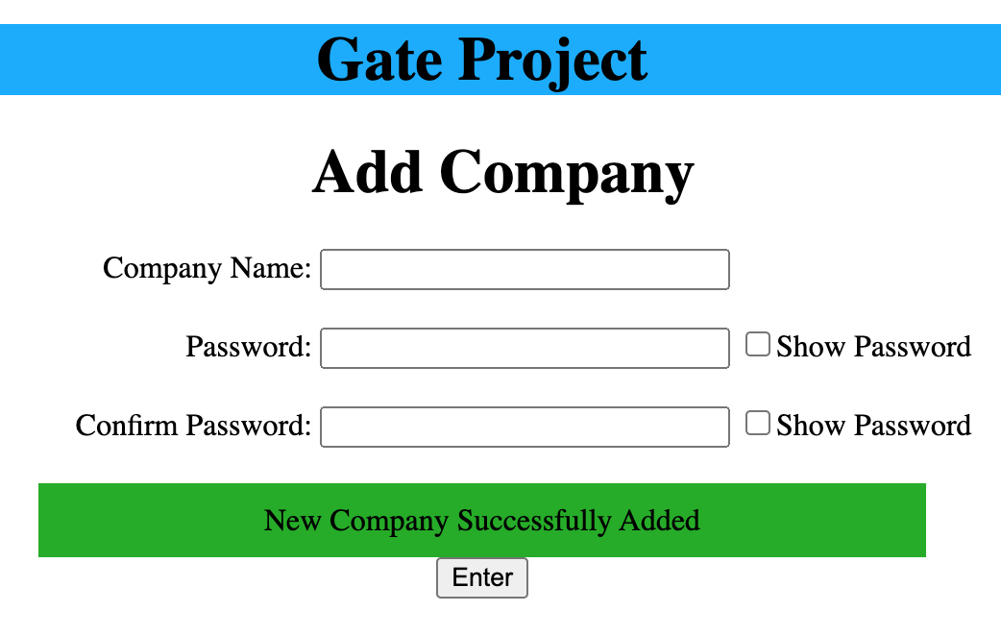

Entering the erroneous data

* Company: Test9
* Password: 123

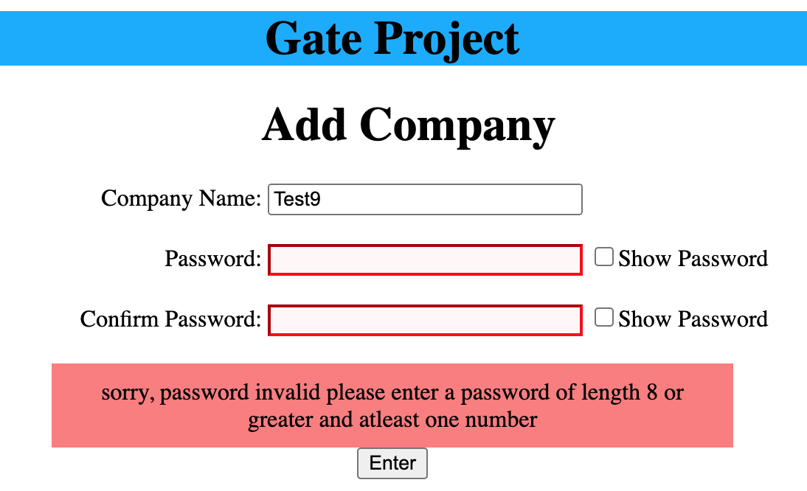

* Company: Test10
* Password: Pass

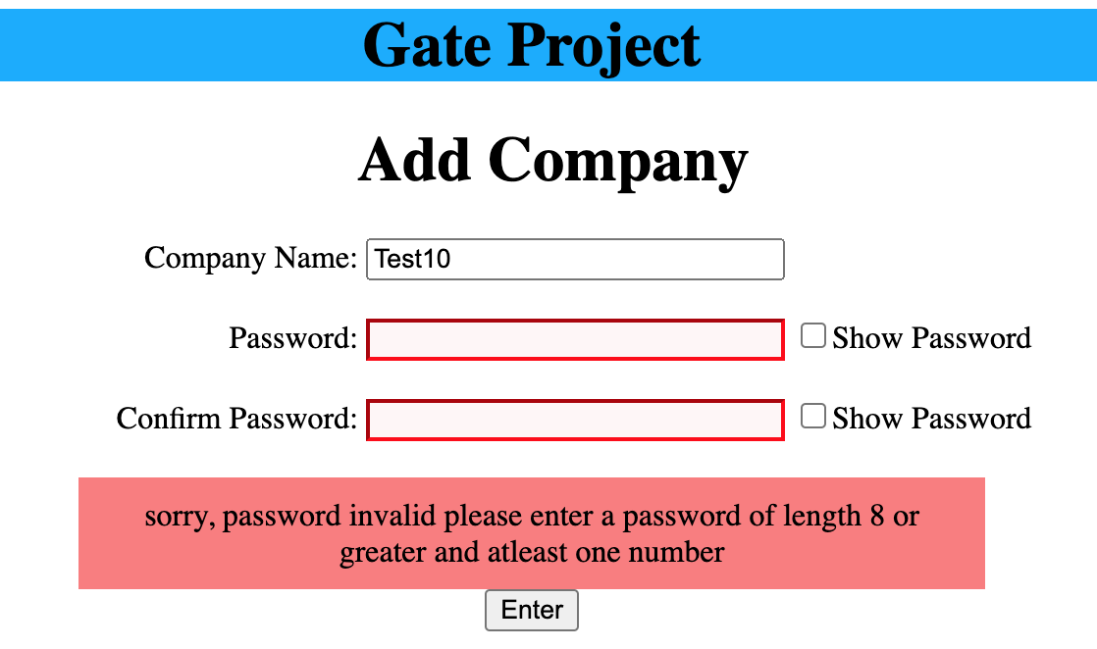

In the first iteration this test failed as 3 numbers entered into the password box would work, however, in the final iteration this has been fixed and everything has been passed

Proof of test 8

**Final Iteration:**

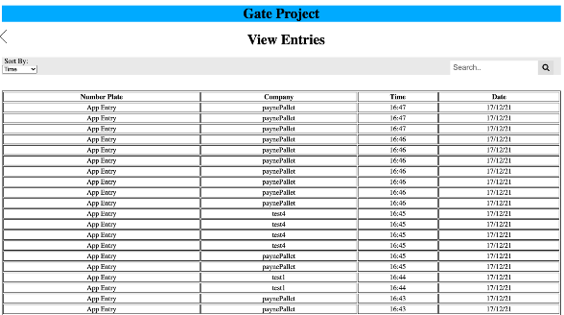

Everything worked, so the program passed all the tests.

Proof of test 9

**First Iteration:**

This feature had not been implemented yet on the page, and so failed the test.

**Final Iteration:**

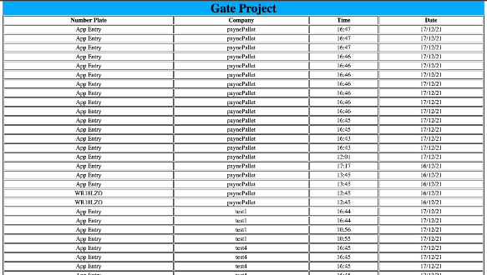

It worked! Passed test.

Proof of test 10

**First Iteration:**

It failed, there was something wrong in the database and so it returned nothing.

**Final Iteration:**

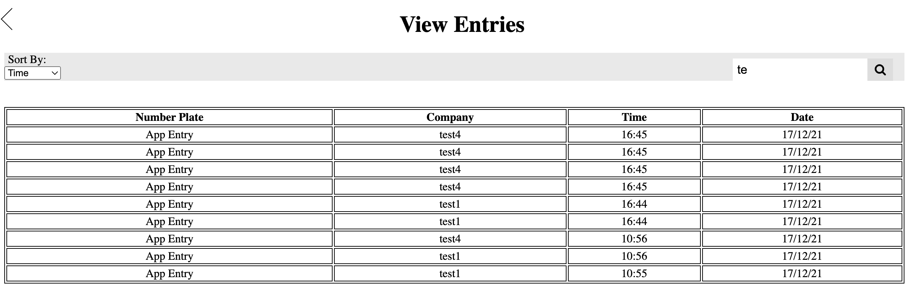

This also works now. Pass.

Proof of test 11

**First Iteration:**



**Final Iteration:**



Passed, no issues.

Proof of test 14

**Final Iteration:**



Displayed all companies beginning with “te”. Passed

Proof of test 15

**Final iteration:**



It works.

Proof of test 24, 25 and 27

**Final iteration:**

After testing this I found that it did not work at all. The vehicle was being detected, however the code to crop around the number plate was completely off, instead cropping around the shed window in the background. When it did crop on the number plate it would also output either nothing or complete gibberish.

**Fixed final iteration:**

After looking at the code I concluded the issue was due to 3 main problems. The first being that the camera was swinging in the wind, making it harder to get a clear image; to fix this I simply got my sister to hold the camera. A more permanent solution would likely be some sort of box which can hold all the components along with the camera in a more solid position. The second issue was the cropping, after testing this on the white number plate I concluded that it prioritises cropping around white boxes, hence the window with the white pane over the back yellow number plate. This likely got through the development stage due to me testing it on an American car, where that back number plates are white rather than yellow. Finally, the character recognition code wasn’t working, to fix this I went to an earlier iteration before the point where I had integrated it into the rest of the modules and found that this version worked fine so I simply copied the code over and used this instead.

Using a regular number plate

See RegularNP.MOV

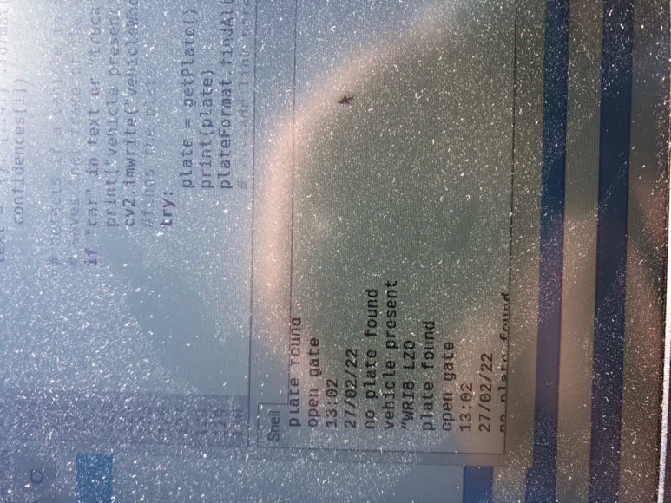as seen in this photo the character recognition read this number plate as “WR18 LZO which is slightly wrong. However, the formatting module removed the “ at the start of the string and found it matched the number plate in the database and so the gate was opened and the test partially passed for normal number plates with the only issue being that the back number plate did not work. Meaning I either have to not make it motorbike friendly or I have to recode the cropping module to find the yellow number plate instead.

Using a private number plate

See PrivateNP.MOV

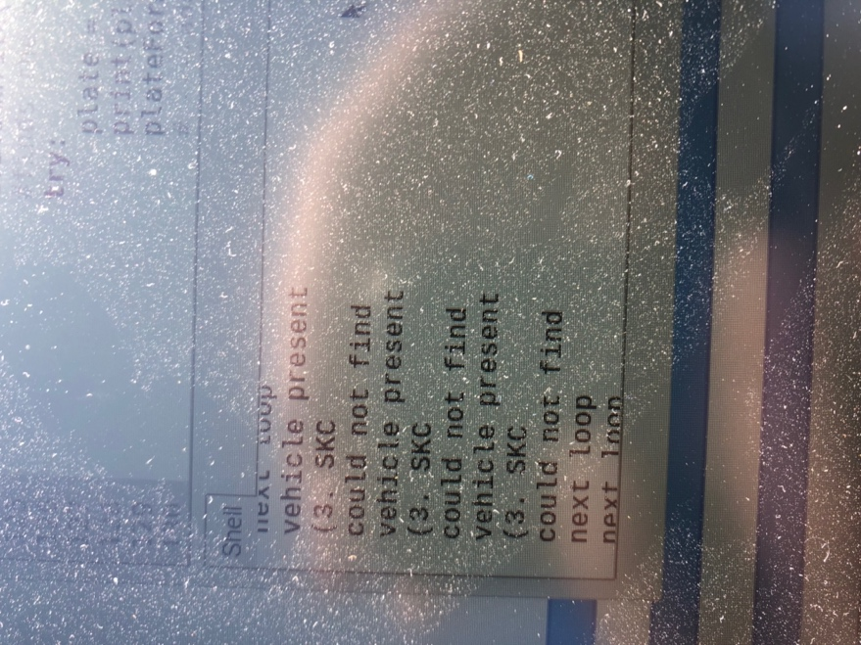as shown in the image to the right the character recognition read the number plate as (3. SKC rather than 13 SKC, due to the limitations of the formatting module on private number plates this did not open the gate and so failed the test. Possible fixes for this could be a better formatting module or a better character recognition library.

Test 28 Fail



As shown in this image a new loop is entered when the vehicle is detected. However, this loop is repeated 3 times on the same image, getting the same result of an unidentified number plate. This is clearly inefficient as this information was found on the first iteration.

This issue stems from the dodgy retraining process of the object recognition which resulted in the same vehicle being detected multiple times in the same frame. An example of this type of error is shown below.



An adaptive solution I took to fix this issue was increasing the percentage certainty required to enter the loop (increasing it from 0.6 to 0.8), this meant less of the boxes triggered a loop. A perfective solution to this error is to retrain the model again so it will only detect one vehicle. This solution is both time consuming and difficult to achieve.

Test 32 Fail

As Irish number plates are longer then 7 characters long (9 characters) and have dashes in them not only can they not be detected as they are seen as too long and therefore fake but they can also not be added to the valid number database as the length will cause it to be rejected.

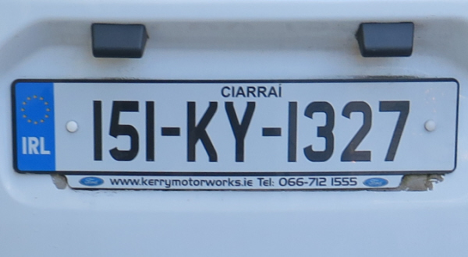

I used an adaptive solution to fix this issue and added in an error for number plates being entered in the database so it would now say “error, number plate is too long. Currently foreign number plates which take a different format to British number plates are not usable in the program”. A perfective solution to this is to have a more page on the number plate section where you can change the country the number plate is from, changing the restrictions required to be added to the database. To ensure this is still secure the system should look out for the IRL at the start of the plate to decide the formatting to check it against.

Removed tests

Due to time restrictions and lack of experience I could not add notifications to my project, and so all delivery tests failed.

# Evaluation (20 marks)

## Testing to Inform Evaluation (5 marks)

Tests ran by the primary user

During the testing of this it started to rain and so had to be stopped as the device doesn’t have a water proof case yet. Solution for this is to either make it so the important hardware is inside or make a casing that is waterproof yet still able to keep the raspberry pi cool so that it does not overheat.

|  |  |  |
| --- | --- | --- |
| Test Number | Test Descriptions | Pass/Fail |
| 1 | Gate opens when vehicle is at the gate | Partial Pass |
| 2 | When button is clicked on the app the gate opens | Pass |
| ~~3~~ | ~~When button is clicked on the gate a notification is sent the relevant people~~ | Removed |
| 4 | David adding new company | Pass |
| 5 | David can delete companies | Pass |
| ~~6~~ | ~~Delivery slot time and date are entered (assuming it is 12:00pm on 4~~~~th~~ ~~March 2021)~~ | Removed |
| 7 | Company with valid name and password can log into the app | Pass |
| ~~8~~ | ~~David selects specific company alerts~~ | Removed |
| ~~9~~ | ~~When notifications are on David is notified for new number plates and deliveries~~ | Removed |
| 10 | David makes a number plate valid/invalid | Pass |
| 11 | Adding a new number plate | Pass |
| 12 | Gate opens when vehicle is there at night | Fail |
| 13 | David can find all features without my help | Pass |
| 14 | Raspberry Pi works for a whole day on the site | Fail |

Test 4 Proof



David added the company myComp through the add company page and it appeared in the view company page.



Test 5 Proof

As shown in the screenshot myComp was deleted, removing it from the view companies page.



Test 10 Proof



David clicked the valid box for 49TP and unvalidated it then clicked the box for WA13WRO and validated it. He was happy with both processes, with no issues arising

Test 11 Proof



David added the number plate WA13WRO through the add number plate page and it was added to the test company page in view companies



Test 12 Proof

I started by driving a car with its lights on to see how the code would react

See nightLight.mov for video

As shown in the video the light dazzled the camera and meant that it could not find a number plate. This in turn led to the LED not turning on. To fix this issue I decided to try it again with my lights off.

Retest 12 in easier conditions

See nightLowLight.mov for video

This did better, as the camera was not dazzled the number plate could be found and read. However, with the lower light it was more inaccurate, meaning the LED did not turn on.

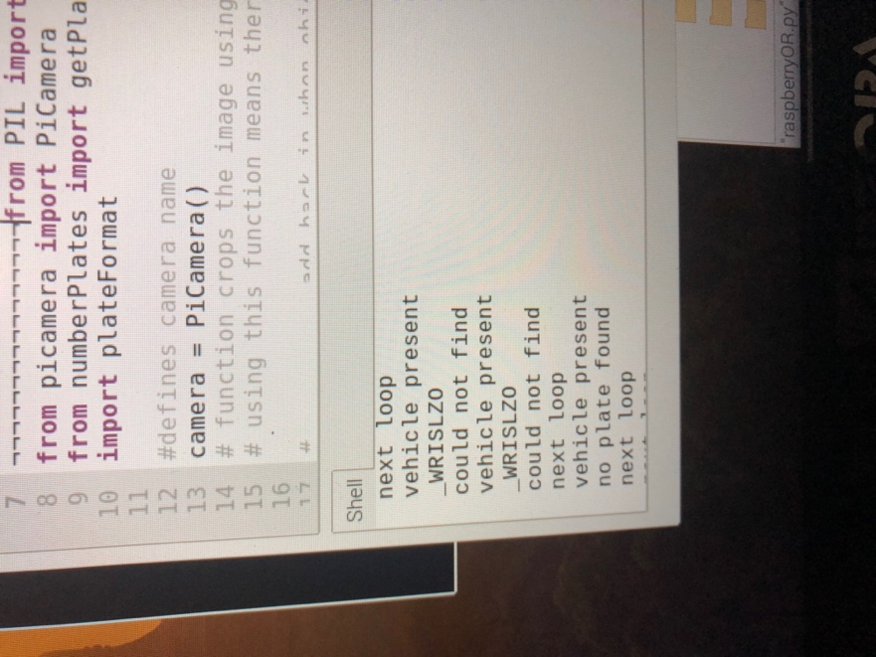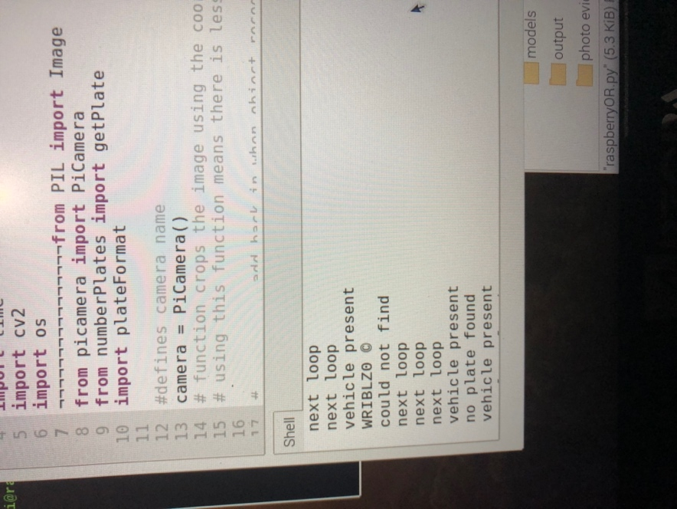

As shown here the vehicle is detected and the character recognition is run. But, with the low light this produced more inaccurate interpretations with an 8 being misread as an S and a 0 being misread as a 0 with a dot in it.

Adaptive solution: Position the camera so that the front lights do not dazzle the image and make reading the number plate impossible (position camera higher rather than light level). Also increase the formatting module to account for the mistakes made by the character recognition in low light.

Perfective solution: Fix the cropping module so that it word on back number plates, this not only solves other issues but also means that the front lights won’t dazzle. Back number plates are also required by law to be lit up and visible, meaning that it will likely be easier to view and read.

David’s comments on the tests + test 13 proof

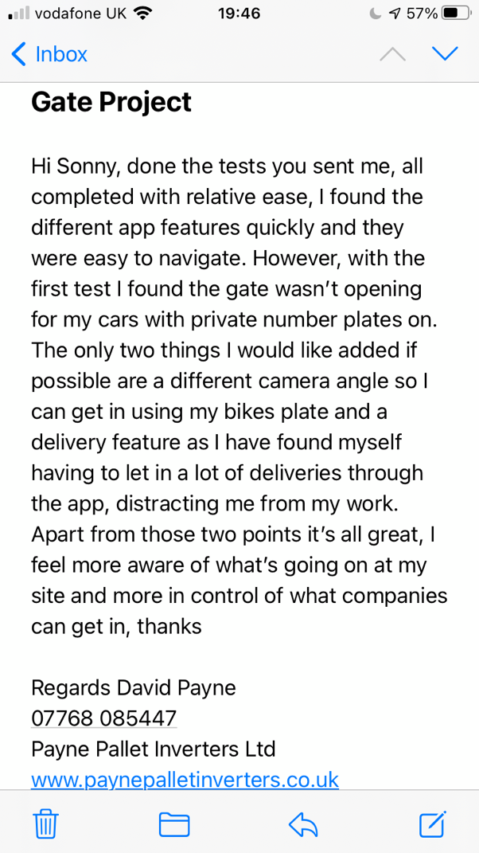As shown by the email on the left David found all the tests were fine except test 1 where he found the gate didn’t open with his private plates.

As shown in this part of the paragraph David did not need help doing the test (which required him to navigate the app. Due to this I am passing test 13.

David’s Points

As shown in the email David found the app easy to navigate and could find the features quickly. However, David didn’t like some of the hardware features, finding it difficult to get in with his private plates and impossible on his motorbikes as the cropping module of the number plate recognition system currently only works on white number plates, meaning the yellow back number plates did not work. However, overall he felt more aware of what was going on at the site, this again shows that he can easily navigate the app, viewing entries, adding companies and validating number plates.

My Points

Overall, I am happy with the app usability, finding it easy and quick to navigate. However, I do find the user interface ugly with a bad colour scheme and a back button which could be in some cases hard to find. I also found that shrinking the page made this formatting even worse, squishing the buttons more together. These issues of formatting can be solved with relative ease if I learned how to use CSS better, as I found this the hardest part of the app side, resulting in me doing the bare minimum and instead focusing on functionality. With the rest of the project, I was relatively happy with all the tests passing to some extent. The main issues in this being the hardware issues which David flagged up.

## Evaluation of Solution (15 marks)

### • Used the test evidence to cross reference with the success criteria to evaluate the solution explain how the evidence shows that the criteria has been fully, partially or not met in each case.

|  |  |  |  |
| --- | --- | --- | --- |
| Success Criteria | Proof | Explanation | Fully/Partially/Not Met |
| Able to identify a number plate from an image | See tests 24, 25 and 27 | Although this works well with standardized UK number plates, I did not have the time to format fully for private number plates (this is due to the lack of structure in private plates making it hard to determine whether the PyTesseract has misread certain numbers for letters e.g. reading an O as a 0. It is also due to the GB present at the start of number plates sometimes being read) | Partially Met |
| Able to add and delete companies and number plates through the Raspberry Pi | N/a | There is no independent code to do this however it can be done rather easily in terminal using MySQL. I skipped this as it can all be done more easily via the app. | Not Met |
| Turns on LED when car number plate matches one in the database (later LED will be changed to gate) | See tests 24, 25 and 27 | See the video at time frame – xx:xx for proof. Gate only opens when a valid number plate is seen. Invalid ones along with ones not present on the database will not turn on the LED | Fully Met |
| Able to add and delete companies and number plates through the app | See tests 3, 6 and 12 | As shown in the screenshots the companies and number plates can be added my David and deleted by David | Fully Met |
| Able to turn on LED when clicked through app (later LED will be changed to gate) | See test 4 | As shown in the video when the button is clicked the LED turns on | Fully Met |
| The system must store and query data in an effective matter | See test 8. Also see design section where the database structure for the project was taken from | As shown in the screenshot all data is in 3rd normal form, hence at its most efficient. Foreign key columns in one table are deleted when the primary key is from the other table | Fully Met |
| Must be able to view entries to the site through the app | See test 8 | As shown in the screenshot David can see all the entries to the site in chronological order | Fully Met |
| Must be able to enter delivery times and be alerted when bell is rung between those times | N/a | Due to time limitations in the coding process all delivery related code was cut out | Not Met |
| Photo of car is shown when phone is alerted for a guest | N/a | Due to time limitations in the coding process all delivery related code was cut out | Not Met |
| App keeps David aware of what’s going on at the site |  | As shown in the email David is happy with this part of the project and feels he can easily control who enters the site along with having access to information saying who had entered the site in the past | Fully Met |
| Number plate recognition is effective and efficient at night | See test 12 done by the end user | Due to David’s site having lights by the gate I didn’t see any reason to test it in full darkness, however, with limited lighting it still struggled to find the number plate, getting dazzled in the front beams. When the front lights were turned off the number plate could be read, but not to the accuracy required. | Not Met |
| Number plate recognition is efficient and time saving | See test 24, 25 and 27 where the gate opened approximately 2 seconds after the car stopped | On normal number plates this worked very well, opening the gate in just two seconds of stopping. However, as it does not work with private number plates I have put it as a partial success | Partially Met |
| System must be consistent with its results | See tests 24, 25 and 27. Along with further testing each hour this was confirmed | During this 24-hour testing period everything appeared to run fine, except from with private number plates. Program did not crash or over heat during this period. | Partially Met |
| Application server must run consistently without problem | Ran server over night with no errors occurring. | I ran this over night and found both the python file and the server still up and running, the raspberry pi seemed fine, and the fan had done the job of stopping it from overheating | Fully Met |
| When the bell is rung David and the relevant people are alerted | N/a | Due to time limitations in the coding process all delivery related code was cut out | Not Met |
| People can submit number plates through the app and David can decline or accept them | See tests 3, 15, 18 and 19 | As shown in screenshots people can easily submit number plates though the app and David can easily validate them | Fully Met |
| Editing the database is efficient and effective | See tests 3, 6 and 12 | Editing the database though the app gives near instant results. (However, has only been tested on a local server, global server may be slower) | Fully Met |

As shown in the email David is mainly happy with the finished product and has signed it off as complete. I am also happy with the result with most success criteria being fully met. However, I do feel there is a lot of room for improvement with many of the failed or partially met criteria being key elements of the project. I would like to come back to this project and fix these issues one day once I have more coding experience and time, that said I am happy to sign it off at its current standard.

### • Provided comments on how any partially or unmet criteria could be addressed in further development and provided comments on how any issues with partially or unmet usability features could be addressed in further development.

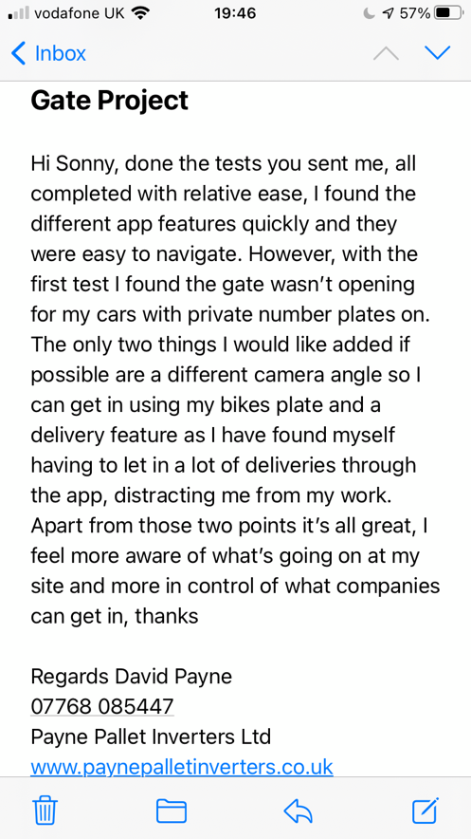

Key issues David found

* Number plate recognition not working with his private plates
* Number plate recognition not working on back number plates, and so not working with his motorbikes
* Lack of delivery features meaning he has to interact with a system that is meant to be making his life easier, not giving him more jobs to do

The partially met number plate recognition issue

This issue was highlighted due to David having a lot of private number plates, and so affected him on a daily basis. A quick fix for this would be to add into the formatting section his number plates as read by the character recognition and the actual number plate so it may be converted. However, this isn’t a very permanent fix and David would likely prefer me to write a module which can fully format the private number plate or create a character recognition system which is more suited to number plates, prioritising certain numbers over the similar letters. Both solutions require a lot more time to be spent on the project and so I cannot do them with the current time limitations.

The unmet motorbike site access issue

Due to David riding a lot of motorbikes he found this to be an issue. To fix this issue I would need to fix the cropping module part of the project, so it will work with back number plates as this is causing the issue rather than the object recognition part of the project which is working fine with motorbikes. However, this would take time to fix and due to current time limitations, I cannot do this.

The unmet delivery alert criteria

When I started coding the app side of the project, I realised I was too unexperienced with coding real apps, and this would not only take more time, but it would also be more complicated to connect to a server and would also require me to spend money to keep it on the app store. Due to this I decided the best route was to go with a web app instead and remove the notification part of the project, as the delivery section relied heavily on notifications this meant that I had to remove this whole section too. Overall, there is no quick fix to this I must instead just be better and more experienced at coding apps to complete this part of the project. If I do this in the future, I will likely use the web app code as a template to work off, ensuring the process of coding this will be quicker and easier.

The object recognition being inaccurate

Despite this not being one of the criteria David complained about I felt I still had to mention it as the fractured OR system means loops are unnecessarily ran, wasting time. Fixing this issue will likely make the whole project run both faster and smoother. To do this I would need to retrain the OR again which is a lengthy process (took a week last time). I would also need to gain more understanding on retraining the model to ensure it is in its most efficient form. Due to all these requirements, I simply do not have the time to redo this at the moment.

### • Provided evidence of the usability features justifying their success, partial success or failure as effective usability features.

|  |  |  |  |
| --- | --- | --- | --- |
| Success Criteria | Proof | Explanation | Fully/Partially/Not Met |
| Easy to find features and navigate the pages | See David’s email | As shown in the email he completed the tests and navigated the page without any issues | Fully Met |
| Gate can open for all types of vehicles | N/a | As shown by the fact that the back number plates can not be used due to being yellow motorbikes could not get into the site, along with people using private plates due to the lack of detail in the formatting module | Not Met |
| Different users can use the app and navigate with ease |  | As shown by the image users other than David can access the app and use it, although with a lot less features. This is very easy to navigate. | Fully Met |
| All valid users can open the gate via the app and their entry may be viewed in the view entries page | See test 4 and 9 | As shown in the screen shot all companies which entered the site through the app were logged and the users were let into the site | Fully Met |

### • Considered maintenance issues and limitations of the solution.

|  |  |
| --- | --- |
| Maintenance issue | Solution |
| Raspberry Pi is not waterproof, having it outside for long periods will likely break it | Perfective solution – create a waterproof box so that it is not affected by the elements. However, must still be able to be cooled so it does not overheat and must be accessible in case something goes wrong. |
| Using a global server will give a monthly fee to keep it up | Adaptive solution – give the user a monthly maintenance fee for using your service, include this server cost in this fee. |
| In the future letters like I, Z and B may be added to number plates as population increases (this happened with the letter O which is now used for Oxford number plates) | Corrective solution - in the future I may need to access the raspberry pi and update the code so that it may work with the new letters. |
| In the future when number plates have been around for 100 years the 3rd and 4th numbers of the number plates will repeat. This could lead to the government reformatting number plates which could break the formatting module of my code | Corrective solution - in the future I may need to access the raspberry pi and update the code so that it may work with the new format.  Perfective solution – create a character recognition system which can distinguish the letter I to the number 1 and so on. Will also not include the GB at the start of some number plates in the string. |
| Character recognition library used is bad and makes mistakes | Perfective solution – find a character recognition library that doesn’t make as many mistakes.  Corrective solution – add more detail to the formatting module so that the mistakes are accounted for and removed. |

### • Described how the program could be developed potential improvements / changes.

Delivery features and alerts

As discussed in the design section of the project delivery features would be a key improvement that if I find time should be a priority. The features for this section would be a scheduling system where you can arrange a time when the delivery should arrive and then get alerts for all vehicles who ring the bell at the gate within this time period. Another delivery feature that I could implement is sending a photo or footage of the vehicle at the gate to the relevant user, and possibly give them a way to communicate with this vehicle so they can be certain it is their delivery. This communication would also help direct the delivery driver to the right unit, however, this could be a problem as multiple users may have deliveries at the same time and may both try to communicate with the vehicle. A final alert feature for David could be an alert for incoming number plates so he knows when they have been added and can validate them quicker.

Change app from web app to phone app

One change I would like to do for this project is to move it from a web app to an actual phone app as this just seems more professional and ensures the users are more connected as a phone app is quicker access than a web app.

Facial recognition for a side gate

A possible feature is a side gate which could be used for people just walking in and out of the site. Although this is a less necessary feature and not a priority it could still be a possible change if there was a different end user with a different site was structured more in a way where people walked in and out. However, despite facial recognition being more convenient it is quite hard to code and so a RFID card may be more suited to a side gate as it is still a reasonably cheap alternative.

Final thoughts

Overall, this project has helped me in my coding languages, not only improving my current skills but expanding on them as I used PHP, CSS, JavaScript, and HTML for the first time. I also found using object recognition and character recognition for the first time interesting as it reminded me of the power and potential of coding. Along with my coding skills this project has also improved my preparation skills, giving me a better idea of what to do before I jump straight into a project with Jackson structured programming, data definition tables and UI diagrams proving very useful as I went back to them time and time again during the coding process to give me direction of what to do next when I was stuck or finished on a module.

Along with the basic skills I feel this project has also shown me the possibilities of coding and that you can push yourself and do projects you before felt were only doable by professionals or big teams and that in doing so you will learn new skills and become more experienced yourself. An example of a seemingly impossible task for me was retraining the object recognition model as I made seemingly little progress in 3 days of intensive coding. However, I eventually overcame this and became more comfortable with using terminal and command line, a skill which I later used when coding the final app pages on the server. I would like to one day come back to this project when I have gained more experience and see how far I can take it as I feel the concept is interesting and useful.